The effect of rehabilitation after surgery in a patient with pectus excavatum: a case study
Enkeleda Sinaj, PT, RN PhD, Faculty of Technical Medical Sciences, University of Medicine, Tirane, Albania

Abstract
Statement of the Problem: Pectus excavatum (Figure 1) is a condition in which a person's breastbone is sunken into his or her chest. Severe cases of pectus excavatum can eventually interfere with the function of the heart and lungs. Pectus excavatum can be surgically repaired. The rehabilitation after surgery can improve posture and increase the degree to which the chest can expand. The aim of the study is to present the effects of rehabilitation after surgery in a patient with pectus excavatum.
Methodology & Theoretical Orientation: This paper presents the case of a 29 year old female patient, who underwent successful physical rehabilitation after 9 weeks from the surgery. The patient underwent an individual physiotherapy program, which lasted six weeks.
Findings: After six weeks of the rehabilitation program, the patient's chest expansion and posture improved significantly.
Conclusion & Significance: The rehabilitation should find a wider application in comprehensive treatment provided for pectus excavatum.

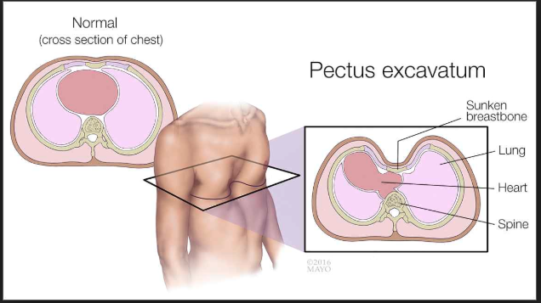
Figure 1.

Recent Publications
- Ewais, M. M., Chaparala, S., Uhl, R., & Jaroszewski, D. E. (2018). Outcomes in adult pectus excavatum patients undergoing Nuss repair. Patient related outcome measures, 9, 65–90. doi:10.2147/PROM.S117771.
- Bal-Bocheńska M. A. (2016). Evaluation of the effects of rehabilitation after surgery using the Ravitch and Nuss methods: a case study. Kardiochirurgia i torakochirurgia polska = Polish journal of cardio-thoracic surgery, 13(1), 72–77. doi:10.5114/kitp.2016.58973
- Jacqui Schewitz, Helena Van Aswegen. (2013). Rehabilitation after pectus excavatum corrective surgery: A single case report. International Journal of Therapy and Rehabilitation. Jun 01, 2013-Volume 20, Issue 6. ISSN (online): 1759-779X
- Nasr A, Fecteau A, Wales PW. (2010) Comparison of the Nuss and the Ravitch procedure for pectus excavatum repair: a meta-analysis. J Pediatr Surg. May; 45 (5): 880-6. doi: 10.1016/j.jpedsurg.2010.02.012. Review. PubMed PMID: 20438918.
- Canavan PK, Cahalin L. (2008). Integrated physical therapy intervention for a person with pectus excavatum and bilateral shoulder pain: a single-case study. Arch Phys Med Rehabil; 89:2195-204.



Biography

Dr. Enkeleda Sinaj is a Lecturer at University of Medicine, Tirana Albania since 2005.She has a degree in Physiotherapy and Nursing. She has obtained her Ph.D. in Rehabilitation Sciences in 2016. She is the author of several scientific articles in international indexed journals and has presented her work in different scientific activities nationally and internationally. Her fields of study are the rehabilitation sciences, care, and research in the health sciences and education.
Email: enkeleda.sinaj@umed.edu.al
sinaj@hotmail.it

