Immediately Available Prophylaxis Against Emerging Respiratory Viral Infections
Dr Amos Chungwon Lee, PhD, Seoul National University, Republic of Korea
Dr Sunghoon Kwon, PhD, Seoul National University, Republic of Korea

Abstract (300 word limit)
Statement of the Problem: In addition to SARS-CoV-2, its variants, and more emerging viral infections to come, prophylaxis methods must be immediately available to prevent devastations that we are currently seeing throughout the world. The heterogeneous clinical phenotype following COVID-19 and other respiratory viral infections varies widely, but many patients become critically ill and die. Despite laudable progress in treating respiratory viruses that has been accelerated by COVID-19, shortages of beds, equipment, drugs, human resources, and specific vaccines will still and, unfortunately, again contribute to poor patient outcomes when new viral pandemics emerge. We anticipate a need for safe, prophylactic therapeutic strategies that can prevent or blunt the initial progression of COVID-19 and future viral infections when existing improved therapies and vaccines may not provide complete, enduring, specific, and/or readily accessible protection.
Methodology & Theoretical Orientation: Herein, we propose testing prophylactic nasopharyngeal administration of type I interferon (IFN-I) for individuals at higher risk to COVID-19 and other respiratory viral infections. IFN-Is (IFN-α and IFN-β) are critical components of innate immunity and the initial cytokines produced by cells during viral infection.
Conclusion & Significance: . It is reasonable to forecast that new respiratory infectious diseases will come in the future and, accordingly, developing antiviral prophylaxis strategies now would be prudent and immediately position a more favorable course of action while new specific vaccines and better therapies are being developed. Based on the COVID-19 experience, protecting first-line health care workers against a new respiratory virus would be paramount and well advised.

Image
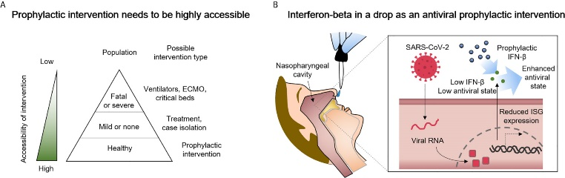
Figure 1 Delivery of type I interferon-beta (IFN-β) to the nasopharyngeal cavity is a candidate prophylactic and early intervention measure against COVID-19 that has high potential for success. (A) A greater accessibility of the intervention can prevent shortages of ventilators, extracorporeal membrane oxygenation (ECMO) machines, and/or critical care beds. (B) Suggested in this perspective is the highly accessible delivery of IFN-β to the nasopharyngeal cavity. The administered IFN-β can partially compensate for reduced interferon-stimulated gene (ISG) expression in SARS-CoV-2-infected cells as way to enhance antiviral immunity.
Recent Publications (minimum 5)
- Lee A C et al. (2021) Nasopharyngeal Type-I Interferon for Immediately Available Prophylaxis Against Emerging Respiratory Viral Infections. Frontiers in Immunology 12, 660298.
- Choi Y, Park C, Lee A. C et al. (2021) Photopatterned Maragoni microswimmers with programmable motion without external stimuli. Nature Communications 12, 4724.
- Choi H., Choi Y, Choi J, Lee A. C et al (2021) Purification of multiplex oligonucleotide libraries by synthesis and selection. Nature Biotechnology. https://doi.org/10.1038/s41587-021-00988-3.
- Lee A C et al. (2021) OPENchip: an on-chip in situ molecular profiling platform for gene expression analysis and oncogenic mutation detection in single circulating tumour cells. Lab on a Chip
20, 912-922.
5. Kim S, Lee A C et al. (2018) PHLI-seq: constructing and visualizing cancer genomic maps in 3D byphenotype-based high-throughput laser-aided isolation and sequencing. Genome Biology 19,158.

Photograph

Biography (150 word limit)
Dr Lee has his expertise in bioengineering to aid life scientist and medical experts. His purpose is to engineer solutions that can generate new biological discoveries as well as create practical approaches in translating biological discoveries into real-world applications. He has been working with 20 groups of medical experts and life scientists fin Republic of Korea, Sweden, Singapore, and the United States for ten years. Especially, he has been working on spatial omics technology to discover RNA biomarkers in cancers. The technological foundation lies in his co-first authored article “PHLI-seq: constructing and visualizing cancer genomic maps in 3D byphenotype-based high-throughput laser-aided isolation and sequencing” that was published in Genome Biology in 2018.
Email: amoslee89@gmail.com

Notes/Comments:

