Title: Comparative Analysis of Canal Centering ratio, apical Transportation, & Remaining Dentin Thickness between single file system i.e. OneShape and WaveOne Rotary by Using Cone Beam Computed Tomography – An In Vitro Study
ABSTRACT

AIM: To compare the canal transportation, centering ability & remaining dentin thickness of OneShape & WaveOne system using CBCT.
Objective: To identify rotary system which respects original canal anatomy.
Materials and Methods: Forty extracted human single rooted premolars were used in the present study. Pre-instrumentation scans of all teeth were taken, canal curvatures were calculated & the samples were randomly divided into two groups with twenty samples in each group, where Group 1 included WaveOne system & Group 2 One Shape rotary system. Post-instrumentation scans were performed and the two scans were compared to determine canal transportation, centering ability and remaining dentin thickness at 1, 3, and 5 mm from the root apex.
Results: Using Student’s unpaired t test results were as follows, For canal transportation Group 1 showed statistical significant difference at 3mm, 6mm and non-significant difference was obtained at 9mm but for Group 2 non statistical significant difference was obtained at 3mm,6mm and 9mm. For centering ability and remaining dentin thickness Group 1 showed non statistical significant difference at 3mm and 9mm, while statistical significant difference at 6mm was obtained. When comparison of remaining dentin thickness was done at three levels using two groups WaveOne and . There was non-statistical significant difference between two groups.
Conclusion: WaveOne single reciprocation file respects original canal anatomy better than OneShape . WaveOne depicted the best centering ability.
Keywords: Oneshape, WaveOne, transportation, centering ability, dentin thickness & CBCT
Introduction
The aim of cleaning & shaping is to remove all the canal contents, specifically the microorganisms. Successful endodontic therapy depends on effective debridement and shaping of the root canal should maintain the foramen position without any deviations from the original anatomy of the canal which is challenging in curved canals. Ideally, during root canal preparation, the instruments should always conform to and retain the original shape of the canal. The ability to keep the instruments centered is crucial in curved canals and to deliver an accurate enlargement to the root canal without any unnecessary weakening to the root structure.^{1,2,3}
When curvatures are present, preparation becomes difficult & there is a tendency for all preparation techniques to divert the prepared canal away from the original axis. Centering is defined as the ability of the instrument to stay centered in the canal.
Canal transportation is one of the most common mishaps during the instrumentation of curved root canals. When Transportation occurs, it has two components - direction and deviation. Direction is an excessive dentine removal in a single direction off the main tooth axis of the canal. Deviation is any undesirable departure from original canal path, which is the distance in millimeters from the pre and post instrumented canal as a function of file action.^{4,5}
According to the Glossary of Endodontic Terms of the American Association of Endodontists in 2003 canal transportation is defined as: “The removal of canal structure on the outside curve in the apical half of the canal due to the tendency of files to restore themselves their original linear shape during canal preparation”. ⁶
Transportation in the apical third of the root canal promotes the harboring of debris and residual microorganisms as a result of insufficient cleaning of the root canals & over-reduction of sound dentin & destruction of the integrity of the root. The etiology associated with an increased risk of canal transportation include insufficiently designed access cavities, use of inflexible instruments, instrumentation technique, tip design, insufficient irrigation during mechanical enlargement, unseen canal curvatures in two dimensional radiography, skill of operator & degree and radius of a root canal curvature both induce a stress on the instruments.^{7,8,9,10} The more severely curved and the shorter the radius of curvature, the greater the risk of transportation. Deviation of the original trajectory of the canal may result in damage of the apical foramen and loss of apical stop. As a consequence, this will lead to extrusion of debris, irrigants, or filling materials and subsequently an irritation of the periapical tissue.
Recently, Wave One and One Shape represent single NiTi file systems which are made of a special NiTi-alloy called M-Wire that is created by an innovative thermal-treatment process. OneShape (Micro Mega, Besancon, France) is to be used in full continuous rotation whereas WaveOne NiTi single-file system has been introduced by Dentsply. The system is designed to be used with a reciprocating motion motor.^{11,12} The benefits of this M-Wire NiTi are increased flexibility and improved resistance to cyclic fatigue. Thus, it is important to assess the canal centering ability of newly introduced single file systems before they can be considered a viable replacement of full-sequence rotary file systems.¹³
In the past, methods for assessment of canal transportation, RDT & centering ability included radiographic method, serial sectioning technique, photographic assessment, SEM & computer manipulation technique.¹⁴ The above mentioned methods were invasive in nature and accurate repositioning of pre and post instrumented specimens is difficult, and there is a disadvantage of loss of specimen, whereas radiographs provide 2-dimensional image of 3- dimensional object.¹⁵
Recently, a non-destructive technology has been advocated for pre and post instrumentation evaluation of canal anatomy. CBCT utilizes a cone shaped x-ray beam and an area detector that captures a cylindrical volume of data in one acquisition & also used in the analysis of the root canal area and parameters such as canal transportation, centering ratio, and the amount of root dentin removed by endodontic instruments.¹⁶
Thus, the purpose of this study was to evaluate and compare the canal transportation, centering ability and RDT after instrumentation with OneShape & Waveone rotary system by using CBCT.
Materials & Method
Sixty extracted human premolar teeth with fully formed apices were included and stored in 10% formalin solution. All teeth were standardized to a length of 9 mm by de-coronation using a diamond disc and According to the criteria described by Schneider Angle of curvature ranging between 10° & 20°, were used in the study. Access cavity was made using no.4 round diamond bur and working length was determined. The samples were embedded in self- cure acrylic resin and then all teeth were scanned by CBCT pre instrumentation. The images were stored then randomly divided into two groups of thirty each.
Group - 1 Canals were shaped using OneShape files till the working length with the X-Smart Plus motor set to 350 rpm and a 5-Ncm torque with a 16:1 contra-angle.
Group -2 Canals were shaped using WaveOne rotary files in a gentle in-and-out motion until the full working length was reached. The instrumentation sequence was as follows: X1 file (size 17, 0.04 taper), followed by X2 file (size 26, 0.06 taper) at the recommended rotation of 350 rpm and the torque at 2.5 Ncm
After instrumentation specimens were scanned using CBCT. The images were stored for further evaluation between before instrumentation & after instrumentation data by using DiCom software.
Canal centering ratio calculation¹⁷
The canal centering ratio was calculated according to the following ratio:
(a_{1 –} a₂) / (b₁ – b₂) or (b₁ – b₂) / (a_{1 –} a₂)
The centering ratio is the difference between the instrumented and non-instrumented canal, which measures the ability of instrument to stay centered. If the numbers are not equal, the lower figure is considered as the numerator & a result of ‘1’ indicates perfect centering capacity and the closer the result to zero the worse the ability of the instrument to keep itself in the canal central axis.
Apical transportation calculation
The following formula introduced by Gambill et al to measure the degree of canal transportation was used. ¹⁷
[(a₁ – a₂) – (b₁ – b₂)]
Where,
a₁ is the shortest distance from the mesial edge of the root to the mesial edge of the uninstrumented canal.
b₁ is the shortest distance from the distal edge of the root to the distal edge of the uninstrumented canal.
a₂ is the shortest distance from the mesial edge of the root to the mesial edge of the instrumented canal.
b₂ is the shortest distance from the distal edge of the root to the distal edge of the instrumented canal. Result of ‘0’ indicates no canal transportation & other than ‘0’ means that transportation has occurred in the canal.
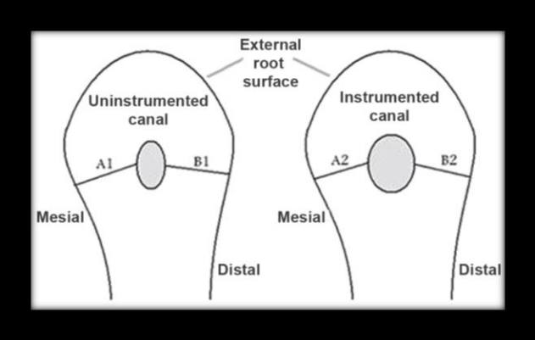
Figure 1 : Evaluation of apical transportation
Remaining dentin thickness calculation¹⁷
The RDT was determined by substracting the uninstrumented canal from the instrumented canal that is the shortest distance from the canal outline to the closest adjacent root surface was calculated at 1,3,5mm levels pre & post instrumentation.
Results
Statistical analysis used was student’s unpaired t-test with 0.05 level of significance. The mean and standard deviation values for centering ratio at the level of 1mm, 3mm & 5mm between both the groups are presented in Table 1. When OneShape was used at 1mm, 5mm non statistical significant difference was obtained, whereas at 3mm there was statistical significant difference. But for waveone non statistical significant difference was obtained at all the levels.
Evaluation of canal transportation was done at 3 levels between two groups (Table 2) There was significant difference at 1mm, 3mm & at 5mm no significant difference was found when using OneShape system but for WaveOne non statistical significant difference was obtained at all the three levels. There was no significant difference between the two groups with respect to remaining root dentin at 1 mm, 3 mm and 5 mm was found ( Table 3).
Centering ability | 1mm | 3mm | 5mm
 | Mean ± SD values | Mean ± SD values | Mean ± SD values
Group 1(OneShape) | 0.04100 (±0.03724) | 0.05320 (±0.03596) | 0.10650 (±0.06276)
Group 2 (WaveOne) | 0.05750 (±0.03252) | 0.06500(± 0.03310) | 0.12780 (± 0.04164)
Table 1- showing the comparison of centering ability at 1, 3 & 5mm for both groups.

Canal transportation | 1mm | 3mm | 5mm
 | Mean ± SD values | Mean ± SD values | Mean ± SD values
Group 1 (OneShape) | 0.6535 (±0.2239) | 0.5480 (±0.2351) | 0.5425 (±0.2127)
Group 2 (WaveOne) | 0.5445 (±0.1105) | 0.6405 (±0.1371) | 0.5515 (±0.1622)
Table 2 - showing the comparison of canal transportation at 1, 3 & 5mm for both groups.
RDT | 1mm | 3mm | 5mm
 | Mean ± SD values | Mean ± SD values | Mean ± SD values
Group 1(OneShape) | 0.2310 (±0. 2934) | 0.5705 (±0.3145) | 0.3890 (±0.1126)
Group 2 (WaveOne) | 0.2890 (±0.1556) | 0.5310 (±0.1934) | 0.2705 (±0.1255)
Table 3 - showing the comparison of RDT at 1, 3 & 5mm for both groups.

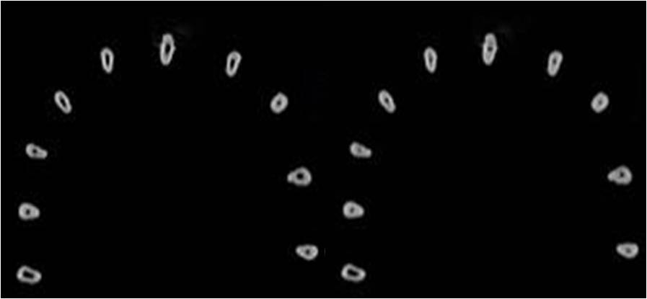
Figure 1- pre & post operative CBCT image at 1mm by using OneShape
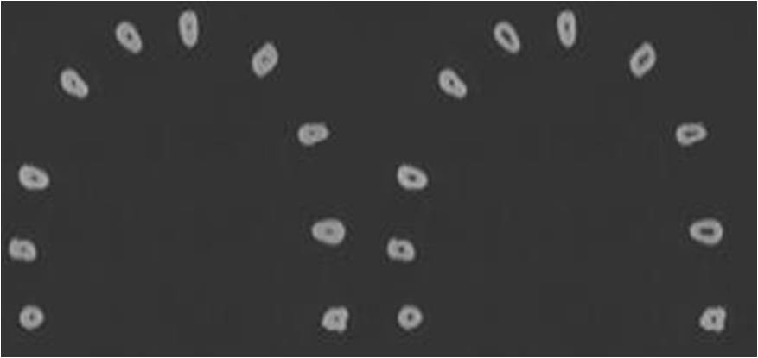
Figure 2- pre & post operative CBCT image at 3mm by using OneShape
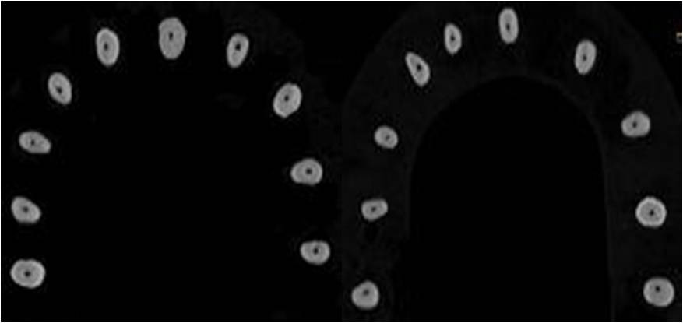
Figure 3- pre & post operative CBCT image at 5mm by using OneShape

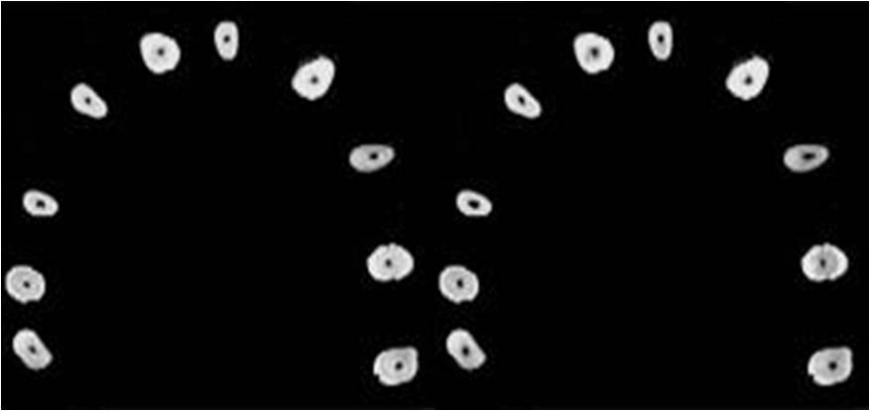
Figure 4- pre & post operative CBCT image at 1mm by using WaveOne

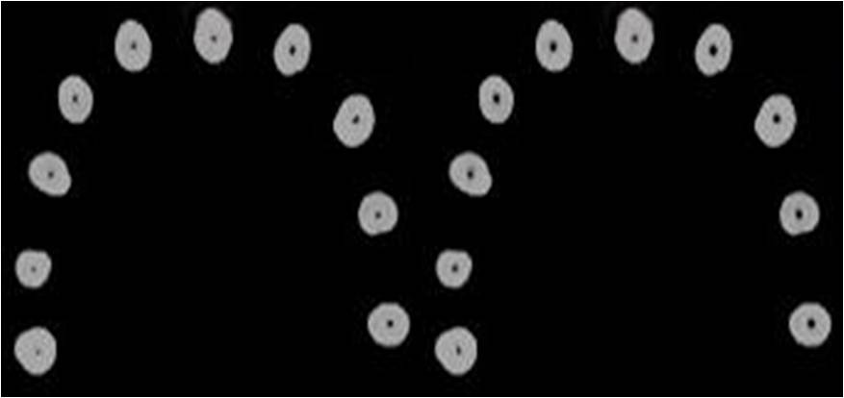
Figure 5- pre & post operative CBCT image at 3mm by using WaveOne
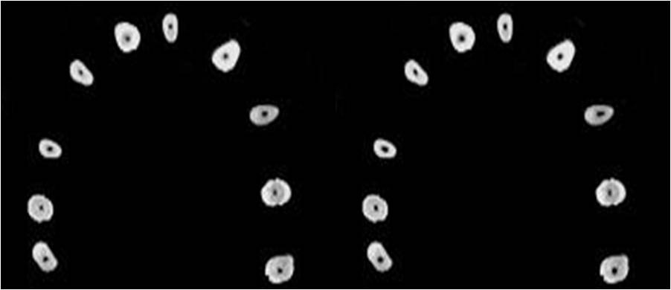
Figure 6- pre & post operative CBCT image at 5mm by using WaveOne
Discussion
Cleaning and shaping of the root canal comprises the most important phase of endodontic treatment. The aim of root canal preparation is to form a continuously tapered shape canal but instruments tend to straighten inside the canal & the cutting edges are forced against the outer side of the curved canal wall (convexity-side) in the apical third of the canal and against the inner side wall at the middle or coronal thirds of the canal (concavity-side), which causes an asymmetrical dentin removal. As a result, the apical canal areas appear over prepared in the direction of the convexity of the canal, and, greater amounts of dentin are removed at the concavity along the coronal plane leading to canal transportation or straightening. ¹⁸
An ideal instrumentation should have equal dentin removal from the canal walls so that it could avoid excessive thinning of root structure. However, the presence of curvatures may pose difficulty in root canal instrumentation. Ledge formation, blockage, perforation and apical transportation are undesirable mishaps that can occur during preparation of curved root canals. Wu et al. stated that apical transportation of more than 300 μm can have a negative impact on the seal of the obturation.¹⁹ Some studies which investigated that the incidence of transportation and straightening of the root canal is common with the use of stainless steel.
To overcome these disadvantages, scientists were in search of a new alloy. They finally discovered Ni-Ti instruments which are thermo-mechanically preceded cause minor canal transportation, which had greater flexibility, shape memory, superelasticity. & instruments that have modified non-cutting tips are better in maintaining the original canal anatomy. The super elasticity permits bending to follow the anatomy of the canal, which reduces stress and torsion forces within the canal, with minimal risk of transportation and have superior ability to remain centered within the canal during instrumentation compared to stainless steel files thus minimizing the straightening of the canal.²⁰ Reciprocation technology is another innovation which has been added to the advanced group of NiTi files and has led to the introduction of a fourth generation of instruments that is based on the single-file technique.²¹
The present study we have utilized OneShape & WaveOne rotary NiTi files systems. WaveOne NiTi single-file reciprocating system has a continuously decreasing taper from its tip to its shaft and is described by various cross sectional designs over the entire length of the working part. In the tip region, the cross-section presents radial lands, while in the middle part of the working length and near the shaft, the cross-sectional design changes from a modified triangular convex cross-section with radial lands to a neutral rake angle with a triangular convex cross-section. ²²
One-Shape instruments have different cross-sectional designs and variable pitch length along the working part. This design helps to eliminate threading and binding of the instrument in continuous rotation. Though there is literature on the reduction of fatigue and extended life span of the instrument but there is requirement of investigations regarding canal shaping ability of single file systems. These are necessary because fast approaches toward the apex with fewer instruments and sharp cutting edges produces aberrations.²³ One Shape system has advantages such as it is a single-use, single-file system and has better cutting efficiency on continuous rotation pertinent to its cross-sectional design. It has a variable cross-section at three different levels, which progressively changes from 3 to 2 cutting edges.²⁴ An additional advantage of anti-breakage control is a safety bonus, which would help the instrument to unwind to avoid separation
The CBCT slices used in the present study were of 1mm thickness. In this study, all the parameters were evaluated at three levels from the apex to straight part of the canal. CBCT analysis has been found to be one of the most accurate methods for the analysis of canal geometry and efficiency of shaping techniques of different rotary systems with low radiation dose and high resolution compared to micro CT
.
It can also be used to compare the anatomic structure of root canal before and after instrumentation. In the present study, pre-instrumentation and post-instrumentation images were acquired by CBCT, a technique that allows analysis of the root canal area without the need for invasive procedures on tooth structrure. Moreover, the results of this study show that the quality of the three - dimensional images obtained by CBCT scanning is an accurate and efficient method of assessment of root canal instrumentation.
In the present study, canals prepared with OneShape showed maximum value for root canal transportation at 1mm and 3mm levels which may be attributed to the reduction in instrument flexibility& indicating a tendency to straighten curved canals.
In the study conducted by Dhingra et al, the canal curvature modification after instrumentation with OneShape file and WaveOne primary reciprocating file was compared, and it was concluded that canal prepared with WaveOne file preserved canal shape, respected the anatomical J-shape and produced a continuously tapered funnel. ²⁵
Capar et al. compared canal transportation, canal curvature, centering ratio, surface area, and volumetric changes in curved mesial root canals of 120 mandibular molars after instrumentation with ProTaper next X2, One-Shape, Protaper Universal F2, Reciproc, Twisted File Adaptive, or Waveone. They revealed no statistical significant difference in canal transportation and centering ratio between PTU, WO and PTN & R Files exhibited greater volumetric changes compared with OS, TFA, and PU.²⁶
Conclusion
Within the limits of this present study, it was found that WaveOne single reciprocation file has less canal transportation and better centering ability & respects original canal anatomy better than OneShape.

References
1. Zahra Sadat Madani et al. Cone beam computed tomography for evaluation of apical transportation in root canals prepared by two rotary systems. Iran Endod J. 2014;9(2):109-112.
2. Guelzow A, Stamm O, Martus P, Kielbassa AM. Comparative study of six rotary nickel-titanium systems and hand instrumentation for root canal preparation. Int Endod J 2005;38:743-52.
3. Schneider SW. A comparison of canal preparations in straight and curved root canals. Oral Surg Oral Med Oral Pathol Oral Radiol Endod 1971; 32, 271-5.
4. Maitin N, Arunagiri D, Brave D, Maitin SN, Kaushik S, Roy S. An ex vivo comparative analysis on shaping ability of four NiTi Rotary endodontic instrument using spiral computed tomography. J Conserv Dent 2013;16:219-23
5. Dhingra A, Kochar R, Banerjee S, Srivastava P. Comparative evalutation of canal curvature modifications after Instrumentation with One Shape rotary and Wave One Reciprocating Files. J Conserv Dent 2014;17:138-41.
6. Dalia Mukhtar Fayyad, Nihal Ezzat Sabet and El-Said Mahmoud Abd El-Hafiz Computed tomographic evaluation of the apical shaping ability of Hero Shaper & Revo-S. Quintessence Int 2012;6(2):119–124.
7. Anshul Arora, Sonali Taneja and Mohit Kumar Comparative evaluation of shaping ability of different rotary NiTi instruments in curved canals using CBCT. J Conserv Dent 2014;17 (1): 35-39.
8. Shen Y, Cheung GS, Bian Z, Peng B. Comparison of defects in ProFile and ProTaper systems after clinical use. J Endod 2006;32:61-5.

9. You SY, Bae KS, Baek SH, Kum KY, Shon WJ and Lee W Lifespan of one nickel-titanium rotary file with reciprocating motion in curved root canals. J Endod 2010; 36: 1991–4.
10. Berutti E, Paolino DS and Chiandussi G. Root canal anatomy preservation of WaveOne reciprocating files with or without glide path. J Endod 2012;38: 101-104.
11. You SY, Kim HC, Bae KS, Baek SH, Kum KY and Lee W Shaping ability of reciprocating motion in curved root canals: a comparative study with micro-computed tomography. J Endod 2011; 37: 1296–300.
12. Dowker SE, Davis GR and Elliott JC. X-ray microtomography: non-destructive three dimensional imaging for in vitro endodontic studies. Oral Surg Oral Med Oral Pathol Oral Radiol Endod 1997;83(4):510-6.
13. Gluskin AH, Brown DC and Buchanan LS. A reconstructed computerized tomographic comparison of Ni-Ti rotary GT files versus traditional instruments in canals shaped by novice operators. Int Endod J 2001;34:476-84.

14. Lim YJ, Park SJ, Kim HC, Min KS. Comparison of the centering ability of wave-one and reciproc nickel-titanium instrument in stimulated curved canals. Restor Dent Endod 2013;38:21 5.
15. Weine FS, Kelly RF and Lyo PJ. The effect of preparation procedures on original canal shape and on apical foramen shape. J Endod 1975; 1: 255–62.
16. Park H. A comparison of Greater Taper files, Profiles, and stainless steel files to shape curved root canals. Oral Surg Oral Med Oral Pathol Oral Radiol Endod 2001;91:715-8.
17. Gambill JM, Alder M, del Rio CE. Comparison of nickel titanium and stainless steel hand-file instrumentation using computed tomography. J Endod. 1996;22:369–75.
18. John T. McCann et al. The effect of maintaining apical patency on canal transportation. Int endod J 2008 41; 431-435.
19. Wu M-K, Fan B, Wesselink PR. Leakage along apical root fillings in curved root canals. Part I: effects of apical transportation on seal of root fillings. J Endod. 2000;26(4):210- 6.

20. Schafer E and Vlassis M. Comparative investigation of two rotary Ni-Ti instruments: ProTaper versus RaCe. Part 2.Cleaning effectiveness and shaping ability in severely curved root canals of extracted teeth. Int Endod J 2004; 37: 239- 48.
21. M. K. Iqbal, S. Firic, J. Tulcan, B. Karabucak and S. Kim. Comparison of apical transportation between ProFileTM and ProTaperTM NiTi rotary instruments. Int Endod J 2004; 37: 359–364.
22. Tasdemir T, Aydemir H, Inan U and Unal O. Canal preparation with Hero 642 rotary Ni-Ti instruments compared with stainless steel hand K-file assessed using computed tomography. Int Endod J 2005; 38: 402-8.
23. Paqué F, Musch U and Hülsmann M. Comparison of root canal preparation using RaCe and ProTaper rotary Ni-Ti instruments. Int Endod J 2005; 38: 8-16.
24. Rhodes JS, Pitt-Ford TR, Lynch JA, Liepins PJ, Curtis RV. Acomparison of two nickel-titanium instrumentation techniques in teeth using microcomputed tomography. Int Endod J 2000;33:279-85.
25. Dhingra A, Kochar R, Banerjee S, Srivastava P, Comparative evaluation of the canal curvature modifications after instrumentation with One Shape rotary and Wave One reciprocating files J Conserv Dent 2014 17(2):138-41.
26. Capar ID, Ertas H, Ok E, Arslan H. Comparison of single cone obturation performance of different novel nickel-titanium rotary systems. Acta Odontol Scand. 2014;72(7):537-42.

