SPLINTING BRACES BY WAX AND CLOSING SPLINTING BRACES SURFACE BY DECORATIVE STICKER – NEW INVENTIONS FOR PREVENTION OF BLISTERING DISEASE OF CHEEKS AND LIPS
A.L.Urakov, N.A.Urakova, A.P.Reshetnikov, M.V.Kopylov, R.R.Gabdrafikov
Izhevsk State Medical Academy, Izhevsk, Russia, urakoval@live.ru

It is shown that traditional braces cause local irritation of the lips and cheeks of patients due to friction. This irritation can cause reversible and irreversible inflammation until the ulcers. This information may be help to prevent the development of blisters, sores, ulcers, i.e. the development of iatrogenic illness that we was called "blistering or calluses disease from braces".
Installed that local injuries of the lips and cheeks are caused not by the braces itself, but by the friction between their hard and hilly parts with the inner surface of the mouth. We found that infrared thermography provides timely detection of early symptoms of the local inflammation of the soft tissues. It is found that the appearance of local hyperthermia zone on the cheek and/or lip inner surface may be considered as a diagnostic symptom for the development of local inflammation.
To prevent iatrogenic disease, we developed an original method of splinting braces and original device that eliminates the friction of the braces on the surface of the lips and cheeks. The essence of the “Method of splinting braces” (RU Patent No 2437632, December, 2011) is lies in the fact that the teeth with braces need to completely cover the wax up to the formation of her wax roller. Then, the resulting wax roller should be immediately securely cover with food wrap. And that's all.
Then we decided to close the braces by food wrap. Studies have shown that splinting braces by wax and sticking them on the food wrap completely prevents the development of blisters on the lips and cheeks. To this end, we invented a “Decorative sticker on the dentition with braces“ (RU Application No. 2016147639 (076523), stated 05.12.2016).
This devices is designed in the form of a tape wound on the spool and is a beautiful analog of a food wrap (Figure 1).
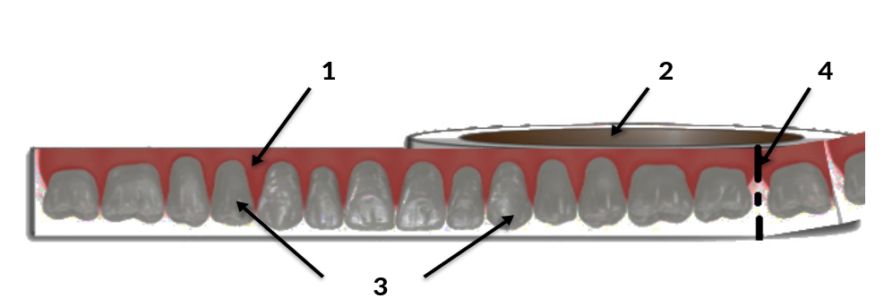
Figure 2. Schematic representation of the device – “Decorative sticker” in its original state. 1 – tape, 2 – coil, 3 – colour photography of the dentition, 4 – notches.

The fact that on the sticker surface of the tape placed series of color photographs - panoramic 3D images of the visible front surface of the upper or lower dentition of a healthy person is whole in full size.
The results showed that уarly diagnosis of the beginning of blistering disease in cheeks and lips by infrared thermograhy and splinting braces by wax and covering the surface by food wrap is prevented local irritation to the lips and cheeks and the development of iatrogenic disease.
Key words: infrared thermography, stomatitis, gingivitis, braces, diagnosis, prevention.

