

Strain engineered multiferroic phase diagram of orthorhombic RMnO3 (R = Gd - Lu) epitaxial thin films
Saumya Mukherjee^{1,2,3}, Kenta Shimamoto¹, Christof Schneider¹, Christof Niedermayer¹
1. Paul scherrer Institute, Villigen, Switzerland.
2. University of Oxford, Oxford, oxford, United Kingdom.
3. Diamond Light Source, Didcot, United Kingdom.

Abstract (300 word limit)
Magnetoelectric multiferroics (MF) demonstrate simultaneous coexistence of magnetic and electric order parameters. In addition, they show unique ability of cross-coupling between order parameters. Rare-earth manganites (RMnO3) in orthorhombic phase is one such archetypical candidate showing magneto-electric behavior. Depending upon R-ion radii they show a wide range of MF phase governed by competing magnetic interactions as shown in the MF phase diagram for bulk (Fig. 1a). Interestingly, on application of epitaxial strain the MF phase diagram shows a dramatic change (Fig. 1b). The most prominent effect observed is that the ground state gets independent of the R-ion radii and is forced to demonstrate a homogenous magnetic and electric property. Under epitaxial strain the films stabilize into an E-type order with ferroelectric ordering along a-axis. This suggested that the competing interactions are tuned to favor a symmetric exchange striction mechanism for the multiferroicity. In our work, we employed neutron and x-diffraction to study the magnetic phase in detail. In addition, in-house capacitance and ferroelectric loop measurements were conducted to confirm the electric ground states. These studies also highlight the development of instrumentation which provided the unique oppurtunity to study the magnetic order of thin films (thickness~10 -40 nm) with neutron diffraction. We plan to discuss in further details and reveal the variation in the microscopic mechanism induced by epitaxial strain to tailor the MF phase diagram. This presentation will help in providing the audience a better outlook on using strain to engineer physical properties of materials.

Key words: Multiferroics, neutron and x-ray diffraction, thin films, ferroelectric and magnetic.

Image
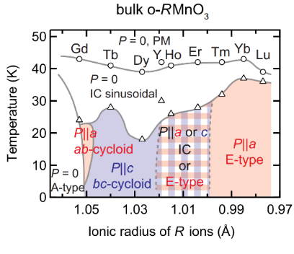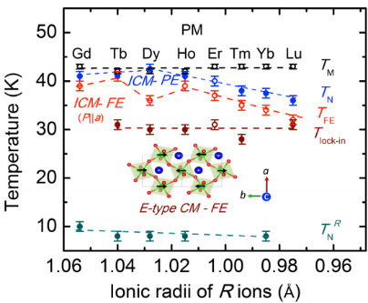
(a) (b)
Fig. 1: Mulitferroic phase diagram of RMnO₃ (a) bulk phase and (b) thin films.
Recent Publications (minimum 5)
- S. Mukherjee et. al, Phys. Rev. B 98, 174416 (2018).
- K. Shimamoto, S. Mukherjee, et. al, Sci. Rep. 7, 44753 (2017).
- K. Shimamoto, S. Mukherjee, et. al, Phys. Rev. B 95, 184105 (2017).
- S. Mukherjee et. al, Phys. Rev. B 95, 104412 (2017).
- C.W. Schneider, S. Mukherjee, et. al, Phys. Rev. B 94, 054423 (2016).

Biography
Saumya Mukherjee has been working in the field of magnetic metallic multilayers and multiferroic perovskite thin films. On course of the research work he gained expertise on measuring magnetic properties using neutron and x-ray diffraction. In addition, spectroscopy and use of polarised neutrons are the other tools which he employed in his studies.

Presenting author details
Full name (As per the passport): SAUMYA MUKHERJEE
University/Industry/Organization name: DIAMOND LIGHT SOURCE
Designation (Director/Prof/Assistant or Associate prof/Researcher/Student): Postdoctoral research associate
Country: United kingdom (temporary resident)/ India (permanent resident)
Mobile number (country code – number): 00447551104581
Email: saumya.mukherjee@diamond.ac.uk
Track number: 19671
Category (Oral presentation/ Poster presentation/Young researcher forum/E-poster): ORAL
Research interest: MULTIFERROICS AND MAGNETISM.

