

Spatially Ordered Poly(3-hexylthiophene) Fibril Nanostructures via Controlled Evaporative Self-Assembly
Myunghwan Byun, Department of Advanced Materials Engineering, Keimyung University, Daegu 42601, Republic of Korea

Abstract
Hierarchically structured, gradient concentric rings of regioregular conjugated polymer, rr-poly(3-hexylthiophene) (rr-P3HT) with randomly or directionally crystallized nanofibrils over large areas were obtained by regulating consecutive “stick-slip” motions of the three-phase contact line in a confined geometry consisting of a upper curved sphere surface and a lower flat Si substrate (i.e., sphere-on-flat geometry), which leads to an axially symmetric capillary-bridge (bound solution). Self-organized concentric P3HT ring patterns resulted from mediating intermolecular interactions between the polymer molecules, and varying the solvent concentration. More interestingly, from the lower solution concentration “shish-kebab” like morphologies were observed in between adjacent rings. These unusual, directionally crystallized structures were formed spontaneously parallel to the moving direction of the contact line on solvent evaporation. Subsequently, I-V characteristics of the directionally crystallized and randomly distributed P3HT nanofibrils formed across the electrodes were investigated and compared.

Key words: gradient concentric rings, regioregular conjugated polymer, controlled evaporative self-assembly, stick-slip, curve-on-flat geometry

Image
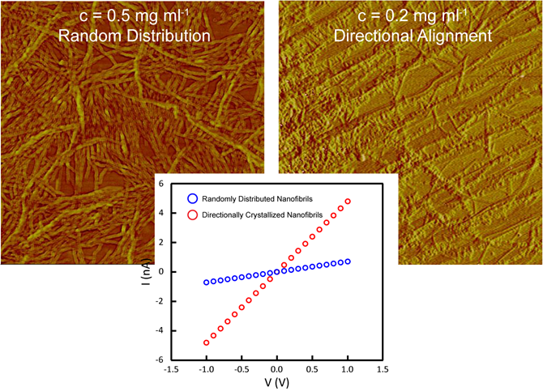
Recent Publications
- H. R. Cho, W. I. Park, Y. -S. Song, J. Jung, A. Choe, H. Ko, M. Byun, Spontaneous Capillary Breakup of Suspended Gradient Polymer Stripes into Spatially Ordered Dot Arrays, Applied Surface Science 475 (2019) 1003.
- J. Jung, M. Byun, M. Chang, Preparation of Organic-Inorganic Nanocomposites using Directly Synthesized Br-Functionalized Nanocrystals, Applied Surface Science 475 (2019) 695.
- W. I. Park, D. -H. Kim, J. Jung, S. W. Hong, Z. Lin, M. Byun, Spatially Ordered Poly(3-hexylthiophene) Fibril Nanostructures via Controlled Evaporative Self-Assembly, Advanced Materials Technologies 4 (2019) 1800554.
- M. Byun, Poly(vinylpyrrolidone)-Modification of Sol-Gel Films for Flexible Piezoelectric Energy Harvesting Systems, Thin Solid Films 663 (2018) 31.
- D.-H. Kim, S.-W. Mhin, M. Byun, Stress-Induced Trench Narrowing at Cu Interconnect of Sub-20nm Node: FEM Simulations, Materials Science in Semiconductor Processing 56 (2016) 100.
- M. Byun, H. Yoo, C. K. Jeong, K. Lee, Performance Enhancement of Electronic and Energy Devices via Block Copolymer Self-Assembly, Advanced Materials 27 (2015) 3982.

Biography
My research interests are mainly centered on experimental studies on designing surface structures of soft functional materials at the micro-to-nanometer scale. Especially, the coupled process of “top-down” lithography and “bottom-up” assembly offers a simple yet robust method for constructing well-ordered, often intriguing structures composed of polymeric functional materials on multiple length scales. A combination of synthetic polymer chemistry and high resolution patterning techniques possibly provides us with systematic manipulation of soft materials that serve advanced applications by controlling both functionality and shape over a wide range of length-scales.

Presenting author details
Full name (As per the passport): Myunghwan Byun
University/Industry/Organization name: Keimyung University
Designation: Assistant prof
Country: Republic of Korea (South Korea)
Mobile number (country code – number): 82-10-4045-2496
Email: myunghbyun@kmu.ac.kr
Track number: Track 12: Nanomaterials and Nanotechnology
Category: Oral presentation
Research interest: Nanomaterials, Nanopatterning, Self-Assembly, Energy Harvesting
Your profile page URL in your department:
Year of birth:
Linked In/Facebook/twitter account:

Note: Please fill up the Red mark fields so that it would be easier for us to cite your details in the conference particulars. (Please do not forget to fix your photo and Logo above the title)

