Noise Effects: Measured Noise Levels versus Personal Perceptions
Natasa Vujica Herzog¹, Borut Buchmeister¹, Lea Spindler^{1,2}

¹ University of Maribor, Faculty of Mechanical Engineering, Maribor, Slovenia
²Josef Stefan Institute, Department of Complex Matter, Ljubljana, Slovenia

Abstract

Noise is recognised as an important stress factor in numerous workplaces. Despite legal regulations and recommendations for the highest allowed noise levels, there are still many problems in practice resulting from noise exposure such as hearing loss, stress and significant discomfort. We studied the influence of noise on workers in two different environments: a technical high school and a manufacturing company. In both cases measurements of noise levels and corresponding frequency noise analyses were performed. In order to study personal noise perceptions, the workers also completed an extended research survey. A comparison between the survey's results and experimentally determined noise levels gives new insights into the health risks of noise exposure in two very different working environments.

Keywords — acoustic measurements, extra-aural effects, noise, survey

Professional Biography

Natasa Vujica Herzog is an Associate Professor at the Faculty of Mechanical Engineering, University of Maribor, Slovenia. Her research area is operations and production management in particularly ergonomics. She is author or co-author of more than 100 publications, several original scientific articles published in international journals, monographs, and chapters in scientific books.

Borut Buchmeister is a Professor at the Faculty of Mechanical Engineering (University of Maribor, Slovenia). He is Head of Laboratory for Production & Operations Management and Laboratory for Discrete System Simulation. Since 2002, he is the Editor-in-Chief of the International Journal of Simulation Modelling.

Lea Spindler has a PhD in Physics from University of Ljubljana, Slovenia. She was a postdoctoral fellow at the Universite de Haut Alsace in France. She is an Assistant Professor at the University of Maribor, her research fields are soft matter and acoustics. She was the coordinator of EU network COST Action MP0802.

Recent Publications

- Gajšek B, Vujica Herzog N, Butlewski M, Đukić G (2017) Research opportunity: incorporation of human factors in order picking system models. Zeszyty Naukowe Politechniki Poznańskiej : Organizacja i Zarządzanie, 72:45-61.
- Vujica Herzog N, Zavec Pavlinič D, Kuzmanović BD, Buchmeister B (2016) Thermal manikin and its stability for accurate and repeatable measurements. International journal of simulation modelling, 15:676-687,
- Šauperl O, Vujica Herzog N, (2014) Workplace design in the clothing shop by considering anthropometry. Asian academic research journal of multidisciplinary, 1:107-122.
- Vujica Herzog N, Vujica Beharić R, Beharić A, Buchmeister B (2014). Ergonomic analysis of ophthalmic nurse workplace using 3D simulation. International journal of simulation modelling, 13: 409-418.
- Polajnar A, Vujica Herzog N, Buchmeister B, Jevšnik S (2012), Strains and stresses of workers caused by exposure to noise. Collegium antropologicum, 36:899-909.


Natasa Vujica Herzog

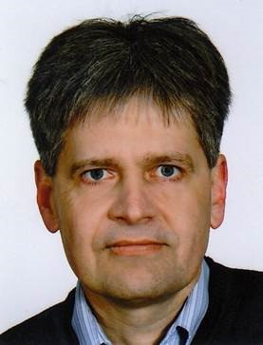
Borut Buchmeister

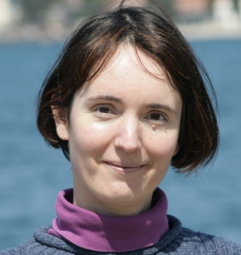
Lea Spindler

Email: natasa.vujica@um.si, borut.buchmeister@um.si, lea.spindler@um.si

