Abstract Template
Abstract Title: THE MODEL OF HUMAN
Collins Ezeiruaku Nwosu

¹ Collins Ezeiruaku Nwosu Affiliation (Personality Insights Institute, USA)

Abstract (not more than 300 words)

This paper attempts to postulate possible behaviours that will trigger stress and poor work decisions which as a result. These behaviours if recognised could also trigger conscious, positive action which creates a better ergonomic environment and overall wellbeing in the long. These human factors were reviewed using the D.I.S.C. model of human behaviour as the foundation. It would reveal possible outcomes which are numerous as they are revealing of what is possible in work places. Hence, recognising the patterns and possible triggers could lead to better structuring of work place interaction well beyond just the physical space arrangement.
Using the following scenario, let me illustrate:
Having a team lead that is an outgoing person who loves to interact with people and carry everyone along may be a great thing. Because such a person is set out to include as many as possible and make the job fun while leading. However, this may be frustrating for a person who is reserved, task oriented and is not so big on building relationships but getting the job done. While the team mate would ask a lot of questions and focus on the assignment, the boss would be more interactive and may not be so detailed as the team mate owing to their spectrum of the human behaviour quadrant. The expected result will be high friction. The boss may misconstrue the cautious, careful, calculating nature of the team member as not believing in them or doubting their leadership. This may create an overcompensation or outright frustration because their model is to be liked, inspiring, influencing. The team mate on the hand may be thinking that the boss does not take them seriously and may end up looking “cold” to everyone. The stress levels on the team and for each party would be significantly high.
With this is in mind interactions, team and office design could be done differently, thereby enhancing desired outcomes and wellbeing of all parties.

Keywords— CAUTIOUS, INSPIRING, OUTGOING, RESERVED.
Task-Oriented
People Oriented
Inspiring
Supportive
D! I
C? s±
Reserved
Dominant
Cautious
Outgoing

Professional Biography (100-150 words)

Collins Ezeiruaku Nwosu is currently undergoing a master’s program in Global Management with the Robert Kennedy College in affiliation with Salford Business School. He is an author, independent certified coach, speaker, trainer, Mentor on the John Maxwell Team. He is also a consultant in the model of human behaviour having been trained by Personality Insights Institute in the United States. In addition, he takes health seriously and is a third-degree black belt in Karate, a serving member on the board of trustees in the Largest Martial Art Association (Nigeria Karate Association) in West Africa where he also serves as hilst doubling as the Director of Marketing. Collins has held senior positions in various organisations spanning the pharmaceutical, mining, financial services, oil and gas. He has a passion for service and bridging the gaps between expectation and actual performance.

Recent Publications (up to 5)

- Linkdn (2016), 1 Successful Leadership Practice, https://www.linkedin.com/pulse/1-successful-leadership-practice-collins-nwosu/
- Linkdn (2016), Compete or Collaborate for success? https://www.linkedin.com/pulse/compete-collaborate-success-collins-nwosu/
- Collins E, Nwosu (2014), Road Series
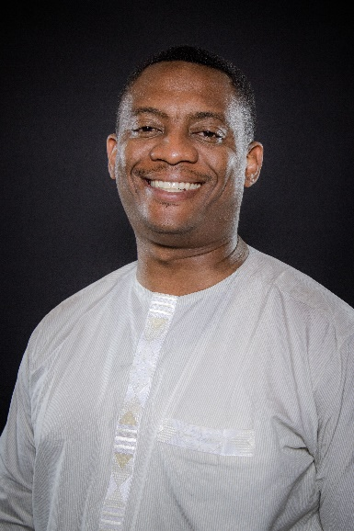
Paste your Photograph here

Email Id: ncollins@pri-globalventures.com

Any Comments: I am more of a business person than an academic. However, I do believe I can contribute meaningfully to the discourse from my wealth of experience and training.

