Abstract Template
Abstract Title: Development of Pictograms for Conveying Instructions to Low-Literacy Users of Labour-Reducing or Other Devices
William S. Kisaalita^{1&3}, Edison J. Sempiira¹, Abia Katimbo², Dana J. Mugisa¹, Joseph Galiwango²

¹University of Georgia, Athens, Georgia, USA
²Smallholder Fortunes, Kampala, Uganda
³Makerere University, Kampala, Uganda

Abstract (not more than 300 words)

We develop and deploy labor-reducing and wellness-enhancing devices. We have found conveying information for safe use of such devices uniquely challenging in low-literacy settings, such as rural sub-Saharan Africa. Since humans have a cognitive preference for picture-based, rather than text-based information, we have considered use of pictograms as vehicles to convey this type of information to device users. Pictogram that are understandable by one community may have a different meaning to others from a different community. Previous work in the development of culturally-meaningful informational pictogram has been conducted on behalf of drug makers to, for example, convey timing of doses and adherence to taking pills among low-literacy patients. We tested a similarly-structured pictogram development process among Ugandan smallholder farmers. Briefly, we broke down the process into five distinct stages. The first stage comprised of conceptualization of information messages. The second stage comprised of designing of the information carrying pictograms with the aid of a local artist. The third stage comprised of assessment of the first generation pictograms by a small group representing potential users. The fourth stage comprised of obtaining feedback from the first generation assessment of failed pictograms and creating second generation set. The fifth stage comprised of repeating the assessment with a different user group representatives from the same cultural and/or occupational backgrounds. We have used this process several times and in each case, the correct target interpretation has been achieved within two to three cycles. We will share detailed insights on what to look out for toward successful implementation of the process in a variety of low-literacy settings.

Keywords—hand-tools, human-centred design, food/energy-security, smallholder farmers

Professional Biography (100-150 words)

William S. Kisaalita obtained his PhD from the University of British Columbia, Vancouver, Canada. He is a Distinguished Faculty Scholar and Professor of Engineering at the University of Georgia, where he directs a development engineering laboratory/studio, 3p-Innovations (poverty-alleviation, prosperity-/wellness-building, and planet sustaining). He is a Fellow of African Scientific Institute and the Uganda National Academy of Sciences; a member of the American Association for Advancement of Science and the American Society for Agricultural and Biological Engineers. He is also a visiting professor at Makerere University. He serves on several editorial boards and is the author of a forthcoming book, “Surviving to Thriving: How to empower the poor through Prosperity-Building Solutions,” by University Press of New England.

Recent Publications (up to 5)

- Wasswa, J.; Sempiira, J.E.; Mugisa, D.J.; Kisaalita, W.S. Quality assessment of butter produced using traditional and mechanized churning methods. African Journal of Food, Agriculture, Nutrition and Development 17(1):11757-11770, 2017.
- Kisaalita, W.S. Perspectives on context, design teams and diffusion of technological innovations in low-resource settings: A practical approach based on sub-Saharan African projects. Technology in Society 46:58-62, 2016.
- Mugisa, D.J.; Katimbo, A.; Sempiira, J.E.; Kisaalita, W.S. Anthropometric characteristics of female smallholder farmers of Uganda – Toward design of labour-saving tools. Applied Ergonomics 54:177-185, 2016.
- Kisaalita, W.S.; Katimbo, A.; Sempiira, J.E.; Mugisa, D.J. Cultural influences in women-friendly labour-saving hand tool design: The milk churner case. Human Factors 58(1):27-42, 2016. [This paper was a Human Factors Prize Finalist].
- Ndyabawe, K.; Kisaalita, W.S. Diffusion of an evaporative cooler among smallholder dairy farmers of Western Uganda. Technology in Society 38: 1-10, 2014.

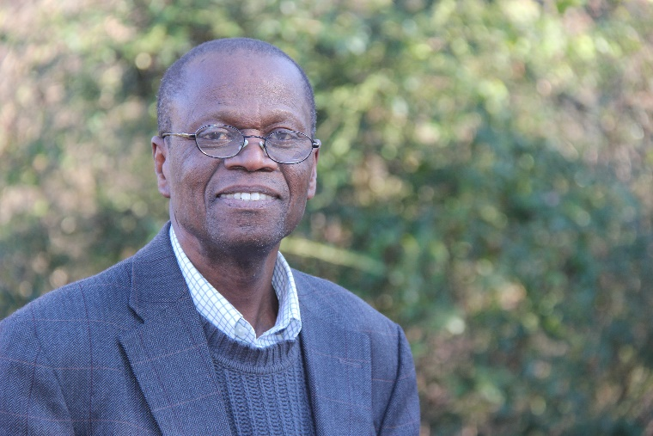

Email Id: williamk@engr.uga.edu

Any Comments: I greatly appreciate the invitation to attend this conference. I am mainly interested in a podium talk. I can do both a podium and a poster on the same topic. I will be less inclined to attend if I am only offered a poster presentation opportunity.

