The Treatment Gap and Misinterpretations of Epilepsy in Gambia

Abstract (300 word limit)

In the United Kingdom people take everything for granted because we always have an NHS with access to specialist hospitals, doctors, surgeons, medicines and medical machines for performing neurological tests.

In comparison there is an extreme lack of services available in Africa especially The Gambia. This is due to a lack of facilities, medical services, trained medical staff, medicines, funding and the general understanding of epileptic seizures.

In my role as Patron of the Gambia Epilepsy Association, the aim now is to bring countries together in different ways to aid those in sub-Saharan Africa who have less neurological services and facilities. This can be achieved by assisting general doctors in those countries, working together with traditional healers, training new epilepsy nurses, provision of neurological services and equipment, providing more epilepsy education and change the general attitudes towards epilepsy.

There are many ways of achieving these goals which starts by building up good relations with other medical organisations worldwide, negotiations with political leaders, media publicity and finding potential sponsors or donors.
Image
Recent Publications (minimum 5)
- Epilepsy In The Gambia (2009) Epilepsia
- Epilepsy and the Olympics (2011) Epilepsia
- Epilepsy In The Gambia: Attitudes In The Developing World (2012) North African & Middle Eastern Epilepsy Journal
- Epilepsy and the Olympics (2015) North African & Middle Eastern Epilepsy Journal
- Epilepsy in the Developing World. How can associations make a better life for epileptic patients? Experience in two different level countries in Africa, Morocco and Gambia (2017) North African & Middle Eastern Epilepsy Journal

Photograph

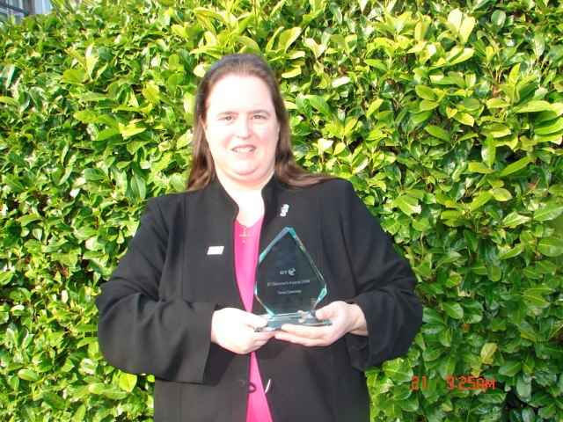Biography (150 word limit)
Tanya has been an epilepsy patient since the age of one and has always had to face many challenges in education, employment and socially. This lead her to start campaigning in the United Kingdom and join the international campaign to bring epilepsy "Out of the Shadows". This work has been ongoing for 35 years during which time Tanya has been an Accredited Volunteer for Epilepsy Action, a Governor of Epilepsy Society (2006-2012), Patron of the Gambia Epilepsy Association (2006 - date), Founder of Epilepsy Footprint and recipient of two BT Chairman's Awards for her work in epilepsy.
Email: TSPENSLEY@EPILEPSYFOOTPRINT.COM

Notes/Comments:

