NECESSITY OF IDENTIFICATION OF MARKERS OF PERIODONTOPATHOGENIC MICROORGANISMS BEFORE DENTAL IMPLANTATION

Elena Oleinik ¹, Аnton Podorozhnii ², Konstantin Janishevskii³

- Private Higher Educational Establishment “Kyiv Medical University”, Chair of the Dental therapy department, professor, UA
- Private Higher Educational Establishment “Kyiv Medical University”, Departament of Prosthetics and Orthodontics, post-graduate student
- Private Higher Educational Establishment “Kyiv Medical University”, Departament of the Dental therapy, UA
Abstract
Rehabilitation of the oral cavity in patients with partial or complete adentia is not possible today without implants. However, over the past decade there has been a significant increase in inflammatory complications after dental implantation, according to some data from 10% to 40%.
Of paramount importance in the etiology of complications of inflammatory genesis are undoubtedly pathogenic microorganisms whose presence is already well documented.
Key words: implant, anaerobes, markers of parodontopathogenic microorganism, molecular-genetic test
Results of the study and discussion
The survey group consisted of 12 people aged 34-52 years, with partial adentia of the upper and lower jaw teeth, with which implants were installed. We used the Micro-IDent plus test (HAIN-lifescience, Germany), based on the principle of PCR-reverse hybridization.
After 3 months 2 patients had complaints about a feeling of discomfort in the area of ​​implant placement, bleeding and swelling of the gum. The mobility of the implants was absent. The diagnosis is peri-implantation of mucositis, which was confirmed by the results of computed tomography. In the inflammatory process the mucosa was involved in the area of ​​5 implants.
The average value of the OHI-S hygienic index for two patients (17%) with symptoms of peri-implant mucositis was 2.9 + 0.48, which was indicated by poor oral hygiene. In 10 patients, who did not complain, the average value of the OHI-S index was 1.2 + 0.52 - satisfactory oral hygiene (p <0.05).
The microbial landscape of pathological foci (Micro-IDent test) in the field of dental implants, obtained with the use of the Micro-IDent diagnostic test. The Micro-IDent test revealed the highest complexities of Porphyromonas gingivalis (76%), and Treponema denticola (55%).
Thus, in order to prevent the development of inflamatory complications, it is necessary to conduct a study of the microflora of the oral cavity.

Biography
Professor Oleinik Elena - in 1992 graduated from the Voronezh State Medical Institute named after NN Burdenko, majoring in dentistry. 1996-2009 - headed the stomatological department of the regional rehabilitation center for children and adolescents with disabilities. From 2009-2011 worked as the director of the center. In 2011, she was invited to work at the Belgorod State University as a professor at the Department of Dentistry.
Since 2017 he has been working as the head of the Department of Therapeutic Dentistry at the Kiev Medical University.
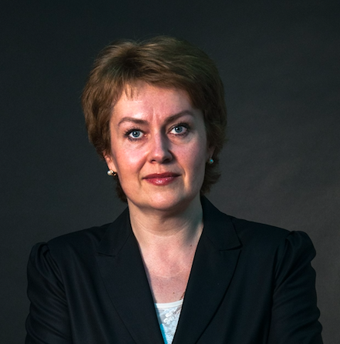

Podorozhnii Anton graduated from the Ukrainian Medical Dental Academy (Poltava) in 2002. Internship in Kharkov Medical Academy of Postgraduate Education.
2006-2009 - courses of improvement of professional skill and clinical residency on a specialty "Maxillofacial surgery" in the Central Research Institute of Dentistry and Maxillofacial Surgery (Moscow). Full member of the European Association of Cranio-Maxillofacial Surgery (EACMFS).

Konstantin Janishevskii graduated from the Kyiv State Institute of Medicine, named after O.O. Bogomoltsa, 1994. Special field «Stomatology», qualification DDS. Since 2006 he is an assistant of the Department of Therapeutic Stomatology Kyiv Medical University.
Research interests: risk factors for the development of major dental diseases, personalized dentistry, laser technologies in the treatment of periodontal diseases.
