UTILIZATION OF REPRODUCTIVE HEALTH CARE SERVICES BY THE WOMEN OF THE CATCHMENT AREA OF COMMUNITY CLINIC IN RAJSHAHI, BANGLADESH

ISLAM , MD SHAHARIAR
National Institute of Preventive & Social Medicine (NIPSOM) , Bangladesh
E-Mail: dr_s_islam@yahoo.com / Phone no: 8801737998282

Abstract
This was a cross sectional type of descriptive study which was carried out with a view to assess knowledge regarding utilization of reproductive health care services by the women of the catchment area of community clinic in Rajshahi. The sample size was 307 which was selected purposively. It was found that majority (98.7%) of the respondents knew about the health care services provided by CC, majority (99.3%) of the respondents knew about the services provided for the common diseases in CC, majority (99.3%) of the respondents knew about the services provided for MCH, majority (99.3%) of the respondents knew about services provided for family planning by CC, majority (95.8%) of the respondents knew about the services provided for health education, majority (96.4%) of the respondents did not know about the services provided for surgery, majority (97.7%) did not know about the services provided for EOC, majority (83.1%) of the respondents knew about services provided for safe motherhood, majority (90.6%) of the respondents knew about the services provided for referral to UHC, majority (44.6%) of the respondents knew that CC deliver support related with family planning diseases, majority (97.7%) of the respondents knew about solving health problems, majority (96.1%) of the respondents came to CC for ANC, majority (53.8%) of the respondents did not know about the services and for this they did not come to CC for ANC. The relationship between educational status of the respondents and going to Community Clinic, types of care was found statistically non- significant (p>0.01). The relationship between occupation of the respondents and by whom the service was provided, type of care was found statistically significant (p<0.01). This study provided some important information which might help the concerned authority to take appropriate measures to improve the health status of the women in Rajshahi district.

Keywords: community clinic, EOC, ANC, safe motherhood, UHC

Biography

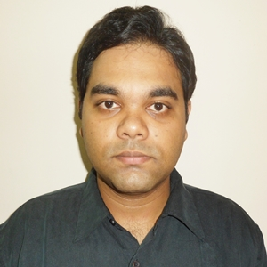

Dr. Md. Shahariar Islam
Medical Officer in Government of People’s Republic of Bangladesh (under ministry of Health & Family welfare) since 2014 , Currently on study leave for MPH course in Health Promotion & Health Education from July 2018 at NIPSOM , Dhaka , Bangladesh.
Contact information :
Address: National Institute of Preventive & Social Medicine (NIPSOM) , Mohakhali ,
Dhaka-1212 , Bangladesh.
Phone no: 8801737998282
Email id: dr_s_islam@yahoo.com
Presentation Category: Oral presentation

Author Category: Student

Name for the Certificate: DR. MD. SHAHARIAR ISLAM

