RECYCLING AND REUSE OF HUMAN EXCRETA
FOR ENERGY GENERATION: A REVIEW
ANIL K. SHRIVASTAVA,
Formerly with Naval Materials Research Laboratory, DRDO,
MUMBAI, INDIA

A B S T R A C T

Almost a billion people in developing world have no access to toilet and practice open defecation. But that waste should not go waste. Rather than tainting the environment and transmitting diseases, it could actually be harnessed to heat or power for millions of homes. The review paper will discuss about utilization of human excreta to produce biogas/energy as an alternative renewable energy. Utilization of human waste is considered beneficial in terms of the process because it does not require additional starter (micro organisms seeds) and a supply of micro organisms occurs continuously during the feeding of raw materials. Product gas resulting from typical dry human feces have LHV and energy values of 17.2 MJ/kg and 24 MJ/kg, respectively, at optimum equivalence ratio of 0.31 values that are comparable to wood biomass.
Non- sewered Sanitary Systems (NSS) are emerging as one of the solutions to poor sanitation because of the limitations of the conventional flush toilets. The new sanitary systems are expected to safely treat fecal waste and operate without any external connections to sewer, water supply or energy source. The Nano Membrane Toilets (NMT) is unique domestic –scale sanitary solution to treat human waste on site. The Reinvent The Toilet Challenge (RTTC) is one of the pioneering schemes initiated in 2011 under the Water, Sanitation And Hygiene (WASH) programme of the Bill and Melinda Gates Foundation to increase access to safe, sustainable and affordable sanitation.
In the present communication merits, demerits, advantages, limitations of various engineered technologies employed will be critically reviewed on the basis of their innovations, user friendliness, cost effectiveness, maintenance etc. Also, health aspects of biogas generated, design and R &D aspects of biogas plant fed by human excreta with or without supplementary feed stocks, treatment of slurry and its use, strategy for promotion and integration with other programmes will be thoroughly discussed.

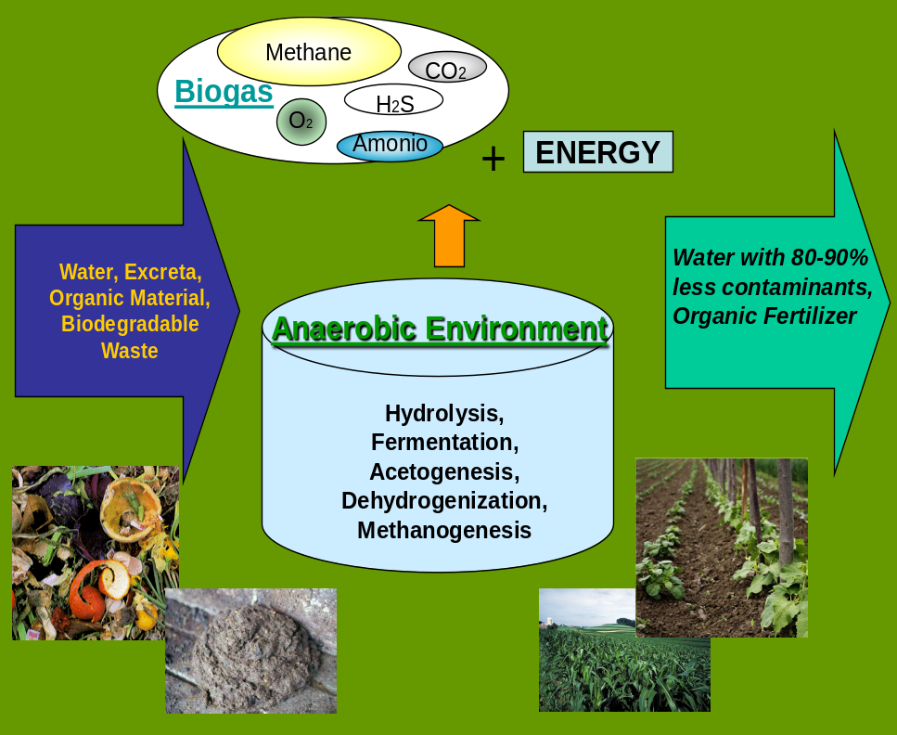

Recent Publications:
- Andriani D, Wresta A. Saepudin A, Prawara B, (2015) A review of recycling of human
excreta to energy through biogas generation : Indonesia case. Energy Procedia 68 : 219-
225.
- Colon J, Aaron A. , Stokes F, Deshusses M A (2015) Anaerobic digestion of undiluted
stimulant human excreta for sanitation and energy recovery In less developed countries.
Energy for Sustainable Develop. 29 : 57-64.
- Liu M , Woudstra T, Promes E J O,. Restrepo S Y G, Aravind P V, (2014) System
development and self sustainability analysis for upgrading human waste to power.
Energy 68: 377-384.
- Monhol F A F, Martins M F (2015) Concurrent combustion of human faeces and polyethylene waste. Waste Biomass Volorization 6 : 425-432.

- MukherjeeS, Chakraborty D (2016) Turning human waste into renewable energy: scope & options for India, National Institute of Public Finance & Policy (NIPFP), New Delhi and Indian Institute of Foreign Trade (IIFT), New Delhi, MPRA Paper No 73669, 13 Sep.

- Onabanjo T, Patchigolla K, Wagland S T, Fidalgo B , Kolios A, McAdam E., Parker A, Williams L, Tyrrel S, Cartmell E. (2016) Energy recovery from human faeces via gasification : A thermodynamic equilibrium modeling approach. Energy Convers. Manage 118 :364-376.

- Speidel M, Kraaij G, Worner A (2015) A new process concept for highly efficient conversion of sewage sludge by combined fermentation and gasification and power generation in a hybrid system consisting of a SOFC and a gas turbine. Energy Convers. Manage 98 :259-267.

- Ward B J, Yacob T W, Montoya L D (2014) Evaluation of solid fuel char briquettes from human waste. Environ. Sci. Technol. 48 : 9852-9858.

- WHO- UNICEF (2014) WHO- UNICEF Progress on drinking water and sanitation, 2014 update. Tech Rep (2014).

Biography of Author: 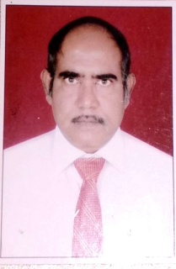
Dr Anil K. Shrivastava obtained the degree of Ph.D. in Chemistry (1983) from Ravishanker University, Raipur, India. Dr Anil has forty years R&D experience in the fields of Analytical Chemistry, Environmental Sciences, Biotechnology, Reliability, Quality & Safety. He had designed, developed, fabricated, tested and installed life supporting system for underwater Naval platforms. In recognition of his meritorious contributions Two National Level Awards, SCIENTIST OF THE YEAR AWARD -2015 and TECHNOLOGY DAY AWARD-2013 were conferred on him.
He worked as Associate Director (Management), Head of Department of Environmental Sciences Group for more than 20 years. Also, he Headed many Technical and Administrative Groups, at Naval Materials Research Laboratory, DRDO, Mumbai.
E-MAIL : akshrivastavaa@yahoo.in

