CDT, the Innovative Technology for Wastewater Recycling: its successful practise in China
Yong ZHAO

(School of Environmental Science and Engineering
Tianjin University, P.R.China)

Abstract (not more than 300 words)

Wastewater desalination and reuse is the solution to water scarcity all over the world. CDT (Capacitive Desalination Technology) is a new and comparative technology. Its basic principle, typical industrial process and current progress are inroduced in this paper. Comparative technology detail on RO (reverse osmos membrane), ED (electrodialysis) and CDT is presented. Especially, massive industrial projects for wastewater recycling by CDT in China are summarized. It is pointed out that due to its higher energy and cost-efficient than RO and ED，CDT will occupy more and more market shares.

Keywords: capacitive desalination technology, wastewater recycling, reverse osmos membrane, electrodialysis

Professional Biography
Yong ZHAO has completed his PhD at the age of 31 years from Tianjin University and postdoctoral studies from Nankai University School of Chemistry. He is the director of the Center for Waste-water treatment and re-use, Tianjin University.
He has undertaken and completed industrial projects for massive waste-water recycling, and has been serving as an editorial board member of repute.

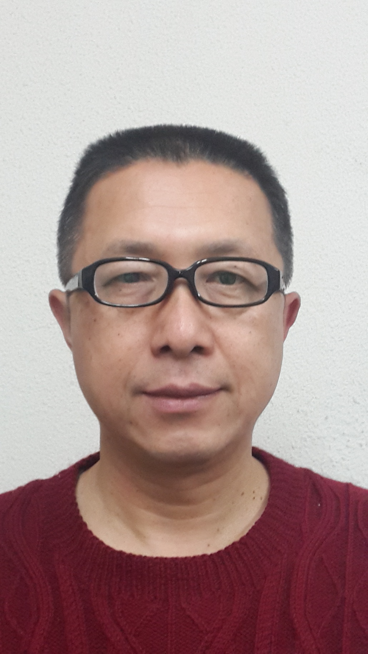
Email Id: yzhao@tju.edu.cn

Any Comments:

