Abstract Template
Abstract Title: Simulation of Groundwater Flow Using Pipe Network Model
Hamed Tavakolipour¹, Parjang Monajemi²

¹ Graduate Student, Civil and Environmental Engineering Department (University of Fasa, Iran)
²Associate Professor, Civil and Environmental Engineering Department (University of Fasa, Iran)

Abstract
In this paper, a new conceptual laboratory-scale model is introduced to simulate groundwater flow under steady state condition.

The proposed model is constructed by a lattice of junctions connected by horizontal and vertical pipes, a simplifications of throats and pores of a real porous media.

By assuming flow through each pipe is laminar, it is shown that the governing equation of the lattice follows steady saturated groundwater flow of a confined aquifer, Laplace equation. Then, using continuity equation for the model, a system of linear algebraic equation is achieved which is equivalent to transforming Laplace equation to a system of linear algebraic equations using numerical methods.
The model is also a novel physical model. A great superiority of this model over physical models such as sand boxes is that porous characteristics like soil permeability or inner impermeable barriers can easily be assigned by changing pipes or closing corresponding valves.

Finally, using this model, different examples are simulated. The results show good agreement with the analytical and numerical solutions. The flexibility and ease to change porous characteristics along with great visibility of how exactly water flows throughout the lattice makes it a great tool for simulating groundwater flow for educational and decision making purposes.

Keywords— analytical model, groundwater, physical model, pipe network, porous media

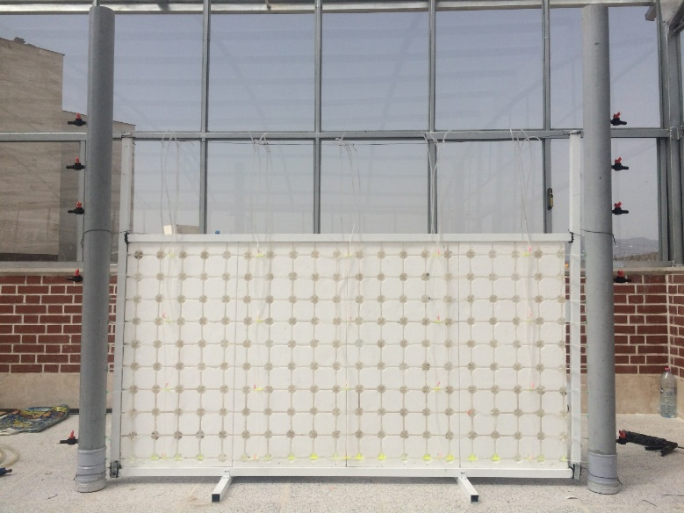

Professional Biography

Hamed Tavakolipour is a graduate student in Environmental Engineering. His M.Sc. thesis is mainly focused on physical and analytical modelling of groundwater flow in aquifers along with its pollution transport. He has been teacher assistant in two courses titled “Engineering Statistics” and “Differential Equations”.

He also cares about Environment. In this regard, he is a member of Engineers without boarders-Iran. Being a main member of EWB-Iran, he has poster presented “The Analog Solar Tracking System” in the 6th SCI world conference 2017.

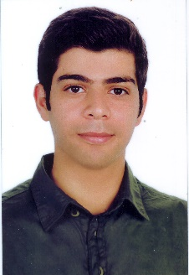

Email Id: hamedtp@gmail.com

