Multifocal Fungal Ball Involving Both Maxillary Sinuses and A Common/Fused Sphenoid Sinus: A Case Report
GAB-KYUN LEE, MD, Pusan National Univaersity Hospital, Pusan, Korea
KYU-SUP CHO, MD, Pusan National Univaersity Hospital, Pusan, Korea

Abstract (300 word limit)
Background: Fungal ball is a non-invasive form of fungal rhinosinusitis that typically involves a single paranasal sinus, most often the maxillary sinus. Simultaneous involvement of three or more sinuses is rare. Case Presentation: A 76-year-old man with diabetes mellitus presented with a three-month history of postnasal drip. CT and MRI showed a polypoid lesion in the left maxillary sinus extending into the left ethmoid sinus and osteomeatal unit, haziness with calcification in both maxillary sinuses, and an expansile lesion in the bilateral posterior ethmoid and sphenoid sinuses with focal erosion of the posterior sphenoid wall. The ethmoid-sphenoid lesion showed heterogeneous T2-intermediate/low and T1-high signal with diffusion restriction and no enhancement; a similar diffusion-restricted pattern was seen in the left maxillary lesion. On preoperative imaging, fungal disease was suspected mainly in the left maxillary sinus, while the right maxillary sinus and the sphenoid lesion were read as chronic sinusitis and a possible mucocele, respectively. Endoscopic sinus surgery revealed fungal debris in both maxillary sinuses and within a common- appearing sphenoid cavity with marked remodeling and loss of the intersinus septum; the posterior sphenoid wall was intact. Histopathology confirmed non-invasive fungal ball at all three sites. Conclusion: This case demonstrates a rare presentation of multifocal fungal ball simultaneously involving both maxillary sinuses and a common/fused sphenoid sinus. The radiologic extent of disease was underestimated preoperatively, underscoring the importance of systematic intraoperative evaluation of every opacified sinus regardless of its imaging appearance.

Image
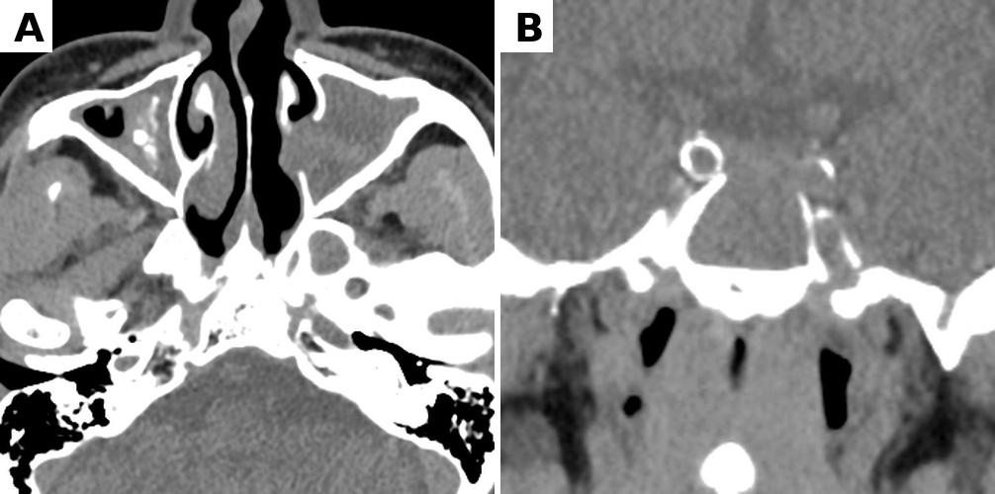
Figure 1. preoperative computed tomography showing bilateral maxillary sinus lesions with intralesional calcifications (A) and a common-appearing sphenoid sinus with marked bony remodeling and loss of the intersinus septum (B).
Recent Publications (minimum 5)
1. Kim S, Lee GK, Park JH, Cho KS, Kim SD. Comparing the Efficacy of Surgical Instruments in Tonsillectomy Patients. Journal of Clinical Otolaryngology Head and Neck Surgery. 2022;33(1):9-15. doi:10.35420/jcohns.2022.33.1.9.
2. Lee JW, Lee BJ, Lee GK, Jang JW, Chun YI, Shin SC, Lee JC, Kim BH, Kim IJ, Kim CR. Risk Factors for Local Recurrence in Patients With N1b Papillary Thyroid Carcinoma. Korean Journal of Otorhinolaryngology-Head and Neck Surgery. 2022;65(8):448-456. doi:10.3342/kjorl-hns.2021.01004.
3. Lee GK, Kim HS, Kim H, Lee JW, Oh SJ, Kong SK. Clinical Analysis of Repeat Balloon Eustachian Tube Dilatation. Korean Journal of Otorhinolaryngology-Head and Neck Surgery. 2023;66(12):824-828. doi:10.3342/kjorl-hns.2023.00626.
4. Lee GK, Kim SH, Jang HB, Park DH, Mun SJ. How to Release Shallow Nostril Stenosis After Pediatric Trauma? The Journal of Cosmetic Medicine. 2023;7(2):94-97. doi:10.25056/jcm.2023.7.2.94.

Photograph

Biography (150 word limit)
GAB-KYUN LEE, MD. is an otolaryngologist and rhinology fellow at Pusan National University Hospital, Republic of Korea. His clinical interests focus on rhinology, with particular emphasis on inflammatory sinonasal disease, chronic rhinosinusitis, endoscopic sinus surgery, and related nasal and paranasal sinus disorders. His research interests include the clinical and surgical management of sinonasal disease, Eustachian tube dysfunction, and rhinologic outcomes. He has authored and co-authored several peer-reviewed publications in otolaryngology, including studies on endoscopic sinus surgery, Eustachian tube dilatation, tonsillectomy, thyroid carcinoma, and pediatric nasal nostril disorders. He has also presented clinical and research findings at academic meetings in otolaryngology and rhinology.
Email: leefresher@naver.com

Notes/Comments:

