The Prevalence and Awareness of Congenital External Ear Deformity Among Primary School Children in Najran, Saudi Arabia: A Cross-sectional Study

Alshehri, Ali Abdullah 1, Asaiel Mubarak Al Hadi 2, Lama Hassan Ahmed Alyami 3, Ibrahim Nasser Al Sulaiman 4, Enas Mubarak Al Hadi 5, Saleh Yahya Al Hareth 6

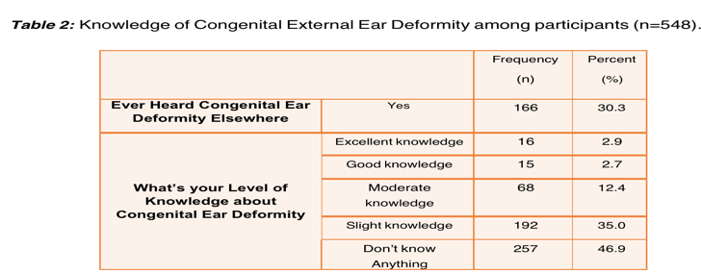

Abstract
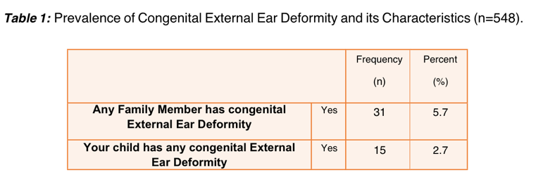
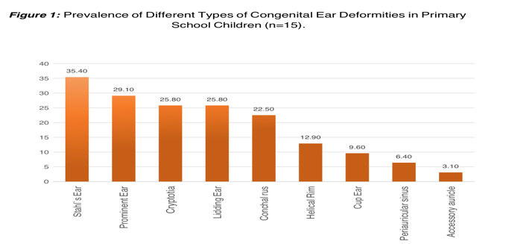
The external ear, comprising the auditory canal and pinna, is susceptible to congenital deformities, impacting 5% of the population [1]. External ear protrusion is the most common defect, affecting 19% of newborns. . They can occur independently or with other congenital anomalies [6]. help this recognition. The purpose of these study: Little is known about their prevalence and awareness in Saudi Arabia, particularly among school students. This cross- sectional study addresses this gap, aiming to inform regional public health policies and interventions.This study was conducted in accordance with the Declaration of Helsinki and was approved by the Institutional Review Board and Research Ethics Committee of Najran University with the given Reference number: 012961-029283-DS. A total of 548 primary school children in Najran, Saudi Arabia, were included. The study was conducted between March 2023 and September 2023.We utilized a pretested, structured questionnaire to collect information on demographic characteristics, the presence of congenital external ear deformities, and the awareness about these conditions from both the selected students and their parents. Qualified healthcare professionals conducted clinical examinations to confirm the presence or absence of congenital external ear deformities in each child.Our study revealed that the majority were males (56.2%), aged 6-10 years (49.3%), and attended primary school (69.5%). A notable proportion of children suffered from chronic illnesses, with hearing impairment being the most prevalent (25.9%). Various congenital external ear deformities were observed, with Stahl's Ear being the most common (18.1%). Knowledge about these deformities was limited among respondents (30.3%), but a majority (73.9%) believed community awareness could reduce deformity prevalence. Awareness levels were influenced by parental education but not by the child's age, gender, or chronic diseases. Conclusion:Our study reveals a significant prevalence of congenital ear deformities among school students in Najran, Saudi Arabia, with limited awareness. Parental education plays a role in awareness. Efforts to enhance awareness and early detection are vital for improving child health in the region.

Image

Recent Publications
- Manstein CH, Narayan D. Congenital ear deformities. Medscape.
- Swartz JD, Faerber EN. Congenital malformation of the external and middle ear: High- resolution CT findings of surgical import. AJR Am J Roentgenol. 1985; 144:501-506.
- Wang RY, Earl DL, Ruder RO, Graham JM Jr. Syndromic ear anomalies and renal ultrasound. Pediatrics. 2001;108: E32.
- Sylva BF, Cornelia W. Classification and diagnosis of ear malformations. GMS Curr Top Otorhinolaryngol Head Neck Surg. 2007; 6:1-21.
- Tony W, Peter V. The anatomy and embryology of the external and middle ear. In: Michael G, George GB, Martin JB, Ray C, John H, editors. Scott-Brown Otorhinolaryngology, head & neck surgery. 7th ed. Hodder Arnold Publishers, UK.
- Iseh KR. Branchial cleft anomaly of external auditory canal: A case report. Ann Afr Med. 2003; 2:83-84.

