STATUS OF REGIONAL LYMPH NODES AT DIFFERENT FORMS OF CHRONIC TONSILLITIS
Trukhin D.V.¹, Nosulya E.V.², Kim I.A.¹, Rychkova I.Y.³
¹ Federal State Budgetary Institution «Otorhinolaryngology Clinical Research Center» of the Federal Medico-Biological Agency, Russia
² State-financed Healthcare Institution of Moscow «The Sverzhevskiy Otorhinolaryngology Healthcare Research Institute», Moscow Department of Healthcare, Russia
³ Pirogov Russian National Research Medical University, Russia

Abstract
Chronic tonsillitis is a common disease. Diagnosis of chronic tonsillitis is traditionally based on the evaluation of clinical signs. However, none of the clinical signs of a chronic inflammatory process is specific for chronic tonsillitis. Laboratory methods are not informative enough. At the moment, various methods are proposed for the differential diagnosis of chronic pathology of the tonsils. The defects of these methods are complexity, anserial equipments, invasiveness, and other pathological and anatomical features. One of the manifestations of chronic tonsillitis, in the absence of inflammatory diseases of other localization, is regional lymphadenitis. Therefore, the determination of the state of the lymph nodes in combination with other signs of chronic inflammation in the tonsils is important in the diagnosis of chronic tonsillitis. One of the most sensitive methods for determining lymph nodes is ultrasound examination. Methods: 60 patients with chronic tonsillitis were examined. The first group included 30 patients with local tonsillar alterations only. The second group consisted of 30 patients with the complication of disease in the past. Regional lymph nodes were examined with an ultrasound system Toshiba Aplio 500 on both sides, determining the localization of lymph nodes, their quantity, as well as the shape, size and structure. Results: 1) Complicated chronic tonsillitis is characterized by multiple lymph nodes. 2) Single lymph nodes are characteristic for local tonsillar alterations. 3) Lymphatic nodes larger than 22.5 mm are characteristic of complicated chronic tonsillitis.
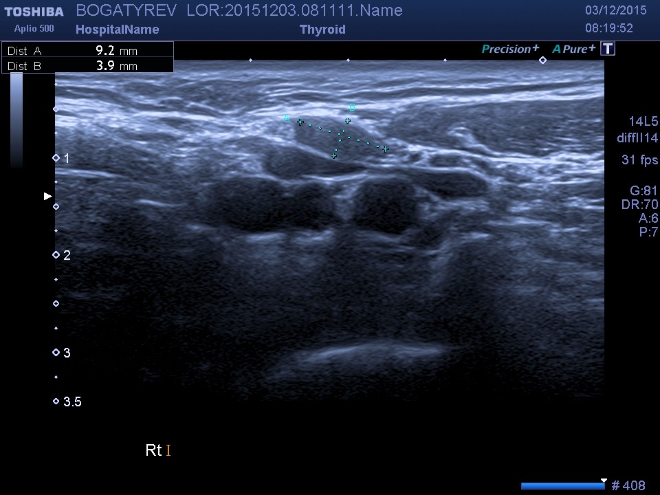
Multiple lymph nodes
Recent Publications:
- B.Peric, E.Nosulya, I.Kim, I.Rychkova, R.Zubarev: Ultrasound examination in differential diagnosis of chronic tonsillitis complications. E-posters abstract book ENT World congress. 2017.
- D.Trukhin, E.Nosulya, I.Kim, I.Rychkova. Differential diagnostics of clinical forms of chronic tonsillitis. Interdisciplinary problems of diagnostics, treatment and rehabilitation of patients with ENT-organ pathology. 83. 2017.
- E.Nosulya, I.Rychkova, I.Kim, R.Zubarev, D.Trukhin, K.Molokov. Method of differential diagnostics of clinical form of chronic tonsillitis, based on ultrasound research of regional lymphouses. Patent for invention RUS 2638429 04/22/2016.
- D.Trukhin. Differential diagnosis of clinical forms of chronic tonsillitis. Translational medicine: the possible and the real. 177-178. 2018.

Biography
D.V. Trukhin works in the department of science of the Federal State Budgetary Institution «Otorhinolaryngology Clinical Research Center» of the Federal Medico-Biological Agency.
E.V. Nosulya is Doctor of Medical Sciences, Professor of the State-financed Healthcare Institution of Moscow «The Sverzhevskiy Otorhinolaryngology Healthcare Research Institute», Moscow Department of Healthcare.
I.A. Kim is Doctor of Medical Sciences, Head of Research Department of the Federal State Budgetary Institution «Otorhinolaryngology Clinical Research Center» of the Federal Medico-Biological Agency.
I.Y. Rychkova is docent at the Department of Ultrasound Diagnostics of the Pirogov Russian National Research Medical University.
Email: trukhin_denys@list.ru

Notes/Comments:

