Various types of ossiculoplasty with sculptured Spine of Henle

S.K.KASHYAP (M.S.) M.L.B Medical college, Jhansi, Uttar Pradesh, India
Abstract
The ear ossicles are the three smallest bones in the human body and their function is to transmit the sound from vibrating tympanic membrane to the oval window. Erosion of ossicles or discontinuity of their joints is common in middle ear pathologies and this causes significant conductive hearing loss in the patients. Squamosal chronic otitis media is the commonest cause for ossicular discontinuity with other causes being mucosal COM, adhesive otitis media and trauma. Lenticular process and long process of incus erosion is the commonest defect found followed by stapes superstructure, handle of malleus, body of incus, head of malleus etc.
The term Ossiculoplasty refers to the operation performed to restore the continuity of ossicular chain. Over the years, various materials like tissue grafts (autografts/homografts/allografts) and synthetic biomaterials have been used for ossiculoplasty. Thees are incus, tragal or septal cartilages, cortical bone. Commercially available prostheses (PORP/TORP) like Titanium, Plastipore, Teflon, Hydroxyapatite.
Our study is aimed at using sculptured Spine of Henle to do the ossiculoplasty. Spine of Henle is a small and dense bony projection in the surface of temporal bone which can be encountered and harvested during post aural approach to middle ear. We have used Spine of Henle in various ossicular defects like lenticular and long process erosions, total or near total erosion of incus, erosion of stapes superstructure.
Contraindications are extensive cholesteatoma eroding outer cortex.
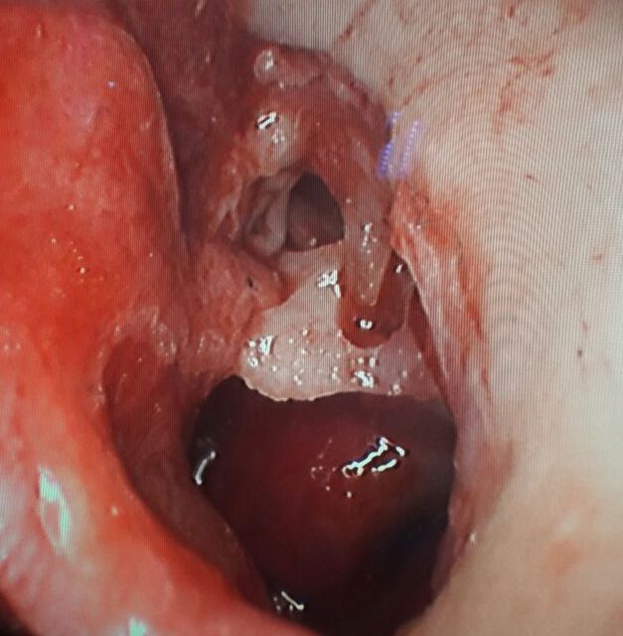
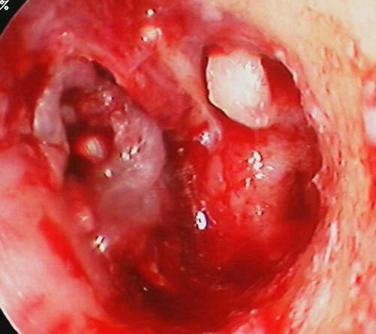
Image 1 Image 2
Images 1 - 2 shows the Spine of Henle being used in two different ways to reconstruct the incudo-stapedial joint in cases of long process of incus erosion.

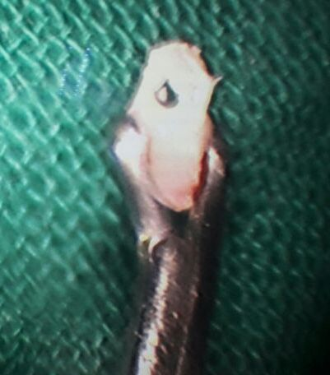

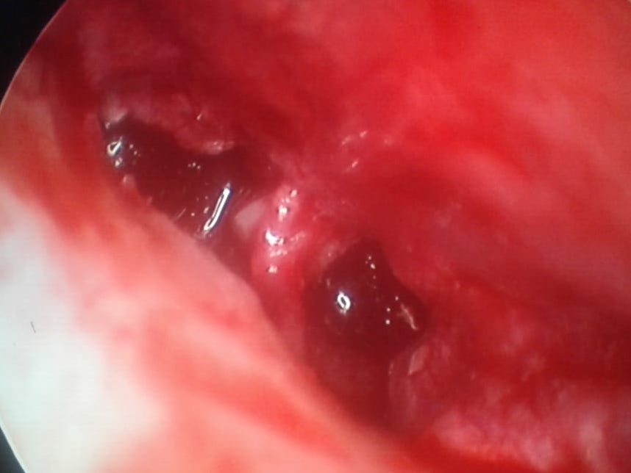
Image - 3 shows the process of sculpturing the harvested Spine of Henle.

Image - 4 shows the spine of Henle is modelled as a “L” strut for erosion of stapes suprastructure and incus

Recent publications
1. Correlation of Endoscopic and CT scan Findings in Laryngeal Carcinoma; JMSCR Vol05; Issue-05; Page 21216-21220, May, 2017.
2. Anatomical variations of sphenoidal inter - sinus septa in terms of number and attachments - a CT finding . J . Evolution Med . Dent . Sci . 201 7 ; 6 ( 1 2 ): 955 - 959 , DOI : 10.142 60/Jemds/201 7 / 204
3. Incidence of Ossicular Chain Pathology in Tubotympanic Type of C.S.O.M”. Journal of Evolution of Medical and Dental Sciences 2015; Vol. 4, Issue 67, August 20; Page: 11701-11707, DOI: 10.14260/jemds/2015/1687
4. Evaluation of aetiological role of misdirected tooth in the incidence of squamous cell carcinoma of oral cavity. Journal of Evolution of Medical and Dental Sciences; 2016; 5(51):3260-3264; DOI:10.14260/jemds/2016/757.
5. Laryngofissure Approach for Large Benign Tumour of Larynx: A Case Report & Review. JMSCR Vol-05; Issue 04, Page 20764-20766; April, 2017
6. Dentigerous cyst with unerupted teeth in bilateral maxilla with oro antral fstula with DM type I : A case report and review of literature. International Journal of Contemporary Medical Research 2016;3(4): 958-960.

Biography
Professor Dr. S.K.Kashyap is specialized in field of Otorhinolaryngology, head, neck and Skull base surgery with a very vast experience. He is currently heading the chair as the Head of department of ENT and Head Neck surgery at M.L.B. Medical college, Jhansi ,India.

