Frequency Analysis of the Cochlea
Dr Erdogan BULUT, PhD, Trakya University, TR

Abstract

Hearing is one of the major senses that is important for distant warning and communication, as well as vision. The function of the ear is to convert physical vibration into an encoded nervous impulse. It can be thought of as a biological microphone.

The organ of Corti is a specialized sensory epithelium that allows for the transduction of sound vibrations into neural signals. The mammalian cochlea contains two categories of hair cells. Inner hair cells send the acoustic information via multiple ribbon synapses that transmit a rapidly. Outer hair cells are important for amplifying sound-evoked vibrations. The amplification mechanism primarily involves contraction of the outer hair cells, which is driven by changes in membrane potential and mediated by Prestin, a motor protein in the outer hair cell lateral membrane.

A few decades ago, the cochlea was viewed as a mechanical and hydrodynamic system for transmitting acoustic signals to hair cells that simply interpreted these inputs as electrical responses. However, hair cells have proven to make a far more important contribution to cochlear function.

The cochlea is capable of exceptional sound analysis, in terms of both frequency and intensity.

Helmholtz (c.1863) suggested that resonators tuned to different audible frequencies were spread along the basilar membrane. George Von Bekesy distanced himself from resonance theory from the 1950s. Using cochleae taken from human cadavers and hydraulic models, he demonstrated that when the cochlea was stimulated by a sound wave, the basilar membrane motion was a wave that travelled from the base of the cochlea. Accordingly, (Travelling Wave Theory-Nobel Prize -1961), different frequencies of sound lead to peak vibrations in different places on the basilar membrane. Low frequencies cause greatest vibrations around the apex, whereas high frequencies elicit greatest vibrations around the base of the cochlea (Tonotopic map).

This theory allowed the cochlea to be considered a passive structure in non-physiological conditions. In the physiologic, all the cellular structures in the cochlea show different mechanical properties specific to the frequency. In the light of our studies, we observed that there is not a tonotopic map in the cochlea. We think that all segments in the cochlea can respond to low, mid and high frequencies. Given the great advances over the past 50 years, it will be interesting to see how our understanding of the ear changes over the next 50 years.

Image
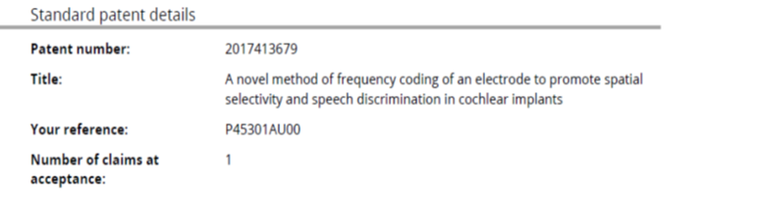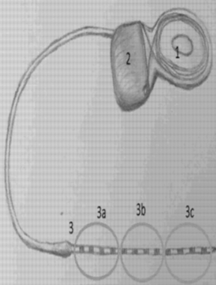
Recent Publications
- Bulut E (2009). The Role Of Outer Hair Cells in Frequency Selectivity of The Organ of Corti, PhD Thesis, Edirne,TR.
2. Shah V, Mittal R, Shahal D, Shinka P, Bulut E, Mittal J, Eshraghi AA (2020). Evaluating the Efficacy of Taurodeoxycholic Acid in Providing Otoprotection Using an in vitro Model of Electrode Insertion Trauma. Frontiers in Molecular Neuroscience, 13(113), 1- 10., Doi: 10.3389/fnmol.2020.00113
3. Bulut E, Öztürk L (2017). Spontaneous otoacoustic emission recordings during contralateral pure-tone activation of medial olivocochlear reflex. Physiology Int. 104(2), 171-182.
4. Bulut E, Budak M, Öztürk L, Türkmen MT, Uzun C, Sipahi T (2017). Dna Methylation of Prestin Gene and Outer Hair Cell Electromotile Response Of The Cochlea In Salicylate Administration. Turkish Journal of Medical Sciences, 47, 1626- 1633
6. Bulut E, Uzun C, Öztürk L, et al. (2017). A New Hypothesis on the Frequency Discrimination of the Cochlea. J Int Adv Otol. 13(2):204-210.
7. Uzun C, Bulut E, Ataş A, Kara E. A novel method of frequency coding of an electrode to promote spatial selectivity and speech discrimination in cochlear implants. Australian Patent 2017413679. December 20, 2017.

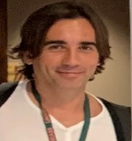
Dr Erdogan is working on the cochlear physiology. He has expertise in audiology and physiology. With his knowledge and experience in experimental audiology for many years, he offers innovative approaches by working on the frequency selectivity of the cochlea. He has an international patent to increase the intelligibility of speech and increase speech in noise, which will change the basic working principle of hearing aid prostheses.
Email: erdoganbulut@gmail.com

Notes/Comments:

