Chronic otitis media –AAD with aural polyp in a profound intellectual disabled girl without facial Nerve palsy.
DR SA Panchappa.Dr RK Swamirao

Abstract (300 word limit)
Chronic otitis media implies a permanent abnormality of the pars tensa or pars flacida due to earlier acute otitis media,negative middle ear pressure or otitis media with effusion(>3 months).Atticoantral disease most commonly involves the pars flacida and charecterised by formation of stratified squamous epithelium;the matrix of which is composed of epithelium that rests on a stroma of varying thickness.Residual and recurrent cholesteatoma common in childhood cholesteatoma.Case history-A female of chronological age 25 yrs,mental age of 10 yrsand IQ of 40 presented with recurrent foul smelling left ear discharge since childhood and mass in the left ear past one year.There is a pale pink polyp n the canal with right beating nystagmus,without gait instability,without facial asymmetry.Neuromedicine and psychiatry medicine opinion obtained.After basic investigations,BERA,CT temporal bones,planned for mastoidectomy and proceed.Conclusion-Post operatively the facial nerve intact functionally.Intellectual disability affects 2% to 3% of total population and profound intellectual disability seen in the 25% of them.

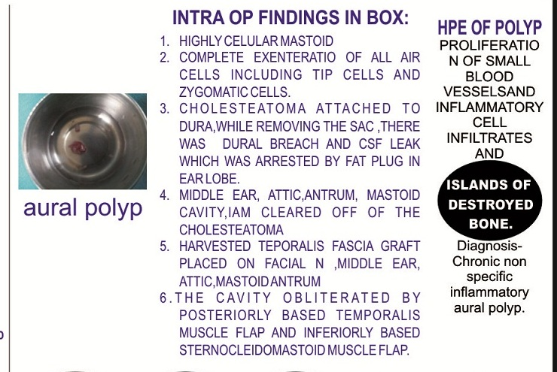

Recent Publications (minimum 5)
1.American Academy of Family Physicians, American Academy of Otolaryngology-Head and Neck Surgery, American Academy of Pediatrics Subcommittee on Otitis Media with Effusion. Otitis media with effusion. Pediatrics. 2004;113:1412–29.Google Scholar
2. Antonelli PJ, Garside JA, Mancuso AA, Strickler ST, Kubilis PS. Computed tomography and the diagnosis of coalescent mastoiditis. Otolaryngol Head Neck Surg. 1999;120:350–4.
3. Gray J. D. The chronic ear. The treatment of cholesteatoma in children. Proceedings of the Royal Society of Medicine. 1964;57:769–771. [PMC free article] [PubMed] [Google Scholar]
4. Sie K. C. Y. Cholesteatoma in children. Pediatric Clinics of North America. 1996;43(6):1245–1252. doi: 10.1016/s0031-3955(05)70517-. [PubMed] [CrossRef] [Google Scholar]
5. Prescott C. A. J. Cholesteatoma in children—the experience at The Red Cross War Memorial Children's Hospital in South Africa 1988–1996. International Journal of Pediatric Otorhinolaryngology. 1999;49(1):15–19. doi: 10.1016/s0165-5876(99)00029-4. [PubMed] [CrossRef] [Google Scholar]

Photograph

Biography (150 word limit)
IEmail-suman.panchappa@nhs.net
I am interested in learning new skills,techniques in surgery.I am keenly involved in teaching.

Notes/Comments:

