Study of Clinical Profile and Outcome of Shock in Paediatric Intensive Care Unit of a Tertiary Care Hospital
- Dr. Eshana Kaur
M.B.B.S, Madurai Medical College, India
- Dr. M.R. Lenin M.D(Paeds)
Assistant Professor
Institute of Child Health and Research centre, India
- Professor Dr. S.Balasankar, MD., DCH
Director and Head of Department, Institute of Child Health and Research centre, Madurai Medical College, India
- Dr. A.N. Karthik M.D(Paeds)
Assistant Professor
Institute of Child Health and Research centre. India

Abstract
Statement of the Problem: The Paediatric Intensive Care Unit (PICU) serves as a critical setting for managing severely ill children. Patient who are in a state of shock represent a significant challenge for clinicians. Despite advances in paediatric care, shock-related morbidity and mortality continue to pose a threat, particularly when accompanied by mechanical ventilation requirements. Cardiogenic shock, for instance, holds a mortality rate as high as 88.9% in children, further exacerbated when comorbidities are present. Thus, comprehensive research into shock's clinical spectrum, epidemiological characteristics, early recognition, and management is imperative to reduce morbidity and mortality. Methodology & Theoretical Orientation: A prospective observational study was conducted on critically ill children aged 1 month to 12 years, admitted to PICU between April 2023 and June 2023, displaying clinical signs of shock. The objectives of the study were to categorize shock incidence in PICU based on their physiological state. Further, we investigated correlation between clinical and lab parameters of shock and patient outcomes. Extensive clinical histories were taken, and laboratory investigations were performed. Various shock types were identified: Additional criteria, such as the SIRS criteria and PRISM score were assessed. Data collected from medical records were statistically analysed using chi-square analysis and spss 21 software. Findings:.The study consisted of 50 patients, with a higher proportion of non-survivors (62%) compared to survivors (38%). The occurrence of shock in the age range of 1 month to 1 year, constituted 42% of total admissions and majority were male. In a developing nation like ours, Septic shock was the most prevalent type (56%), followed by hypovolemic shock (22%). Highest mortality was among those with Cardiogenic shock. The presence of Systemic Inflammatory Response Syndrome (SIRS) criteria was observed in 84% of shock patients. Patients who received ventilation within the PICU showed lower mortality (66.6%) compared to those intubated outside the PICU (85.7%). PRISM score showed significant correlation with mortality (p=0.374). 32 patients had score>10. Conclusion & Significance: The findings of this study hold several clinical implications. They underscore the importance of early intervention, timely antibiotic administration, and the critical role of mechanical ventilation in improving outcomes. The variation in mortality rates across different age groups, genders, shock types, and clinical presentations highlights the need for personalized treatment approaches.

Image
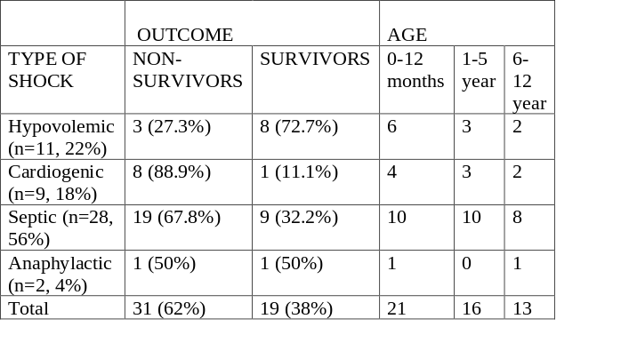
Recent Publications
- Frankel LR, Mathers LH. Shock. In: Behrman RE, Kliegman RM, Jenson HB, editors. Nelson Textbook of Pediatrics. 16th ed. WB Saunders; 2000. p. 262-266.
- Perkin RM, Levin DL. Shock in the pediatric patient. Part I. J Pediatric. 1982; 101: 163-169.
- Tobin JR, Wetzel RC. Shock and multiorgan system failure. In: Rogers MC, ed. Textbook of Pediatric Intensive Care. 3rd ed. Williams & Wilkins; 1996. p. 555-605.
- Singh D, Chopra A, Pooni PA, Bhatia RC. A clinical profile of shock in children in Punjab, India. Indian Pediatr. 2006 Jul; 43(7): 619-623
- Joseph R, Randall T, Wetzel C. Shock and multiorgan system failure. In: Rogers MC, Nichols DG, eds. Textbook of Pediatric Intensive Care. 3rd ed. Williams and Wilkins; 1996.p.589-605

 Biography
Dr has the inquisitiveness and passion in improving the healthcare and wellbeing. She welcomes new projects with open arms and aces them to her best abilities. She may be a recent graduate, yet she has been an all-rounder and the brightest performer amongst the numerous batches of our college. She has avid interest in research and at present has two other ongoing research papers too..
Email: eshanakaur6756@gmail.com

