Diaphragmatic ultrasound for monitoring therapy in patient with COPD exacerbation in emergency department

Dr C. Carelli, Emergency School, University of Naples “Federico II”, Naples, Italy
Dr G. Cristiano, Emergency department, C.T.O. Hospital, Naples, Italy
Dr C. A. de Rosa, Emergency School, University of Pavia, Pavia, Italy
Dr C. S. Cimmino, Emergency department, C.T.O. Hospital, Naples, Italy
Dr F. Paudice, Emergency department, C.T.O. Hospital, Naples, Italy
Dr R. Epifani, Emergency department, C.T.O. Hospital, Naples, Italy
Dr M. G. Monsurro’, Emergency department, C.T.O. Hospital, Naples, Italy
Dr L. Pagliuca, Emergency department, C.T.O. Hospital, Naples, Italy
Dr V. de Simone, Cardiology department, C.T.O. Hospital, Naples, Italy
Dr G. Fiorentino, Department of Intensive Care, AORN Ospedale dei Colli, Naples, Italy
Dr M. Guarino, Emergency department, C.T.O. Hospital, Naples, Italy

Abstract

Chronic Obstructive Pulmonary Disease (COPD) can cause a diaphragmatic dysfunction (DD), due to the progressive air trapping which leads to muscle fatigue and atrophy, compromising patient’s survival and the duration of mechanical ventilation followed by weaning difficulties. Diagnosis and monitoring of DD are possible via diaphragmatic ultrasound (US) by virtue of its non-invasiveness and high availability in the emergency department (ED).

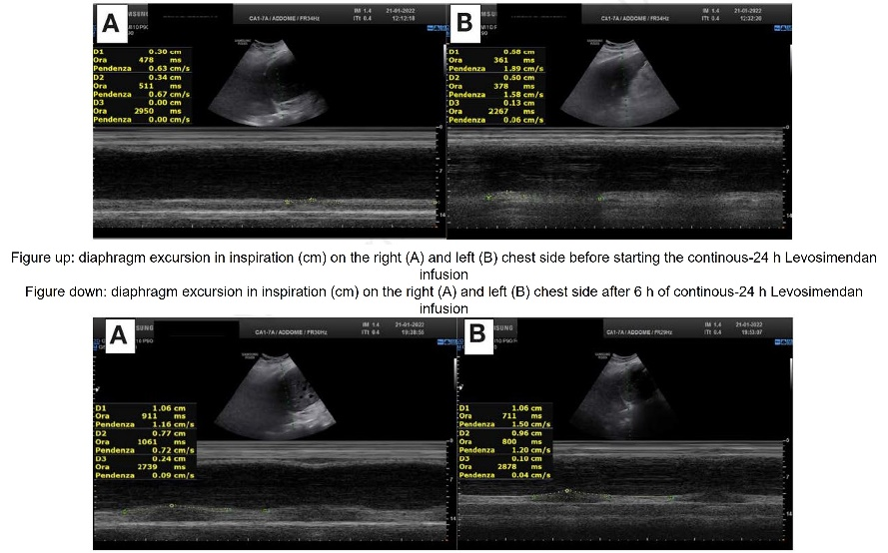
Woman, 77 years old, arrived in ED for a COPD exacerbation. On clinical evaluation, she was awake but confused, with dependent oedemas. The ABG on room air showed a condition of hypoxemia and respiratory and metabolic acidosis; the US evaluation revealed a bilateral B-profile with an irregular pleural line, multiple consolidations and a bilateral pleural effusion; the echocardiogram demonstrated a dilated right ventricle with inefficient contractility and a dilated and hypocollapsing inferior vena cava. Thus, non-invasive ventilation and specific drug therapy were started. Despite the therapy, in less than 24 hours she began drowsy (GCS 8) and the US evaluation showed an almost motionless diaphragm: Levosimendan treatment was started in continuous infusion, in order to improve the diaphragm contractility and reduce the breathing work. After six hours of treatment, a progressive increase in diaphragmatic excursion (DE) and in right-to-left ratio of maximal excursion were observed with a progressive improvement of ABG parameters and clinical status.

Diaphragmatic US is an essential tool for the evaluation of COPD-induced DD in ED: it allows for close monitoring of DE and the right-to-left ratio of maximum excursion, easily repeatable at patient’s bedside, and evaluation of therapy effectiveness in real time.

Image
Recent Publications
- Shaikh H, Laghi F. Role of Diaphragm Ultrasound When NIV Fails in COPD Exacerbations. Respir Care. 2019 Dec;64(12):1600-1602.
- Rocha FR, Brüggemann AK, Francisco DS, Medeiros CS, Rosal D, Paulin E. Diaphragmatic mobility: relationship with lung function, respiratory muscle strength, dyspnea, and physical activity in daily life in patients with COPD. J Bras Pneumol. 2017 Jan-Feb;43(1):32-37.
- Baria MR, Shahgholi L, Sorenson EJ, Harper CJ, Lim KG, Strommen JA, Mottram CD, Boon AJ. B-mode ultrasound assessment of diaphragm structure and function in patients with COPD. Chest. 2014 Sep;146(3):680-685.
- Laghi FA Jr, Saad M, Shaikh H. Ultrasound and non-ultrasound imaging techniques in the assessment of diaphragmatic dysfunction. BMC Pulm Med. 2021 Mar 15;21(1):85.
- Zambon M, Greco M, Bocchino S, Cabrini L, Beccaria PF, Zangrillo A. Assessment of diaphragmatic dysfunction in the critically ill patient with ultrasound: a systematic review. Intensive Care Med. 2017 Jan;43(1):29-38.
- Topcuoğlu C, Yümin ET, Hizal M, Konuk S. Examination of diaphragm thickness, mobility and thickening fraction in individuals with COPD of different severity. Turk J Med Sci. 2022 Aug;52(4):1288-1298.

Biography
Dr Claudia Carelli is an Emergency Resident at University of Naples “Federico II” and she is training in the emergency department of C.T.O. Hospital of Naples. Dr Claudia Carelli has her expertise in hemodynamic monitoring and in the using of non-invasive device.

Email: cl.carelli@hotmail.com

Notes/Comments:

