Design, Synthesis, and Antimicrobial Activity of Certain New Indole-1,2,4 Triazole Conjugates
Dr Reem I. Al-Wabli PhD, KSU, KSA
Mona A. Alsulami MSc, KSU, KSA
Dr Sarah I. Bukhari PhD, KSU, KSA
Nadine M. S. Moubayed MSc, KSU, KSA
Dr Maha S. Al-Mutairi PhD, KSU, KSA
Dr Mohamed I. Attia PhD, KSU, KSA

Abstract (300 word limit)

The increasing prevalence of microbial infections and the emergence of resistance to the currently available antimicrobial drugs urged the development of potent new chemical entities with eminent pharmacokinetic and/or pharmacodynamic profiles. Thus, a series of new indole-triazole conjugates 6a-u was designed and synthesized to be assessed as new antimicrobial candidates using the diameter of the inhibition zone and minimum inhibitory concentration assays against certain microbial strains. The target compounds 6a-u have been successfully synthesized according to Figure 1. The synthesis was commenced by esterification of indole-2-carboxylic acid in ethanol. The ethyl ester derivative 2 was converted to the corresponding acid hydrazide 3 through reaction with hydrazine hydrate in ethanol. Subsequently, the appropriate isothiocyanate, was allowed to react with compound 3 to yield the respective thiosemicarbazide derivatives 4a-c. Cyclodehydration reaction of the compounds 4a-c was carried out in aqueous 10% NaOH to give compounds 5a-c. Thereafter, the target compounds 6a-u were achieved through a nucleophilic substitution reaction in which the appropriate benzyl halide was subjected to nucleophilic attack by the thiol group of compounds 5a-c. The triazole derivatives 5a-c were elaborated to their respective N-alkyl derivatives 6a-u as sole products through the reaction with the appropriate benzyl halide in dry acetone. Their in vitro antibacterial evaluation revealed good to moderate activity against most of the tested Gram-negative strains with diameter of the inhibition zone (DIZ) values in the range of 11–15 mm and minimum inhibition concentration (MIC) values around 250 μg/mL. Meanwhile, their in vitro antifungal evaluation demonstrated a potent activity against Candida tropicalis with MIC value as low as 2 μg/mL for most of the tested compounds. Moreover, compound 6f is the most potent congener with an MIC value of 2 μg/mL against Candida albicans. In addition, the antibacterial and the antifungal activities results imply the significance of the para benzyl substituent.

Image
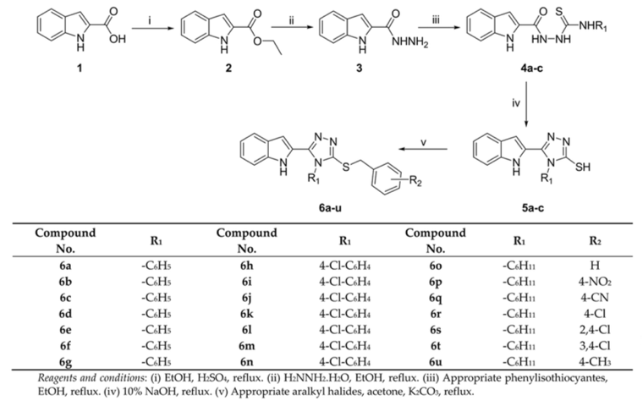
Figure 1. Synthesis of the target compounds 6a-u.
Recent Publications (minimum 5)

Photograph

Biography (150 word limit)
Mrs. Mona Alsulami is currently a senior scientific evaluation expert at Saudi Food and Drug Authority and she is a registered pharmacist at Saudi Arabia. In December 2020, she earned her MSc degree in Pharmaceutical Chemistry from king Saud university, KSA. Mona Alsulami graduated from king Saud University with a bachelor degree in pharmaceutical science. She began her journey as a pharmacist working diligently to provide exceptional patient. Mona Alsulami has her expertise in Drug Design and Development, evaluation of the quality of the medication proposed to be registered in KSA to ensure the safe and effectiveness of the medication. Mona developed a deep passion for drug development and its impac on public health. Motivated by this interest, she pursuing an advanced degree in Drug Discovery further enhancing her knowledge and skills in this specialized area.
Email: alsulami.mona@gmail.com

Notes/Comments:

Dears,

Unfortunately, I don’t have 5 publication at the moment but and I would be grateful if you accept my abstract.

Many thanks,

Mona

