Influence of formulation and lyophilization process variations on protein aggregation and chemical degradation: Impact of Scale Up
Paritosh Pande, PhD, Mohammed M. AbouGhaly, PhD, Prof. Elizabeth M. Topp, Prof. Michael J. Pikal

Abstract
Statement of the Problem:
Currently nearly half of the therapeutic proteins are freeze dried but the freeze-drying does not guarantee stability partly because the product temperature during a freeze drying cycle cannot be directly controlled. Variations in product temperature can significantly impact the product critical quality attributes (CQAs), even for biosimilars having the similar formulations. Therefore, a better understanding of product temperature variations and their impact on meaningful critical quality attributes (CQAs) will enable development of sampling strategies to better assess the influence of distribution in CQAs like protein chemical degradation and aggregation on the probability of releasing out of specification product.

Methodology & Theoretical Orientation:
Currently, we are evaluating the variations in CQAs related to protein degradation by:
- Assessing the variations in key physical properties like phase composition (i.e. phase separation and crystallinity), specific surface area, and glass transition temperature (Tg) in the product vials, as well as levels of product degradation. Attempts are being made to identify the physical properties that are predictive of chemical degradation and aggregation.

- Quantify the position-dependent differences in product temperature history caused by differences in vial heat transfer coefficient (Kv) and assess whether or not these differences are likely to cause differences in stability, particularly aggregation (which can potentially generate adverse immune response).

Conclusion:
Preliminary results indicate that temperature history differences due to variations in Kv are not likely to result in significant differences in stability. Significant intra-batch variations in ice nucleation temperature result in modest variations in specific surface area with possible stability consequences, but current results indicate a large difference in ice nucleation temperature between laboratory and manufacturing with likely adverse stability consequences.

Significance:
Although, the current research focuses on proteins, the general scale-up technology will also apply to generics and vaccine products. An understanding of these variations in CQAs will reduce the probability of releasing out-of-specification product.

Image
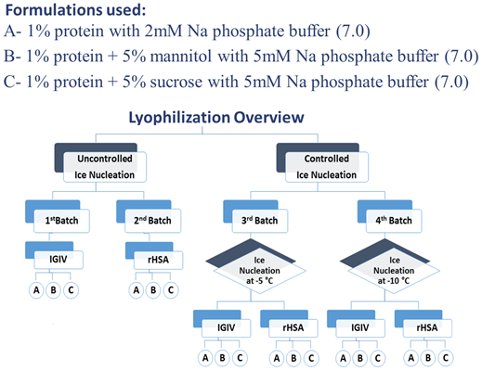
Recent publications
- Pikal MJ, Pande P et. al. (2018) Impact of Natural Variations in Freeze Drying Parameters on Product Temperature History: Application of Quasi Steady State Heat and Mass Transfer and Simple Statistics, Accepted, AAPS PharmSci Tech.
- Fang R, et. al. (2018) Effect of Controlled Ice Nucleation on Stability of Lactate Dehydrogenase During Freeze-Drying. J Pharm Sci. Mar;107(3):824-830.
- Roland, D. (2015, Sep 22). New weapon in push to lower U.S. biotech drug prices; in Europe, uptake of biosimilars has been slowed by safety concerns, low awareness. Wall Street Journal (Online).
- Moorthy BS, Iyer LK, and Topp EM. (2015). Mass spectrometric approaches to study protein structure and interactions in lyophilized powders. Journal of Visualized Experiments (JoVE) (98), e52503.
- Xu Y, et al.. (2014). Protein Quantity on the Air-Solid Interface Determines degradation Rates of Human Growth Hormone in Lyophilized Samples. J. Pharm. Sci., (103), 1356-1366.
- Moorthy BS, Schultz S, Kim S, and Topp EM. (2014). Predicting protein aggregation during storage in lyophilized solids using solid state amide hydrogen/deuterium exchange with mass spectrometric analysis (ssHDX-MS). Molecular Pharmaceutics, 11/6: 1869-1879.

Biography (150 word limit)
Dr. Paritosh Pande did his Postdoctoral fellowship at Prof. Michael J. Pikal’s lab at the Department of Pharmaceutical Sciences at the University of Connecticut and is currently Research Scientist at R&D Center of Excellence of IMA Life North America Inc. He received his Bachelor’s degree in Chemistry with a focus on drugs and dyes, Master’s degree in Biochemistry with a focus on clinical chemistry from University of Mumbai and Ph.D. in Chemistry in 2012 from University of Connecticut. At the product development front, Paritosh is currently utilizing his protein biochemistry expertise to study the effect of formulation and lyophilization process variations on aggregation and chemical degradation of recombinant and therapeutic proteins formulations. As part of R&D team at IMA life, Paritosh also designs and executes the lyo cycle transfer and scale-up studies for customers at the IMA development lab and at manufacturing sites of pharma and biotech companies.

Email: paritosh.pande@imalife.com

Notes/Comments:

