Effect of granulation and tableting process parameters on microbial bio-burden in tablets containing plant based ingredients: A case study

Rohit P. Dugar¹, Tom La¹, Mary A. Murray¹

¹Nutrilite Health Institute, Amway R&D, 5600 Beach Boulevard, Buena Park, CA, USA- 90621.

Abstract

Strict guidelines are enforced by governing bodies of different countries for the APC of dietary and natural products. In the current study, effect of processing parameters on microbial bio-burden is explored. Effect of process parameters of high shear (HS) and fluidized top spray (TS) granulation on microbial bio-burden of tablets containing natural products was studied. Components of formulation were accurately weighed and blended using a V-blender to prepare 6 kg batches each for HS and TS processes. 2⁴ full factorial design was created using Minitab® as shown in Table 1. High shear wet granulation was carried out in a GEA PMA™ using starch slurry in de-ionized water. Wet mass was passed through a co-mill and then dried in a fluidized bed drier until constant LOD values were obtained. Fluidized top spray granulation was carried out in a GEA MP1™. Inlet air temperature and velocity were modified as per Table 1. Post drying, granules were milled at two different speeds and then compressed on a rotary tablet press at two different main compression forces. Aerobic plate count (APC) swabs, loss on drying and water activity were performed before each processing stage through final tableting. Initial dry blend APC was an average 50000 CFU/g. Figure 1 shows a 1.3-fold decrease in APC after the milling step post high shear granulation while a 3.5-fold kill after the drying step in fluidized bed drier. Post tableting, a 47-fold APC decrease was observed for low compression forces while a 50-fold for high forces. High rate of microbial kill during tableting could be attributed to the high shear forces and localized heating while the press is running. This work takes a deep dive into identification and optimization of each processing step involved in tableting in regard to the microbial load of the final formulations.
Table 1
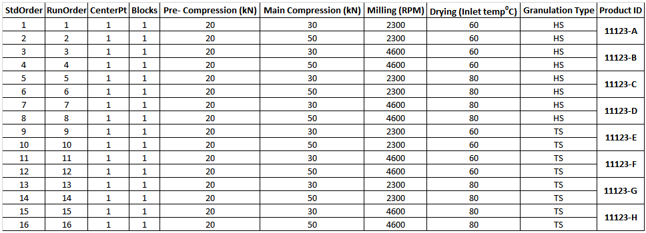

Figure 1

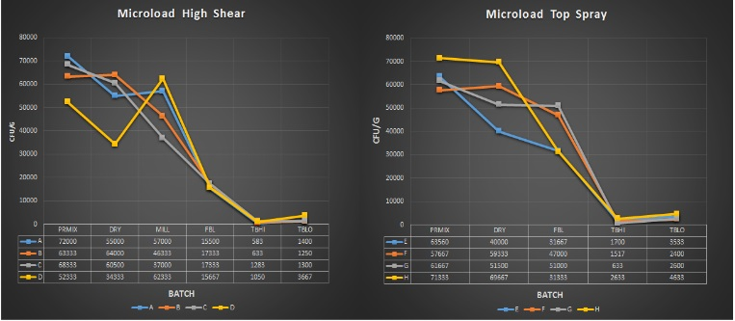

Recent publications
• Smruti P. Chaudhari, Rohit P. Dugar. Application of surfactants in solid dispersion technology for improving solubility of poorly water soluble drugs. Journal of Drug Delivery Science and Technology. https://doi.org/10.1016/j.jddst.2017.06.010.
• Bhavin Y. Gajera, Rohit P. Dugar, Rutesh H. Dave. Formulation development and optimization of Ibuprofen poloxamer melt granules using hydrophilic excipients. British Journal of Pharmaceutical Research. 10.9734/BJPR/2016/29048. ISSN: 2231-2919, Vol.: 13, Issue.: 6. Published: 7th November 2016.
• Rohit P. Dugar, Rutesh H. Dave, Bhavin Y. Gajera. Fusion method for solubility and dissolution rate enhancement of ibuprofen using block copolymer poloxamer 407. AAPS Pharm Sci Tech. 10.1208/s12249-016-0482-6. December 2016, Volume 17, Issue 6, pp 1428–1440. Published: 27th January 2016.
• Rohit P. Dugar, Priyadarshi Gupta, Rutesh H. Dave. Effect of relative humidity on Acetaminophen tablet properties prepared by different techniques using Polyvinylpyrrolidine derivatives as binder. International Journal of Pharmaceutical Sciences and Research. http://dx.doi.org/10.13040/IJPSR.0975-8232.6(11).4629-38. Dugar et al., IJPSR, 2015; Vol. 6(11): 4629-4638. Published on 1st November 2015.
• Rohit P. Dugar, Rutesh H. Dave. To determine the optimum wet granulation end point and study the fundamental rheological and thermal properties of Microcrystalline Cellulose using Hydroxypropyl Methylcellulose as a binder with different solvents. International Journal of Pharmaceutical Sciences and Research. http://dx.doi.org/10.13040/IJPSR.0975-8232.5(9).3616-26. Dugar and Dave, IJPSR, 2014; Vol. 5(9): 3616-3626. Published: 1st September 2014.



Biography
Rohit P. Dugar, Ph.D. is currently working as a formulation scientist at Nutrilite health Institute in the supplement product development group. His current role entails development and optimization of formulas for new supplement products for global and regional launches. His expertise spans in various areas of solid dosage form design including the formulation design and process engineering of several drug delivery systems. Dr. Dugar has extensively worked on tableting sciences and its related parameters during his graduate career. His interests are novel drug delivery systems, bioavailability enhancements of botanicals, stability optimization for natural products and several others. He has published 6 peer reviewed publication in a wide variety of areas related to pharmaceutical dosage from design. He has presented several posters at national conferences throughout USA about his research work.
Email: rohit.dugar@amway.com

