Synthesis and Evaluation of modified polymeric composed of Chitosan and Hyaluronic Acid (HA) for effective treatment of Fingal infections in burn wounds: A proof with in vivo study
Hina Raza, Surriya Manzoor
Corresponding author: Hina Raza, hinaraza@bzu.edu.pk, Bahauddin Zakariya University, Multan Pakistan

ABSTRACT (250-300 words)

The development of fungal infections and slow healing rate, and hypertrophic issues continue to remain major challenges in wound treatment. The present study aimed to fabricate a novel polymeric spongy composite containing nystatin (model drug) & silver (Ag) nanoparticles to enhance burn wound healing.
Different formulations were developed & characterized by using various analytical techniques. Ag Nanoparticles having spherical morphology and size in the range of 2µm shown by SEM and XRD, synthesized by chemical reduction method. A fine porous structure of gel embedded with Ag Nanoparticles was characterized by various analytical techniques. Data were computed by using one-way ANOVA (p>0.05). Cytotoxic analysis on L929 mouse skin fibroblast cells showed a decrease in cell viability as Ag concentration increased (inactivating Fibroblast and keratinocytes) with 10mg as the safest concentration (94%) Optimized formulation (F2) presented in-vitro drug release up to 90.59% ±0.76 at pH 7.4, swelling studies (87.5% ± 0.57), water retention (26.60± 0.34), pH (5.31±0.03) and Fickian drug release mechanism(DD solver). For 21 days animal studies burn wound (2cm) was created in 24 rats divided equally into four groups. The group receiving CHG/Ag/Nystatin healed the wound within 18 days while in other groups healing was delayed. The developed formulation could be used as a carrier for other anti-fungal drugs facilitating the early healing of the wound.
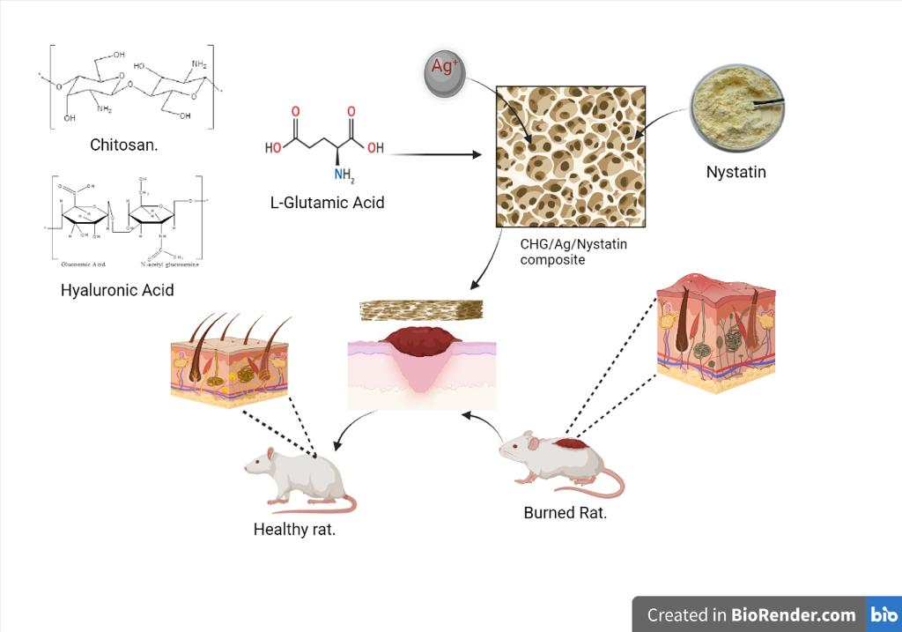

Recent Publications
- Raza, H., Ilahi, Y., Rashid, Z., Nazir, S., Manzoor, S. and Yousif, M.D., 2022. PBPK modelling of ceftriaxone Na-loaded starch-sodium alginate polymeric blend prepared by water-in-oil emulsification for oral delivery. Materials Research Express, 9(11), p.115301.
- NAZİR, S., Hina, R.A.Z.A., NİSAR, M., RASHİD, Z., SHAMİM, R., Bushra, A.L.A.M. and Amjad, K.H.A.N., 2023. Assessment of Anxiety and Burden on caregivers for haemodialysis patients in southern Punjab, Pakistan. Fabad Journal of Pharmaceutical Sciences, 48(1), pp.53-60.
- Hayat, M., Manzoor, S., Raza, H., Khan, M.I., Shanableh, A., Sajid, M., Almutairi, T.M. and Luque, R., 2023. Molecularly imprinted ormosil as a sorbent for targeted dispersive solid phase micro extraction of pyriproxyfen from strawberry samples. Chemosphere, 320, p.137835.
- Khan, M.A., Raza, N., Manzoor, S., Shuja, R., Raza, H., Khan, M.I., Azam, M. and Shanableh, A., 2023. Experimental design by response surface methodology for efficient cefixime uptake from hospital effluents using anion exchange membrane. Chemosphere, 311, p.137103.
- Manzoor S, Garcia JF, Shah KH, Khan MI, Abbas N, Raza H, Mubarik S, Hayat M, Iram A, Yar A, Shanableh A. Multipollutant Abatement through Visible Photocatalytic System. Catalysts. 2023 Jan;13(1):65.
BIOGRAPHY (100-150 words)

Dr. Hina Raza has expertise in the delivery of drugs, mucosal vaccines, pharmacy, pharmacy education, and Nanocarrier fabrication. Currently working as Assistant Professor In the Faculty of Pharmacy, ZU Multan, Pakistan.
I read Pharmacy at the Bahauddin Zakariya University (200-2005; 1st Class with Honours) and registered as a pharmacist after a pre-registration year in industry and hospital. I then gained my P…. degree. I completed a postdoc Fellowship from the school of Pharmacy, UCL, London Uk. Member of Bactivac network, University of Birmingham.


Phone No. 00923057905890:
- Category*: (Oral presentation)
- Linked In https://www.linkedin.com/in/hina-raza-31718b181?lipi=urn%3Ali%3Apage%3Ad_flagship3_profile_view_base_contact_details%3BJixD3IbKTjWkOiJLEn2lFQ%3D%3D
- 00923057905890
- Research Interest*: polymer synthesis, mucosal vaccines development, Target Drug delivery colon cancer

