Exosome as MiRNA Delivery System: The Next Generation Treatment for Cancer
Dr Marco Tomasetti, PhD, UNIVPM, Italy
Dr Federica Monaco, PhD, UNIVPM, Italy
Mr Luca Volpini, MSc, UNIVPM, Italy
Prof Lory Santarelli, MD, PhD, UNIVPM, Italy
Abstract
MiRNA-based therapies have been reported as new approach for treating several diseases including cancer. Although promising, there are several issues to be addressed: in the circulation, naked RNA molecules must avoid enzymatic degradation, renal clearance, and phagocytic entrapment, poor stability, and immunogenicity. Inside the tumour, the RNA molecules must overcome their intrinsic physicochemical properties such as high molecular weight, negative charge, and a high hydrophilicity, permitting them to efficiently cross negatively charged biological membranes and internalize into cancer cells. Finally, even after internalization into cells, few RNA molecules can escape endosomal entrapment, possibly because most extraneous agents are internalized through an endocytic and endo-lysosomal pathway. Exosomes, nanoparticles of endosomal origin, have their endogenous miRNA packaging capacity and have been described as vesicles naturally produced by all cell types, and to be present in most biological fluids. Even though exosomes have potential for disease therapy, some undesirable features prevent their success in clinical applications, including a short half-life, poor targeting property, low concentration at the target site, rapid clearance from the cancer stroma, and inefficient payload. Recently, it was observed exosomes enriched with miR-126 were efficiently internalized by malignant mesothelioma (MM) cells and induced cytotoxicity. However, the miRNA-cargo delivered by exosomes into cancer cells was immediately released by the cell themselves in the tumour micro-environment through exosome themselves. The inhibition of exosome release by an inhibitor of nSMase (GW4869), accumulated the miRNA within the cells in a dose and time enough to induce cell death. The GW4869 combined with exosome-enriched miR-126 induced death in MM cells and inhibited tumour growth by inducing three sequential events; intracellular miRNA accumulation, which in turn induced a protective autophagy that was inhibited by GW4869. This therapeutic approach may overcome the clearance problems, thus allowing the use of low amount of exosomes in a single dose.
Image
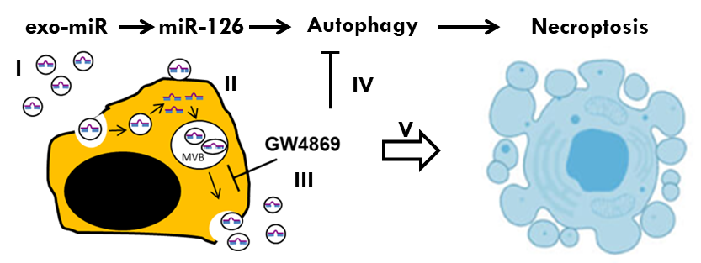
Figure 1: Sequential events of exosome-enriched miR-126 treatment. Exosomes enriched miR-126 were untaken by cancer cells (I). The internalized miR-126 was loaded by the cancer cell into the newly formed exosomes (II) and eliminated by exosomal release (III). Inhibition of exosome release by GW4869 leads to the accumulation of miR-126 within the tumor cell, inducing autophagy. GW4869 inhibits the autophagic survival process (IV) leading to cancer cell death (V).

Recent Publications
- Winkle M, El-Daly SM, Fabbri M. Calin GA (2021) Noncoding RNA therapeutics - challenges and potential solutions. Nat Rev Drug Discov 20:629–651.
- Kulkarni JA, Witzigmann D, Chen S, Cullis PR, van der Meel R (2019) Lipid Nanoparticle Technology for Clinical Translation of siRNA Therapeutics. Acc. Chem. Res 52:2435–2444.
- Khan H, Pan JJ, Li Y, Zhang Z, Yang GY (2021) Native and Bioengineered Exosomes for Ischemic Stroke Therapy. Front Cell Dev Biol 9:619565.
- Kalluri R, LeBleu VS. The biology, function, and biomedical applications of exosomes (2020) Science 367(6478):eaau6977.
- Monaco F, Gaetani S, Alessandrini F, Tagliabracci A, Bracci M, Valentino M, Neuzil J, Amati M, Bovenzi M, Tomasetti M, Santarelli L (2019) Exosomal transfer of miR-126 promotes the anti-tumour response in malignant mesothelioma: Role of miR-126 in cancer-stroma communication. Cancer Lett. 28;463:27-36.
- Monaco F, De Conti L, Vodret S, Zanotta N, Comar M, Manzotti S, Rubini C, Graciotti L, Fulgenzi G, Bovenzi M, Baralle M, Tomasetti M, Santarelli L (2022) Force-feeding malignant mesothelioma stem-cell like with exosome-delivered miR-126 induces tumour cell killing. Transl Oncol 20:101400.



Biography
Dr Marco Tomasetti has his experience in Cancer biology focusing his research on the identification of miRNA involved in cancer development and their use either as promising biomarker for early cancer detection or in therapy. Recently he developed a new therapeutic approach by using exosomes as delivery system for miRNA-based therapy. The Occupational Medicine Laboratory, Department of Clinical and Molecular Sciences to which he belongs has a history in studying malignancies induced by exposure to environmental/occupational carcinogens. The Institution is a referent centre for asbestos-related diseases such as malignant mesothelioma and lung cancer.

