Multiple machine learning, molecular docking, and ADMET screening approach for identification of selective inhibitors of CYP1B1
Mr. Baddipadige Raju, Dr. Om Silakari
M. S. (Pharm.), Molecular Modeling Lab, Department of Pharmaceutical Sciences and Drug Research, Punjabi University, Patiala, Punjab, India

Abstract (300-word limit)
Cytochrome P4501B1 is a ubiquitous family protein that is majorly overexpressed in tumors and is responsible for biotransformation-based inactivation of anti-cancer drugs. This inactivation marks the cause of resistance to chemotherapeutics. In the present study, integrated in-silico approaches were utilized to identify selective CYP1B1 inhibitors. To achieve this objective, we initially developed different machine learning models corresponding to two isoforms of the CYP1 family i. e. CYP1A1 and CYP1B1. Subsequently, small molecule databases including ChemBridge, Maybridge, and natural compound library were screened from the selected models of CYP1B1 and CYP1A1. The obtained CYP1B1 inhibitors were further subjected to molecular docking and ADMET analysis. The selectivity of the obtained hits for CYP1B1 over the other isoforms was also judged with molecular docking analysis. Finally, two hits were found to be the most stable which retained key interactions within the active site of CYP1B1 after the molecular dynamics simulations. Novel compound with CYP-D9 and CYP-14 IDs were found to be the most selective CYP1B1 inhibitors which may address the issue of resistance. Moreover, these compounds can be considered as safe agents for further cell-based and animal model studies.

Image

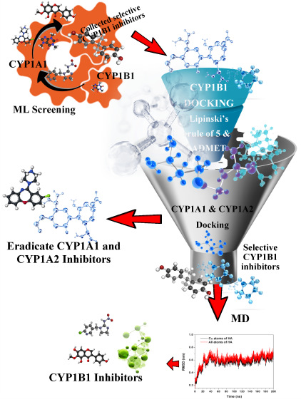

Photograph


Biography (150-word limit)
Baddipadige Raju completed his M. S. (Pharm.) degree in Pharmacoinformatics from the National Institute of Pharmaceutical Sciences and Drug Research (NIPER), Mohali, Punjab, India. He is currently pursuing a Ph.D. in Medicinal Chemistry from the Department of Pharmaceutical Sciences and Drug Research, Punjabi University, Patiala, Punjab, India, under the supervision of Dr. Om Silakari. He is a senior research fellow in the ICMR fellowship project and works, by using in silico techniques, on designing heterocycles for addressing the problem of Drug metabolizing enzymes medicated Anticancer drug resistance.

Email: rajureddy1314@gmail.@gmail.com

Notes/Comments:

