Colon Targeting Drug Delivery System: Standard and Novel Strategies
Shivani Gaikwad, Boston, USA

Abstract

Colorectal cancer is one of the dangerous cancers known worldwide with a high fatality rate. There are many treatment strategies like chemotherapy, radiation therapy but with multiple side effects. Effective treatment can be achieved by directly targeting the colon. Many formulations targeting cancerous cells in the colon are designed and used. Targeted delivery has numerous advantages over conventional ones like site specificity, decrease in the amount and frequency of the dose, thus reducing the adverse effects especially caused by antineoplastic agents. This review aims to summarize primary methods and novel strategies for treating colorectal cancer and diseases related to the colon. Novel methodologies are designed to combat the drawbacks of the existing ones.
Image
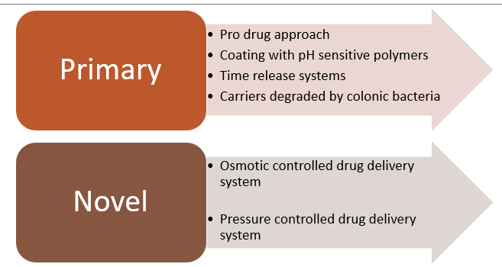
Figure 1: Approaches for Colonic Drug Delivery, Primary and
Novel Techniques.

 Biography
Shivani Gaikwad has her expertise in evaluation and passion in improving the health and wellbeing. She holds a master’s degree in Pharmaceutical Sciences with concentration in Pharmaceutics and Drug Delivery from Northeastern University, Boston, MA Shivani’s research experience primarily involves developing targeted drug delivery systems, for cancerous condition and in the treatment of neurodegenerative diseases. Apart from the research work, she also holds a Presidential position of Hindu Communities at Northeastern University. One of her many hobbies includes learning new languages.

Email: shivanigaikwad97@gmail.com

