Identifying potential small molecule inhibitors for Signal Transduction Activator of Transcription 3 (STAT3) dimerization, for cancer treatment.
Dr ABC, RN PhD, TLI Foundation, USA
Dr ABC, RN PhD, TLI Foundation, USA

Abstract
Cancer is a major health concern in the whole world, being the leading cause of death in both the economically developed and also less economically developed countries alike. The economic and social burden of cancer is predicted to increase in its intensity in the coming years, especially in the less developed countries where about 82% of the world’s population is said to be residing. New, more effective treatments needs to be developed as the traditional treatment options for cancer patients has, for a very long time been limited, either involving surgery, radiation therapy or chemotherapy, which describes the administration of cytotoxic drugs to patients, these routes of treatment are often expensive, cause toxic side effects and not often effective in every patient. Signal transduction activator of transcription 3 (STAT3) belongs to the STAT3 protein family of cytoplasmic transcription factors, STAT3 has caught the attention of many researchers due to its significant role in the development of cancer; the protein is persistently activated in many cancers that ultimately result in factors that aid tumor growth and constitutive STAT3 activation in a variety of human tumors has been demonstrated by several studies. As a result, there have been recently been increased efforts to develop a means to disturb or inhibit STAT3 signaling as a potential therapeutic option in cancer patients. The proposed mechanism (Figure 1) by which STAT3 is involved in cancer begins with its activation at the cell surface which ultimately results in the homodimerization of two STAT3 molecules, these STAT3 dimers translocate to the nucleus where they are involved in the transcription of responsive target genes, which results in tumor formation if this STAT3 activation is not controlled under normal homeostatic conditions. With this in mind, the objective essentially is to identify, using a fluorescence polarization (FP) assay, small molecules that can stop unregulated STAT3 activation during cancer by preventing this dimerization process of STAT3 molecules such that they are unable to enter the nucleus to influence transcription.

Image
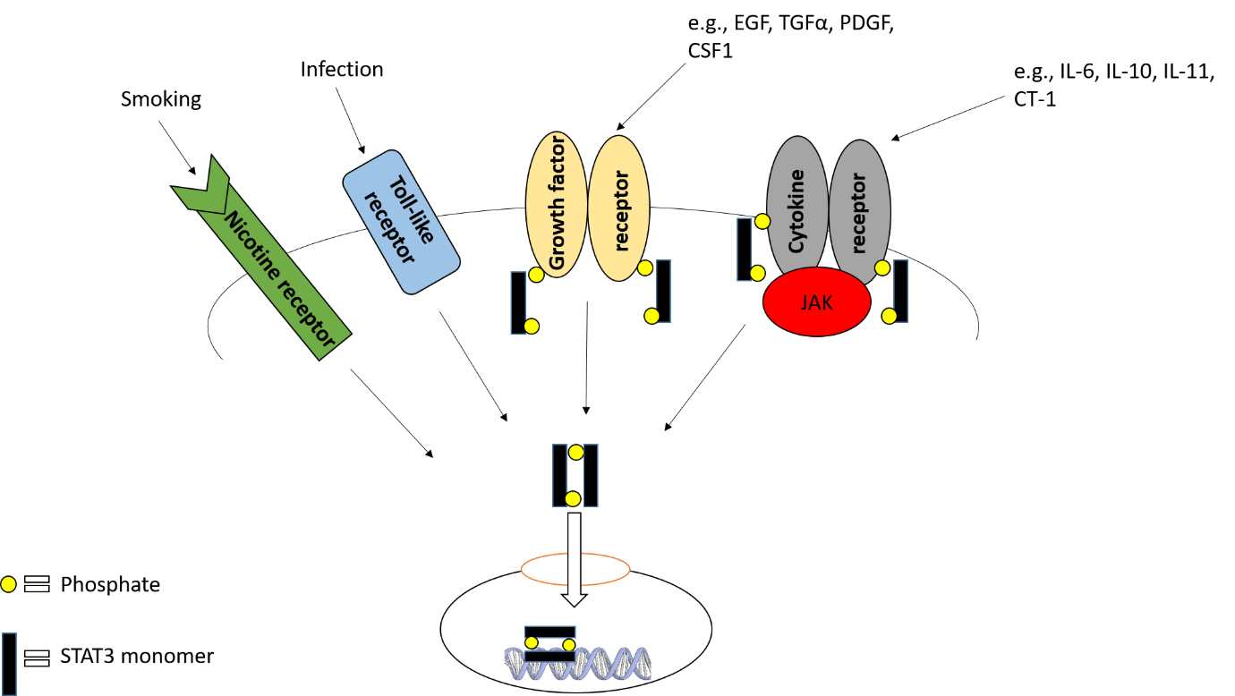
Figure 1: The canonical STAT3 signaling pathway, STAT3 activation can occur through ligand binding to cytokine or growthfactor cell surface receptors. In addition to this, activation can occur through external factors such smoking or infections that affect nicotine and toll-like receptors. After STAT3 molecules are phosphorylated, they homodimerize to form a dimer by interaction of the SH2-domain of one STAT3 monomer with the Y⁷⁰⁵ residue of its partner. These STAT3 dimers finally translocate to the nucleus where they can perform its main function, which involves regulating the transcription of responsive target genes by binding to their promoter regions. The ultimate aim is to hence, identify small molecules that can prevent this STAT3 dimerization process altogether, thus preventing STAT3 from entering the cell nucleus to influence gene transcription.

Recent Publications (minimum 5)

- Sgrignani, J., Garofalo, M., Matkovic, M., Merulla, J., Catapano, C. and Cavalli, A. (2018). Structural Biology of STAT3 and Its Implications for Anticancer Therapies Development. International Journal of Molecular Sciences, 19(6), p.1591.
- Huang, W., Dong, Z., Chen, Y., Wang, F., Wang, C., Peng, H., He, Y., Hangoc, G., Pollok, K., Sandusky, G., Fu, X., Broxmeyer, H., Zhang, Z., Liu, J. and Zhang, J. (2015). Small-molecule inhibitors targeting the DNA-binding domain of STAT3 suppress tumor growth, metastasis and STAT3 target gene expression in vivo. Oncogene, 35(6), pp.783-792.
- Zhao, M., Jiang, B. and Gao, F. (2011). Small Molecule Inhibitors of STAT3 for Cancer Therapy. Current Medicinal Chemistry, 18(26), pp.4012-4018.

- Yue, P. and Turkson, J. (2008). Targeting STAT3 in cancer: how successful are we?. Expert Opinion on Investigational Drugs, 18(1), pp.45-56.
- Al Zaid Siddiquee, K. and Turkson, J. (2008). STAT3 as a target for inducing apoptosis in solid and hematological tumors. Cell Research, 18(2), pp.254-267.

Photograph

Biography
.My name is Muzaffar Latif, I have completed my bachelors in human and medical science, after which I had decided to focus on my interest in the pharmaceutical industry by enrolling in a masters in drug discovery and development. It was during my masters project that I released that by main interest lies within research in drug discovery for anti-cancer medication, my project has taught me many transferable skills and technical lab skills which I am currently trying to bring forward with me in a PHD course relating to cancer research.
Email: muzaffar.latif.17@ucl.ac.uk

Notes/Comments:

