

Comparison of Ki-67 indices between QuPath and manual histopathology review in mouse pituitary
Vinaya Srirangam Nadhamuni¹, Antonia Solomou¹, Anisha Mistry¹, Márta Korbonits¹
¹Department of Endocrinology, William Harvey Research Institute, Bart’s and the London School of Medicine and Dentistry, Queen Mary, University of London, Mile End Rd, Bethnal Green, London E1 4NS

Background and Aims: Ki-67 immunostaining is used in diagnostic evaluation of pituitary tumours to identify aggressive subgroups. Image analysis software (e.g. QuPath¹) can be used to estimate Ki-67. Patients with germline AIP mutations are at increased risk of developing pituitary tumours². We have developed pituitary-specific homozygous and heterozygous Aip knockout mice and compared Ki-67 in mice pituitaries using QuPath and manual review in order to identify significant differences in performance.
Methods: H&E reviewed using Pannoramic Viewer to identify adenomas (if found, Ki-67 estimated in this area). If no adenoma identified, 10 high-power fields (x40) selected and QuPath and histopathologist estimates of total and positive cells recorded. Logarithmic transformation of raw data undertaken (due to positive skew of observations) prior to analysis. Difference between paired estimates evaluated using Wilcoxon signed rank test (p<0.05).
Results: 8 samples were included (seven animals 12 month-old and one 15 month-old at culling; 2 wild-type, 3 heterozygous and 3 homozygous). One sample showed an adenoma. Mean number of positive cells by QuPath: 68.9 (8-131) and histopathologist: 40.5 (6-67). Differences between number of positive cells by QuPath and histopathologist were significantly different (W= 36, p-value=0.007813).
Conclusions: QuPath may overestimate number of positive cells in estimating Ki-67 due to occasional erroneous inclusion of artefact and non-tumour cells (e.g. immune cells) as positive (Figures 1 and 2). Heterogenous staining intensity may also complicate estimation using image analysis software. It is important to bear in mind these potential limitations while taking advantage of such software, especially in a diagnostic setting.
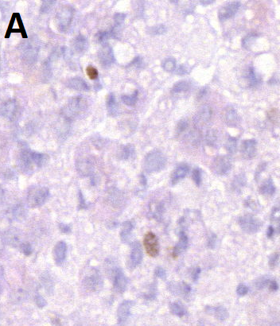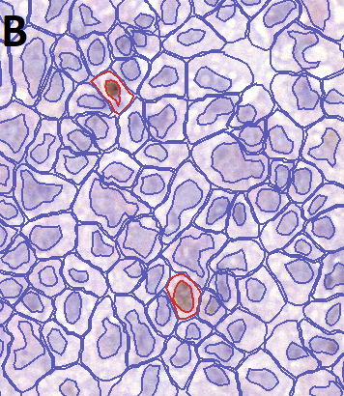
Figure 1: Immune cell (arrowed, 1A) erroneously included as positive tumour cell (figure 1B).

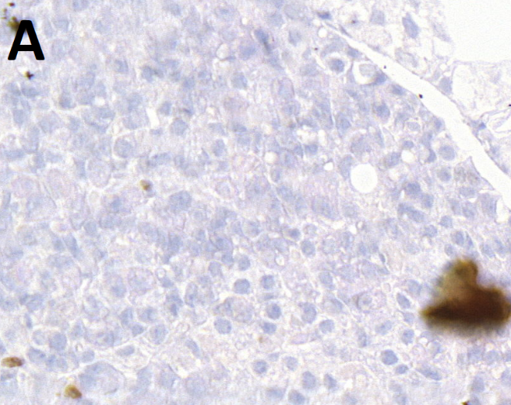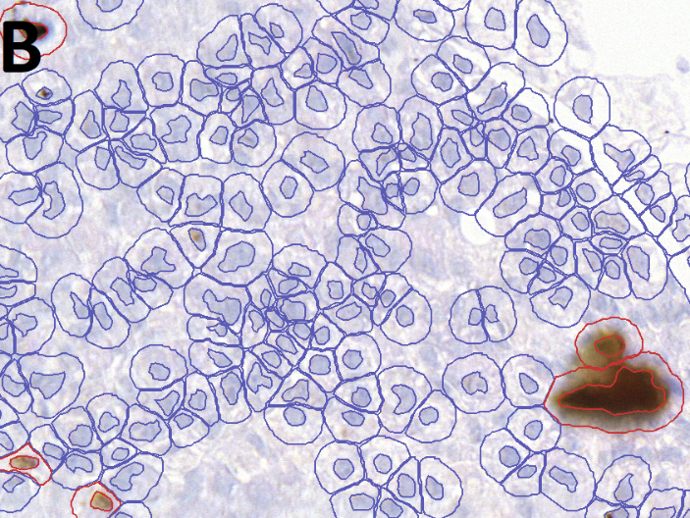
Figure 2: Artefact (arrowed, 2A) erroneously included as positive tumour cell (figure 2B).

Biography

I am an Academic Clinical Fellow (ACF) and ST2 trainee in Histopathology at Queen Mary, University of London (QMUL), UK. I am currently investigating methylation profiles in pituitary adenomas. My career aim is to develop into a Clinical Academic Histopathologist. In order to further this aim, I have been awarded funding by the CRUK City of London Programme for a Clinical Research Training Fellowship at QMUL in Professor Trevor Graham’s laboratory from September 2019 and will combine digital pathology and genomic data analysis (using the 100,000 Genomes project data on colorectal cancer).

Presenting author details
Full name: Vinaya Srirangam Nadhamuni
Contact number: 07846864913
Email id: v.s.nadhamuni@qmul.ac.uk
Category: (Oral presentation/ Poster presentation) Oral preferred (poster also acceptable).
Session name: Track one: Digital Pathology: exploring the scope and application.
Research interest: Genomics, epigenomic regulation (especially methylation), histopathology including digital pathology
References

1 Bankhead, P. et al. QuPath: Open source software for digital pathology image analysis. Sci. Rep. 7, 16878, doi:doi:10.1038/s41598-017-17204-5 (2017).
2 Caimari, F. & Korbonits, M. Novel Genetic Causes of Pituitary Adenomas. Clin. Cancer Res. 22, 5030-5042, doi:10.1158/1078-0432.ccr-16-0452 (2016).

