Ameloblastoma: A Rare Case Report In Female Child
Ajit Singh¹, Ruby Rao², Shivani kalhan³, Pawan Singh⁴, Shilpa Garg⁵
^{1,2}Demonstrator, ³Professor and Head, ⁴Associate Professor, ⁵Assistant Professor
SHKM Govt. Medical College Nalhar Haryana

Introduction
Ameloblastoma is the most common benign odontogenic tumors of the jaws that constitutes about 1% of all cysts and tumors of the jaws.1It is generally a painless, slow growing, locally aggressive tumor causing expansion of the cortical bone, perforation of the lingual or the buccal cortical plate and infiltration of the soft tissues. It has peak incidence in third and fourth decade of life but rare in children age group with equal gender predilection (1:1).2The relative frequency of mandible to maxilla is reported to be varying from 80–20% to 99–1%. In the mandible majority of Ameloblastomasare found in the molar ramus region.³

Case summary
A 14-year-old female child reported with a swelling on the left side of the face since 1yearand pain while chewing food since 4 months. The swelling was insidious in onset and gradually increased to the present size. There was no historyof trauma or toothache or decrease in the size of the swelling or any discharge from the swelling. Thepatient was experiencing pain while chewing hardfood. The patient also had altered sensation over the left cheek region.
Haematological Investigation:- Normal.
Radiological Investigation:-A large well-defined radiolucent expansile lesion in the left body and ramus of the mandible with multilocular appearance causing expansion of ramus of mandible.
Clinical Diagnosis:-?Malignancy ?cystic lesion was made and surgery was performed
Histopathological Examination
Gross Examination:-In department of Pathology, received multiple biopsies from lingual side mucosa,buccal mucosa,bony cavity tissue and tooth bud for histopathological examination.
Microscopic Examination :-The histopathological examination of the biopsy specimen revealed the presence of stratified squamous epithelium over follicles that consist of a core of loosely arranged angular cells resembling the stellate reticulum of an enamel organ. A single layer of tall columnar Ameloblast-like cells had been found surrounding the central core. The plexiform pattern consist of long anastomosing cord or large sheet of odontogenic epithelium covered by ameloblastic cells. The subepithelium tissue show chronic inflammatory cells. No other parts from buccal mucosa, bony cavity tissue and tooth bud show any features of malignancy.
Diagnosis:- Plexiform pattern of Ameloblastoma.

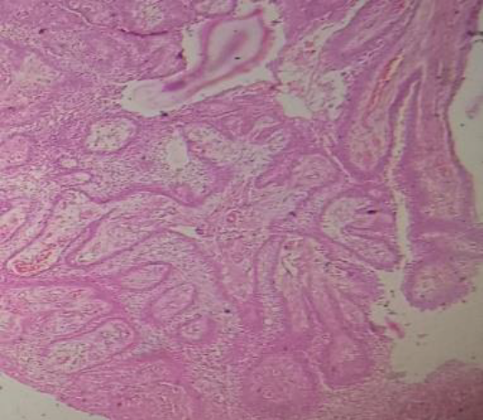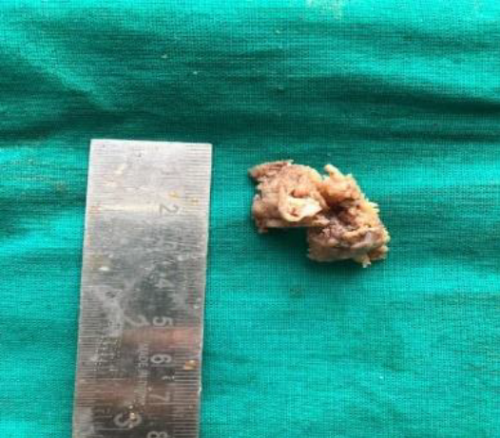
Fig.1 Histopathology shows Plexiform pattern Fig.2 Grey white soft tissue piece

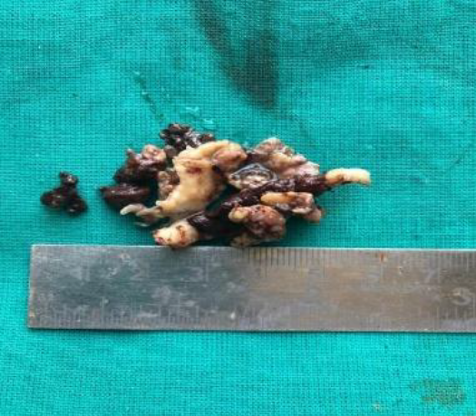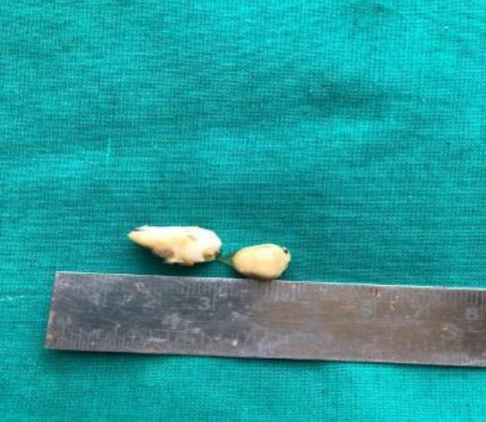
Fig.3Bony cavity tissue Fig.4 Tooth bud
Discussion
Ameloblastoma is the second most common odontogenic neoplasm occurring in the oral cavity after odontoma. In our report the patient is a 14years old female who presented with a large ameloblastoma of the left mandible. According to the study conducted by Reichert PA and Philipsen HP⁴ in mandible the most common site of occurrence is molar and ascending ramus region accounting for 39% .
In 1827 Cusack was the first person to describe this tumor⁵. The name "Admantinoma" was introduced byMallassez in 1885,which nowadays is used to describe a rare type of bone cancer. Churchill coined the term “Ameloblastoma” in1930⁵.According to WHO the tumor is a benign,but locally invasive neoplasm that often has diverse histologic patterns⁶. This group of tumors comprise of various histopathological types and clinical behavior.
Ameloblastoma accounts for about 1% of all the cyst and tumors of the jaw and 18% of the different odontogenic tumors. The mandible has five times higher occurrence of the tumor as compared to the maxilla. The average age ofoccurrence as reported in literature is 38.9 years. Itoccurs with equal frequency in both sexes.

Conclusion
Ameloblastoma is most common benign odontogenic tumor of jaw. It has peak incidence in 3rd and 4th decade but rare in childrens age group with equal gender predilection.

References
1.Kahairi A, Ahmad RL, IslahWan L, etal.Managementoflargemandibularameloblastoma—a case report and literature reviews. Arch OrofacSci 2008;2013:52–5
2.Giraddi GB, BimleshwarSingh C, et al. Ameloblastoma—series of7treated cases—and review of literature. Arch Oral Sci Res 2011;2013:152–5
3.Wood NK, GoazPW. Differential diagnosis of oral and maxillofacial lesions.In:WoodNK, GoazPW, KallalRH, editors. , eds. MultilocularRadiolucencies. 5th edn
Elsevier Publishing, 2007:333–55
4.HertogD, Van der Waal I. Ameloblastoma of the jaws: a critical reappraisal based on a 40-years single institution experience. Oral Oncol 2010;2013:61–4
5.Nakamura N, MitsuyasuT, Higuchi Y, et al. Growth characteristics of ameloblastoma involving the inferior alveolar nerve: a clinical and histopathologic study. Oral Surg Oral Med Oral PatholOral RadiolEndod2001;2013:557–62
6.GumgumS, HogorenB. Clinical and radiologic behaviourofameloblastoma in 4 cases.JCanDent Assoc2005;2013:481–4
7.Becelli R, CarboniA, CerulliG, etal. Mandibularameloblastoma:analysisof surgical treatment carried out in 60 patients between 1977 and 1998. J CraniofacSurg 2002;2013:395–400
8.CankurtaranCeylanZ, ChioseaSimon I, LeonjrBE, et al. Ameloblastoma and dentigerous cyst associated with impacted mandibular 3rd molar teeth. Radiographics2010;2013:1415–

