Protective effects of Oleuropein against Dyslipidemia and Diabetic Retinopathy in Psammomys obesus

Hedya Jemai¹, Awatef Jelassi², Moncef El Feki², Nourhène Boudhrioua¹ & Rafika Ben Chaouacha-Chekir¹
1- Laboratory of Physiopathology, Food and Biomolecules of the Higher Institute of Biotechnology Sidi Thabet, Manouba University, BiotechPole Sidi Thabet, Ariana, Tunisia,
2- Laboratory of Biochemical Analysis, La Rabta University Hospital, Tunis- Tunisia.

Abstract

Oleuropein is the major bio-phenol in Olea europea leaves, with powerful antioxidant activities. We investigate its protective effects against retinal and biochemical alterations in Diabetes. For this purpose, Psammomys obesus was used. Maintained on a high- fat diet, it developed Diabetes with clear metabolic syndrome resulting in retinal functional and structural alterations. Animals were divided into four groups (n=6): Control, Control+ Oleuropein, Diabetic and Diabetic+Oleuropein. Body weight, glycaemia and retinal functions (Electroretinogram, Optical Coherence Tomography and Funduscopic exam) were regulatory controlled during three months. After the sacrifice, immuno-histochemical study was occurred on retinal slides to elucidate any structural abnormalities. Moreover, biochemical components were measured. Our results show a pronounced Dyslipidemia in Diabetic animals which was significantly repaired with Oleuropein. Moreover, immunohistochemical analysis showed an important cell loss in the retina in Diabetic Psammomys obesus. In fact, glutamine synthetase in Müller cells was less intense compared to the control group. Moreover Diabetes downregulated the expression of synaptophysin throughout the plexiform layers and caused a considerable loss of retinal ganglion cells marked by NeuN antibodies. Furthermore, OCT and Eye fundus measurements reveal decreased retinal thickness, and some retinopathy features, including vessel swelling and tortuosity, caliber changes and abnormal new growth of vessels on retinal surface in Diabetic animals compared to the control. The ERG parameters: rod-response, a-wave, b-wave, i-wave, PhNR, 30 Hz flicker, OPs and Scone amplitudes were also affected by Diabetes. Oleuropein show a significant correction in all the measured parameters.

Image

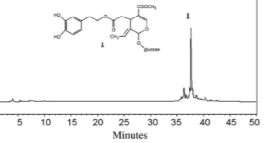
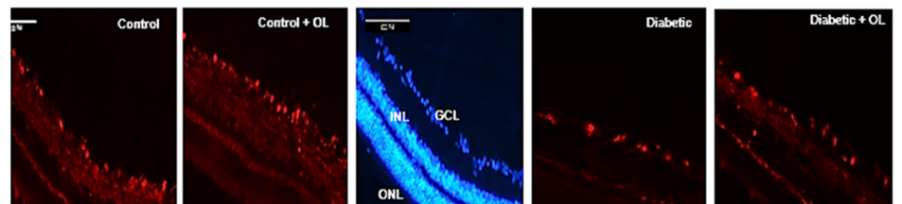
Figure1. Significant protective effects of Oleuropein (1) in the retina
in Diabetic Psammomys obesus
Publications
- Hedya Jemai,Wissal Dhifi, Sihem Mbarek, Souhaieb Chrigui,Imane Hammoum, Basma Baccouche, Ahmed Dellaa, Nourhène Boudhrioua, Awatef Jelassi, Nouha Gammoudi, Moncef Feki, Fatiha Chigr& Rafika Ben Chaouacha-Chekir. Diabetic Retinal and Biochemical Dysfunctions in Psammomys obesus and Protective Effects of Oleuropein. Submitted in Curr Eye Res 2019.
- Jemai Hedya, El Feki A, Sayadi S. Antidiabetic and antioxidant effects of hydroxytyrosol and oleuropein from olive leaves in alloxan-diabetic rats. J Agric Food Chem. 2009, 4, 57
- Dellaa A, Polosa A, Mbarek S, Hammoum I, Messaoud R, Amara S, et al. Characterizing the Retinal Function of Psammomysobesus: A Diurnal Rodent Model to Study Human Retinal Function. Curr Eye Res. 2016:1–9
- Baccouche B, Benlarbi M, Barber AJ, Ben Chaouacha-Chekir R. Short-Term Administration of Astaxanthin Attenuates Retinal Changes in Diet-Induced Diabetic Psammomys obesus. Curr Eye Res. 2018 Sep;43(9):1177-1189.
- Hammoum I, Benlarbi M, Dellaa A, Szabo K, Dekany B, David C, Almasi Z, Rozina I. Hajdu, Azaiz R, Charfeddine R, Lukats A &Rafika Ben Chaouacha-Chekir.Study of retinal neurodegeneration and maculopathy in diabetic Merionesshawi: A particular animal model with human-like macula. J Comp Neurol. 2017;1–25.

Biography
Dr Hedya JEMAI. PhD. In Biological Sciences in Tunisia, Master in Biology and Health. Expertise in Animal Physiology, Antioxidants and Histology. Worked on Diabetes, Retinopathy, Hypercholesterolemia, and Experience in Research and Teaching in Higher Institute of Biotechnology Sidi Thabet, Manouba University (ISBST), Center of Biotechnology of Sfax (CBS) and in Faculty of Medicine of Monastir (FMM).
Email: hedya.jemai@gmail.com

