A Polylysine dendrigraft able to balance acneic and non acneic strains of Cutibacterium acnes to prevent acne and skin imperfections.

Dr Joan Attia, PhD, IFF- Lucas Meyer Cosmetics, Toulouse.
Dr Olivier Lesouhaitier, PhD, Rouen University, Evreux.

Abstract
Acne is one of the most common skin diseases worldwide, affecting up to 85% of the population. At the pathophysiological level, two factors play a crucial role: the sebaceous gland and Cutibacterium acnes (C. acnes). New genomic analysis tools have shown that C. acnes, former P. acnes, a major member of the normal skin microbiota was subdivided into heterogeneous species including acneic bacteria such as RT4, RT5 strains, and commensal bacteria such as the RT6 strain. Moreover, recent data indicated also that the loss of diversity of C. acnes species is associated with acne severity.
Taking all this information, we have developed a green polylysine dendrigaft, the Dendrimer (G2), able to rebalance acneic and non acneic stains of C. acnes to protect skin from inflammation, imperfections and acne. In vitro studies revealed the capacity of the G2 to increase membrane fluidity of acneic strains RT4 and RT5 and decrease their biomass in contrast to the RT6 strain. Moreover, G2 showed also a strong anti-adhesion power of C. acnes on human keratinocytes. Ex vivo studies indicated also an anti-inflammatory effect by decreasing IL1α and TLR2 expressions. These data were confirmed in vivo: the study was conducted during 28 days on hemi-face, with a twice daily application of G2 (2 ppm) or Placebo cream on 23 volunteers. After 28 days, we observed a significant decrease of the sebo-regulating effect by 11%, retentional and inflammatory lesions by 31% and 63%, respectively. Interestingly, G2 application promoted also the diversity of C. acnes by increasing the expression of its no acneic strains compared to its acneic strains. To conclude, we have demonstrated that G2 could be the new skin care ingredient able to balance acneic and non acneic strains of C. acnes to improve skin microbiota and protect skin from inflammation, imperfections and acne.
Image
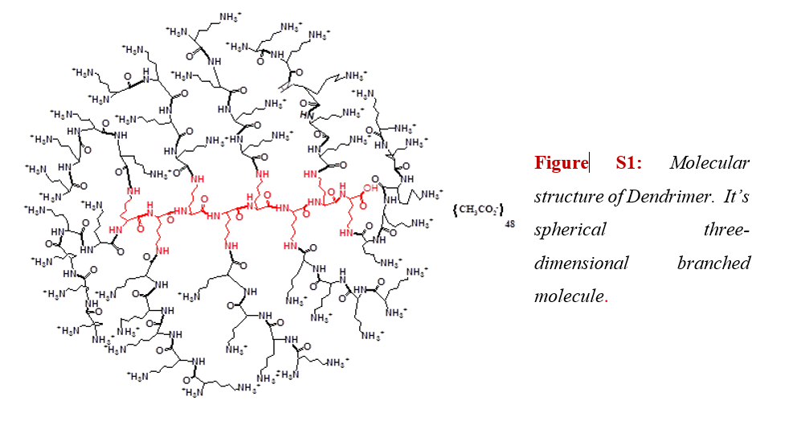
Recent Publications
- Borrel V, Gannesen AV, Barreau M, Gaviard C, Duclairoir-Poc C, Hardouin J, et al. Adaptation of acneic and non acneic strains of Cutibacterium acnes to sebum-like environment. Microbiologyopen 2019a;8(9):e00841.
- Collet H, Souaid E, Cottet H, Deratani A, Boiteau L, Dessalces G, et al. An expeditious multigram-scale synthesis of lysine dendrigraft (DGL) polymers by aqueous N-carboxyanhydride polycondensation. Chemistry 2010;16(7):2309-16.
- Dagnelie MA, Corvec S, Saint-Jean M, Bourdes V, Nguyen JM, Khammari A, et al. Decrease in Diversity of Propionibacterium acnes Phylotypes in Patients with Severe Acne on the Back. Acta Derm Venereol 2018;98(2):262-7.
- Gannesen AV, Zdorovenko EL, Botchkova EA, Hardouin J, Massier S, Kopitsyn DS, et al. Composition of the Biofilm Matrix of Cutibacterium acnes Acneic Strain RT5. Front Microbiol 2019;10:1284.

Biography



PhD on Biomolecules and therapeutic pharmacology and Master’s Degree in Neurosciences, I have more than 13 years experiences in Dermo-cosmetics research.
At IFF-Lucas Meyer Cosmetics since more than 8 years, I am in charge of the research and development for the cosmetics ingredients (active and functional ingredients and delivery systems) for the cosmetics market.
Email: Joan.attia@lucasmeyercosmetics.com

Notes/Comment

