Five follow-up of patients with high-risk area basal cell carcinoma treated with interferon

Vladimir Sánchez Linares. Assistant Professor at Medical Science University. Sancti Spíritus, Cuba

Abstract
Background: Surgery is the treatment of choice for patients with basal cell carcinoma (BCC). When surgery is not a choice, only radiotherapy is recommended for patients with high-risk area BCC. Interferons could be an acceptable therapeutic option for these patients. Objective: To evaluate the long-term clinical response to interferon therapy in patients with high-risk area BCC. Methods: Patients with high-risk area BCC were treated with perilesional injections of alpha-2b+gamma interferons. Those with incomplete clinical response were reevaluated, and their residual tumors were surgically excised and declared cured. Patients treated with interferons alone and those treated with interferon plus surgery were followed-up for five years. Time to event for recurrence were estimated by Kaplan-Meier survival analysis. Results: After 16 weeks, 143 (73, 3%) patients showed a complete response (95% CI 67,2%-80,1%). Patients developed a recurrence with a mean of 55 months (95% CI 53,8-57,4). The estimated rate of been recurrence free at five years was 87.7% (95% CI 82,9-92,4). Fifteen (7,7%) patients abandoned the study during the follow-up period. Adverse events were frequent but moderate or mild, been fever and local pain the most frequent ones. Conclusions: Perilesional injections of alpha-2b+gamma interferons to patients with high-risk area BCC, offer a satisfactory cure rate after a five years follow-up with an acceptable safety profile.
Keywords: basal cell carcinoma, high-risk area, interferon, skin cancer no melanoma
.

Image

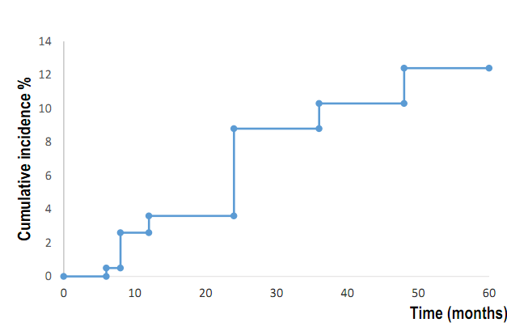

Figure 1. Survival analysis for the development of local recurrence

Recent Publications
- Sánchez Linares V, Bello Rivero I. HeberFERON y calidad de vida en el carcinoma basocelular facial. Gac méd espirit. 2022; 24(1). Available from https://revgmespirituana.sld.cu/index.php/gme/article/view/2389/pdf
- Sánchez Linares V, Ríos Rodríguez ME, Román Simón M, Pérez García CD, Díaz Hernández Y, Bello-Rivero I. HeberFERON en el carcinoma basocelular periocular. Serie de casos. Gac méd espirit. 2021; 23(1). Available from: https://revgmespirituana.sld.cu/index.php/gme/article/view/2248/pdf
- Sánchez Linares V, Martínez Fando B, Hernández González T, González Pérez A, Bello Rivero I. Tratamiento de carcinoma basocelular en la nariz con una combinación de interferones Alpha-2b y Gamma. Rev haban cienc méd. 2022; 21(5):e4723. Available from: https://revhabanera.sld.cu/index.php/rhab/article/view/4723/3218
- Sánchez Linares V, Brito García E, Bello Rivero I. Remote effect of interferons in basal cell carcinoma. J Dermat Cosmetol 2022; 6(4):105-6. Available from: https://medcraveonline.com/JDC/JDC-06-00220.pdf
- Sánchez Linares V, Brito García E, Martínez Fando B, Álvarez Gómez Y, Bello Rivero I. HeberFERON en el tratamiento de pacientes con carcinoma basocelular de la oreja. Gac méd espirit 2023; 25(2). Available from: https://revgmespirituana.sld.cu/index.php/gme/article/view/2530/pdf
- Sánchez Linares V, Tamayo Pérez O, Brito Garcia E, Bello Rivero I, Rondón Madrigal E. HeberFERON en el tratamiento del carcinoma basoescamoso. Rev cuba med 2023; 62(3) Available from: https://revmedicina.sld.cu/index.php/med/article/view/3178/2445

Biography
Vladimir Sánchez Linares this to complete your PHD to the 46 years in September at the University Medical Sciences of Sancti Spíritus Cuba. He is the head of the skin cancer program and postgraduate professor of dermatology too, is a teacher and assistant investigator. He as 30 publications. He is reviewer for the journal Gaceta Médica Espirituana in Sancti Spíritus Cuba
Email: vladisanchezl76@gmail.com
Presenting author details
Full name: Vladimir Sánchez Linares
Contact number: +5354338848
Category: (E-Poster presentation)

