Building knowledge about laser hair removal through new in-silico studies
Dr Gregorio Viera-Mármol, Physics PhD, Sinclair, Spain

Abstract (300 word limit)

The efficacy and safety of conventional laser hair removal technology is fundamentally based on clinical case studies. However, the internal temperature of hair during treatment and thus the efficacy of the laser pulse cannot be measured or evaluated. Also, the level of heat that reaches the surrounding skin tissue is just estimated in order to prevent burning. In this sense, any method that enables the measurement of the temperature that reaches the hair and skin during a laser pulse is a potential tool to improve laser hair removal technique and to increase the safety of laser technology.
Here we develop new numerical multiphysics simulation software to simulate the hair removal process using COMSOL Multiphysics® software. We create 3D models of dermal tissue that include the epidermis, dermis and hair follicle structure. Subsequently, laser pulses of 755 nm, 810 nm and 1064 nm with different power and pulse characteristics have been simulated. Through a process of numerical calculation, we simulated the heating of skin and hair follicles with various characteristics and determined the temperature and thermal damage in order to anticipate the efficacy and safety of laser hair removal. We show that the best results are obtained with shorter pulse durations and, therefore, with the highest laser power. Moreover, we demonstrate that longer wavelengths provide better efficacy and safety for dark skin. The model developed in this study can be used to gain a better understanding of the laser hair removal process, to conduct clinical studies, develop better and safer devices, and to assist clinicians in the selection of parameters for achieving optimal and safe results during hair removal.

Image
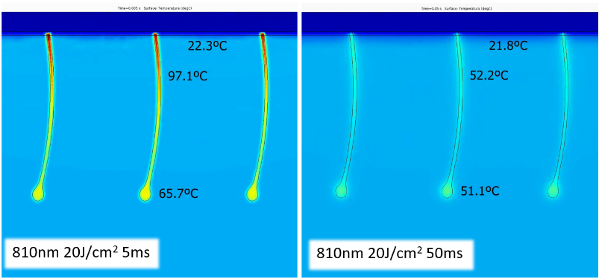Figure 1: Illustrative example of the heating of the hair structure after 5 ms and 50 ms laser pulses respectively.

Recent Publications (minimum 5)
- Vignoli, F, Mármol, GV. Cryolipolysis for fat reduction using Cooltech® Define technology: A large-sample retrospective clinical study. J Cosmet Dermatol. 2023; 00: 1-10. doi:10.1111/jocd.15981
- Pall, A. and Viera-Mármol, G. (2022) Triple Wavelength and 810 nm Diode Lasers for Hair Removal: A Clinical and in Silico Comparative Study on Indian Skin. Journal of Cosmetics, Dermatological Sciences and Applications, 12, 164-173. doi: 10.4236/jcdsa.2022.124014
- Gold, MH, Biron, J, Wilson, A, et al. Safety and efficacy for hair removal in dark skin types III and IV with a high-powered, combined wavelength (810, 940 and 1060 nm) diode laser: A single-site pilot study. J Cosmet Dermatol. 2022; 21: 1979–1985. doi:10.1111/jocd.14926
- Fajardo-Urdiales C, Rodríguez-Casimiro AB, Villena J, Pérez MLl, Vicente Solà JS, Viera-Mármol G (2019) Comparative Clinical Study and Thermal Modelling of Photoepilation of Thin Hair by Primelase Excellence 810nm and Blend and Soprano XL 810nm. International Research Journal of Pharmacy and Medical Sciences. 2019;3(1):15-24.
- Buendía-Bordera G., Gaviria-Parada J, Martí-Giménez M, Pérez MLl, Oliva-Morel J., Viera-Mármol G. (2019). Use of high-power Diode Laser at 1060nm for the treatment of vascular lesions. Journal of Vascular Surgery, 2019; 5(4); 415-418. https://doi.org/10.1016/j.jvscit.2019.06.015
Photograph

 Biography (150 word limit)
Professional with 22 years of experience in laser and optics for different medical, scientific, industrial and defense applications. Doctorate in applied physics and optics in 2000 honoured with an Extraordinary Award and specialized in advanced materials and techniques of synthesis and characterization of materials. Director of research and general manager of leading company in the manufacture of laser devices. Currently CTO and Scientific&Clinical Director of Sinclair. Creator of the technology of ultra-high power diode laser of Primelase and of mathematical methods to simulate the heating and cooling processes of living tissues using laser, RF, ultrasound and cold based techniques. More than 50 publications in scientific journals in addition to several patents published on new materials.

Email: gregorioviera@sinclair.com

Notes/Comments:

