Physiological changes of normal facial skin and moderate acne skin caused by long-term exposure to acidic environment

Guihua Lin*, Yanzhu Jiang, Shan Du, Rong Xiao

Affiliations
AMOREPACIFIC (SHANGHAI) D&I CENTER CO.,LTD. PR China
* Corresponding author

Abstract

With the transformation of the high-efficacy era, whether it is for anti-acne or exfoliating, Chinese consumers of different skin types have an increasing demand for acidic care. At present, there are relevant efficacy studies on products with high content of acidic ingredients, but there are very few researches on dosage forms with content limited by Chinese regulations (the total content of alpha-hydroxy acids and their salts and esters shall not exceed 6%). To study the effects of long-term exposure to an acidic environment (5% gluconolactone) on the skin barrier, absorption of follow-up products and skin type. 43 women were enrolled in the study, 22 with normal skin and 21 with moderate acne. TEWL, hydration, sebum, redness, keratin, blackheads, pores, ceramides, cholesterol and fatty acids were measured on week 0 and week 4. Niacinamide absorption was analysed on week 0 and week 4 to evaluate the effect of acidic care on the absorption of subsequent products. Intercellular lipids CER[NP], CER[NS], CER[NP/NS], cholesterol, fatty acids, skin barrier related parameters TEWL and hydration were significantly increased, sebum were significantly decreased in the normal and moderate acne skin. Skin redness and niacinamide absorption were improved in moderate acne skin. Low-concentration acidic care enhance skin barrier and absorption by changing the intercellular lipids without negatively affecting skin. Gentle acidic care can build healthy skin and suitable for daily use in both normal and acne skin.

Image

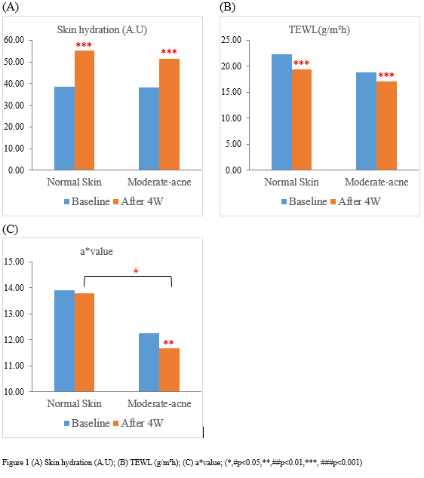

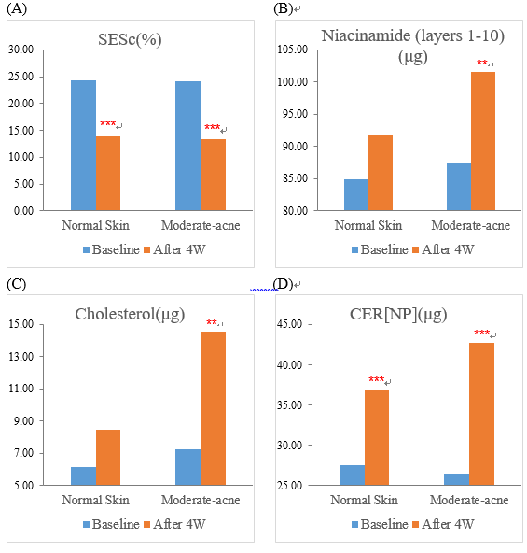

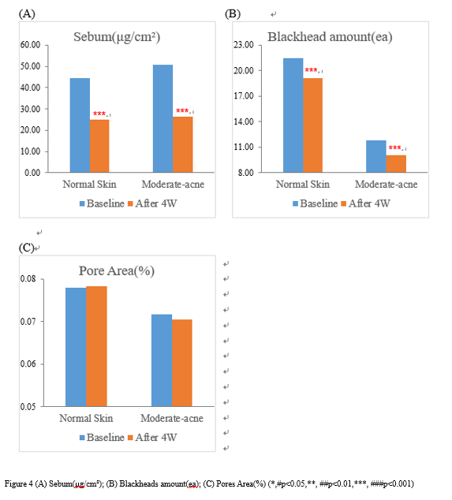
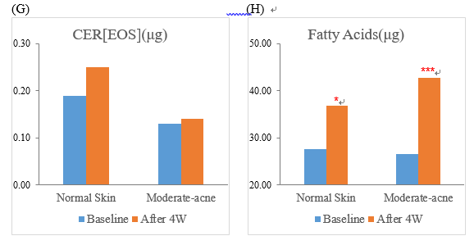

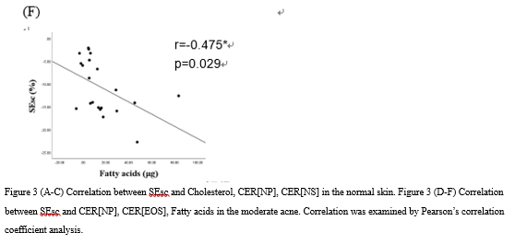
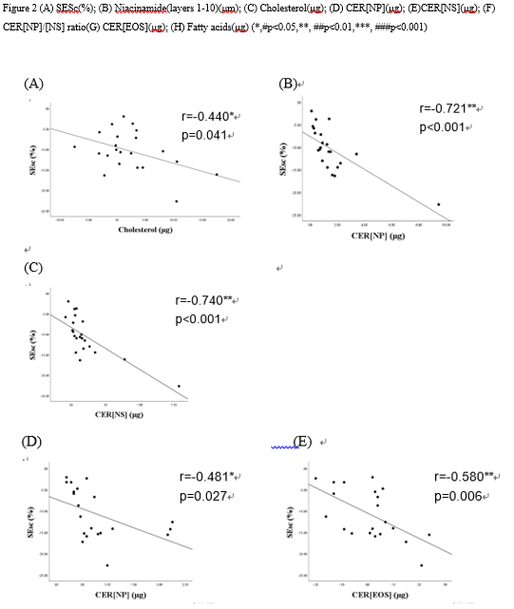

References

- Van Scott EJ, Yu RJ. Control of Keratinization with α-Hydroxy acids and related compounds. I. Topical treatment of ichethyotic disorders. Arch Dermatol. 1974 Oct;110(4):586-590.
- Hachem J-P, Roelandt T, Schürer N, et al. Acute acidification of stratum corneum membrane domains using polyhydroxyl acids improves lipid processing and inhibits degradation of corneodesmosomes. J Invest Dermatol. 2010 Feb;130(2): 500–510.
- Hunt M J, Barnetson R S. A comparative study of gluconolactone versus benzoyl peroxide in the treatment of acne. Aust J Dermatol. 1992;33(3):131-134.
- Knox S, M.O’Boyle N. Skin lipids in health and disease: A review. Chem and Phys Lipids. 2021;236:105055.
- Yokose U, Ishikawa J, Morokuma Y, et al. The ceramide [NP]/[NS] ratio in the stratum corneum is a potential marker for skin properties and epidermal differentiation. BMC Dermatol. 2020 Aug 31;20(1):6.
- Coderch L, Lopez O, Maza A D L,et al. Ceramides and skin function. Am J Clin Dermatol. 2003;4(2):107-129.

- Franklin K. Akomeah, Gary P. Martin, Andy G. Muddle, Marc B. Brown. Effect of abrasion induced by a rotating brush on the skin permeation of solutes with varying physicochemical properties. Eur J Pharm Biopharm. 2008 Mar;68(3):724-734.
- Samantha N. Andrews, Eunhye Jeong, Mark R. Prausnitz. Transdermal delivery of molecules is limited by full epidermis, not just stratum corneum. Pharm Res. 2013 Apr; 30(4):1099-1109.
- H. Trommer, R. H. H. Neubert. Overcoming the stratum corneum: the modulation of skin penetration. Skin pharmacol physiol. 2006; 19(2): 106-621.
- Jarzabek-Perz S, Mucha P, Rotsztejn H. Corneometric evaluation of skin moisture after application of 10% and 30% gluconolactone. Skin Res Technol. 2021 Sep;27(5):925-930.
- Berardesca E, Distante F, Vignoli GP, et al. Alpha hydroxyacids modulate stratum corneum barrier function. Br J Dermatol. 1997;137: 934-938.
- Mayrovitz HN. Transepidermal water loss and stratum corneum hydration in forearm versus hand palm. Skin ResTechnol. 2023 Mar;29(3):e13218.
- A.V. Rawlings, I.R. Scott, C.R. Harding, P.A. Bowser Stratum corneum moisturization at the molecular level. J Invest Dermatol. 1994 Nov;103(5):731-741.
- Danso M, Boiten W, Drongelen V, et al. Altered expression of epidermal lipid bio-synthesis enzymes in atopic dermatitis skin is accompanied by changes in stratum corneum lipid composition. Journal of dermatological Science. J Dermatol Sci. 2017 Oct;88(1):57-66.
- Lee JY, Jeon SH, Han SS et al. Positive Correlation of Triacylglycerols with Increased Chain Length and Unsaturation with ω-O-Acylceramide and Ceramide-NP as Well as Acidic pH in the Skin Surface of Healthy Korean Adults. Metabolites. 2022 Dec 24;13(1):31.
- Nakamura T, Yoshida H, Haneoka M, et al. Season- and facial site-specific skin changes due to long-term mask wearing during the COVID-19 pandemic. Skin Res Technol. 2022 Sep;28(5):749-758.
- Smeden JV, Janssens M, Kaye E.C.J, et al. The importance of free fatty acid chain length for the skin barrier function in atopic eczema patients. Exp Dermatol. 2014 Jan;23(1):45-52.
- Smeden JV, Janssens M, Gooris G.S, et al. The important role of stratum corneum lipids for the cutaneous barrier function. Biochim Biophys Acta. 2014 Mar;1841(3):295-313.
- Mathur V, Satrawala Y, Rajput MS. Physical and chemical penetration enhancers in transdermal drug delivery system. Asian J Pharm. 2010,4(3):173-183.
- Sochorová M, Audrlická P, Červená M. Permeability and microstructure of cholesterol-depleted skin lipid membranes and human stratum corneum. J Colloid Interface Sci. 2019 Feb 1;535:227-238.

Biography
Lin Guihua has completed master from Chungbuk national university and published graduation thethis in journal of alzheimer’s disease (IF 4.1). Lin Guihua is Amorepacific’s cosmetics clinical efficacy senior researcher.

Presenter Name:Lin Guihua
Type of Presentation: Poster

Email: guihualin@naver.com

Photograph



Notes/Comments:

