“Cutaneous Mastocytosis, an Unusual Presentation: A Case Study"
Dr. Hetav Pandya (Resident – DDV – Wcare Hospital, Pune)
Dr. K B Pandya (M.D. – Skin & V.D. – The Rejuvene Clinic, Rajkot)

BACKGROUND
Cutaneous Mastocytosis is a rare skin disorder, characterized by an accumulation of mast cells in the skin. It is a complex disorder that can present in a variety of ways and can vary in severity. The exact cause of the disorder is unknown, but it is believed to be an inherited disorder.
OBSERVATION
The patient in this case study was a 7-month-old male infant who presented with a 5-month history of pruritic skin lesions. On physical examination, Erythema with Numerous reddish‐brown monomorphic maculo-papules, plaques and nodules were present. There were vesicles & Bullae also present not following any particular pattern. Darier’s sign was elicited revealing a strong positive result. Skin biopsy confirmed the diagnosis of cutaneous mastocytosis. The patient was started on medications (Levocetirizine, Montelukast, Ranitidine and a Mild Topical Steroid with Antibiotic), with the symptoms improving after 2 weeks. The patient is still under home care and observations.
KEY MESSAGE
Multiple Clinical presentation is rarely seen in a single patient, i.e., To have the symptoms of Urticaria Pigmentosa + Nodular Mastocytosis with bullae.
About Dr:
Dr. Hetav Pandya is a resident of Dermatology & Venerology, studying from Pune Wagholi. He obtained his bachelor’s degree from Sumandeep Vidyapeeth University, Baroda, India; and is currently pursuing a specialization in the field. He has a keen interest in the diagnosis and management of skin diseases and has conducted research in the field of dermatology and other related topics. He is an active member of the Indian Association of Dermatologists, Venereologist & Leprosy, IDS and is involved in various state levels & national dermatology conferences.
Email: hetav11@gmail.com
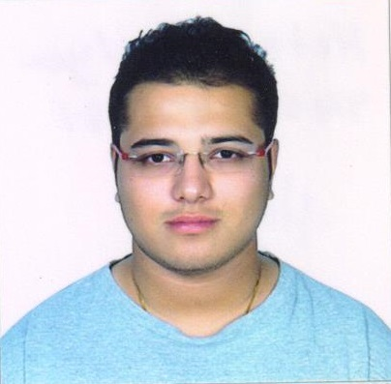
About Guide:
Dr. K B Pandya is a senior Consultant Dermatologist & Cosmetologist with well over 35 years of experience and has been Attending various National and International Conferences and Presented research papers. He has a one-of-a-kind centre based in Rajkot, India and has been a member of EADV, IDS, IADVL, AAD, WCD and many more.

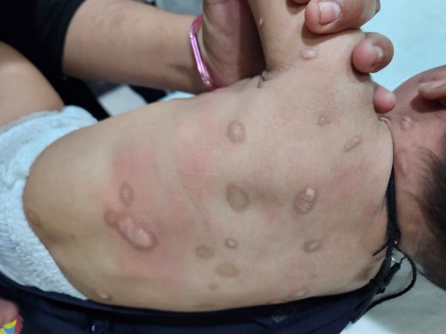
This case study highlights the importance of recognizing the signs and symptoms of cutaneous mastocytosis in infants. Early diagnosis and treatment are essential for reducing the symptoms and improving the patient’s quality of life. Furthermore, the articles also discuss the diagnosis of MIS: ‘Mastocytosis In Skin’; a type of provisional diagnosis, which can be beneficial in treating infants as Bone Marrow examination is usually avoided. Additionally, further research is needed to understand the underlying cause of the disorder and to develop more effective treatments as there is no permanent cure to Mastocytosis.

