The role of antioxidants in skin care
Dr. Olumayowa Abimbola Oninla, MBChB, FMCP.
Obafemi Awolowo University, Ile-Ife, Osun State, Nigeria

Abstract
Statement of the Problem: Free radicals (FRs) are highly reactive atoms or molecules with unpaired electron(s) in their external shell constantly produced by the body and essential for health. Excess production and/or reduction in antioxidants level can cause serious harm quickly by producing oxidative stress which affects all body organs most especially the skin. There are intrinsic and extrinsic causes of FR generation. These molecules are potential cause of biological damage to DNA, direct damage to molecules such as lipids and amino acids as well as keratinocyte apoptosis by activation of several intracellular signaling pathways, including caspase 3, cytochrome C, and activation of MAPKs (mitogen-activated protein kinases). FRs are responsible for skin aging (both intrinsic and extrinsic/premature aging), sunburns and hyperpigmentation, impaired wound healing, dark skin tones and increased risk of skin cancers. Antioxidants prevents and reverses these effects. They prevent oxidative stress to the body tissues by neutralizing toxic oxygen molecules released as free radicals. The nature of AOs in the body are either as antioxidant enzymes (catalyse reactions involved in conversion of FRs to oxygen and water), chain breaking AOs (prevent propagation of oxidative chain reactions) and preventive antioxidants (metal binding proteins whose functions are to sequester free iron or copper to prevent production of the hydroxyl radical from other FRs). Naturally occurring AOs are present in the skin, ingested in diets and can be topically applied in skin products. Synthetc AOs such as resveratrol analogs available in as cosmeceuticals. Incorporating antioxidants into routine skin care and treatment regimens for skin conditions is paramount to skin health.

Image

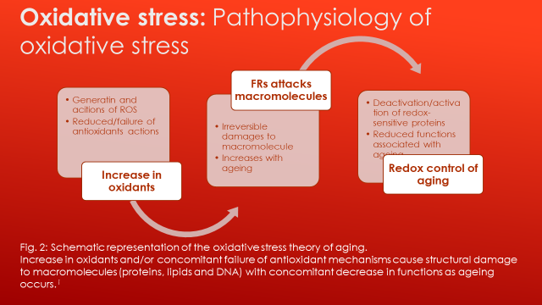

Recent Publications
1. Oninla, O.A., Akinkugbe, A.O., Otike-Odibi, B.I., Oripelaye, M.M., & Olanrewaju, F.O. (2021). Atopic Dermatitis in Adults: Epidemiology, Risk Factors, Pathogenesis, Clinical Features, and Management. In (Ed.), Atopic Dermatitis - Essential Issues. IntechOpen. https://doi.org/10.5772/intechopen.97287
2. Awopeju OF, Oninla OA, Odeyemi AO, Adebowale AA, Awoniyi FO, Zifodya JS, et al. (2020) Gender-Specific Association of Body Fat Composition with Risk of Obstructive Sleep Apnea among People Living With HIV/AIDS: A Cross-Sectional Study. Journal of Sleep Disorders and Therapy; 9:324. DOI: 10.35248/2167-0277.20.9.324
3. Awopeju, O.F., Oninla, O.A., Olowookere, S.A., Ogunnaike-quaye, M., Erhabor, G.E. (2020). Sleep quality, purpose in life, and health related quality of life among people living with HIV in Nigeria. Journal of HIV/AIDS & Social Services; 21(3):1-17. DOI:10.1080/15381501.2022.2038759
4. Umar, A., Oripelaye, M.M., Olanrewaju, F.O., Onayemi, O., Olasode, O.A., Oninla, O.A. (2020). Determinants of discordant immune response in a cohort of human immunodeficiency virus-infected patients initiating antiretroviral therapy. Sahel Medical Journal [serial online]; 23:22-8. Available from: https://www.smjonline.org/text.asp?2020/23/1/22/280935
5. Oninla, O., Oninla, S., Otike-Odibi, B., Oripelaye, M., Olanrewaju, F., & Mohammed, T. (2019). African Skin: Different Types, Needs and Diseases. International Journal of TROPICAL DISEASE & Health, 36(3), 1-13. https://doi.org/10.9734/ijtdh/2019/v36i330143

Photograph

 Biography
Dr. Olumayowa Abimbola Oninla is a Senior Lecturer at Department of Dermatology and Venereology, Obafemi Awolowo University, and Consultant Dermatologist and Venereologist, OAU Teaching Hospitals' Complex, Ile-Ife, Osun State, Nigeria. She is a Fellow of National Postgraduate Medical College of Nigeria, International Fellow of the American College of Physicians, and trainer of residents in National Postgraduate Medical College of Nigeria and West African College of Physicians. Dr. Oninla is a member of various national and international societies including National Association of Dermatologists (Nigeria), African Society of Dermatology and Venereology, International League of Dermatological Societies, European Association of Dermatology and Venereology, International Society of Pediatric Dermatology, International Dermoscopy Society, and International Psoriasis Council. She has published more than 30 research articles with four book chapters with focus on skin infections, age and gender related dermatoses, adult HIV medicine, and currently, dermoscopy study of skin diseases in the dark-skinned.

Email: mayooni@yahoo.com

Notes/Comments:
Images can be edited.

