Differential diagnosis of annular urticarial lesions
Dr Sinem Ornek, MD, Health Sciences University Diskapi Yildirim Beyazit Training and Research Hospital, Turkey

Abstract

Annular urticarial lesions are routinely encountered conditions in daily dermatology practice and they are usually associated with acute and chronic urticaria. When they are short-lived, migratory, transient and pruritic, and healing with no residual skin marks, the diagnosis of urticaria can be made clearly and easily. Nonetheless, annular urticarial lesions can be the presenting signs of various cutaneous and systemic diseases (Figure 1). The clinicians should be aware of these conditions in order to avoid misdiagnosing them as ordinary urticaria. A careful evaluation of individual lesion characteristics and of associated systemic findings help the clinicians excluding many differential diagnoses and making the exact diagnosis. There are many clues that clinicians can use when making these evaluations. The distribution and morphology of the lesions, the duration of an individual lesion, any postinflammatory pigmentation or purpura after disappearance of the lesions, lesion-related symptoms like pruritus, burning and/or pain sensations, and associated systemic findings such as arthralgia, fever, myalgia, fatigue hypotension, wheezing, dyspnea, laryngeal edema are some aspects to be taken into consideration while assessing a patient with an annular urticarial eruption. In this presentation, the differential diagnoses which may manifest as annular urticarial lesions are discussed under the categories of skin diseases and systemic diseases by emphasizing the major clinical features, distinctive laboratory features, diagnostic tests and management strategies. In addition, the questions that should be asked in patients presenting with annular urticarial lesions are addressed, and a simplified algorithm is presented for the differential diagnosis.
Image
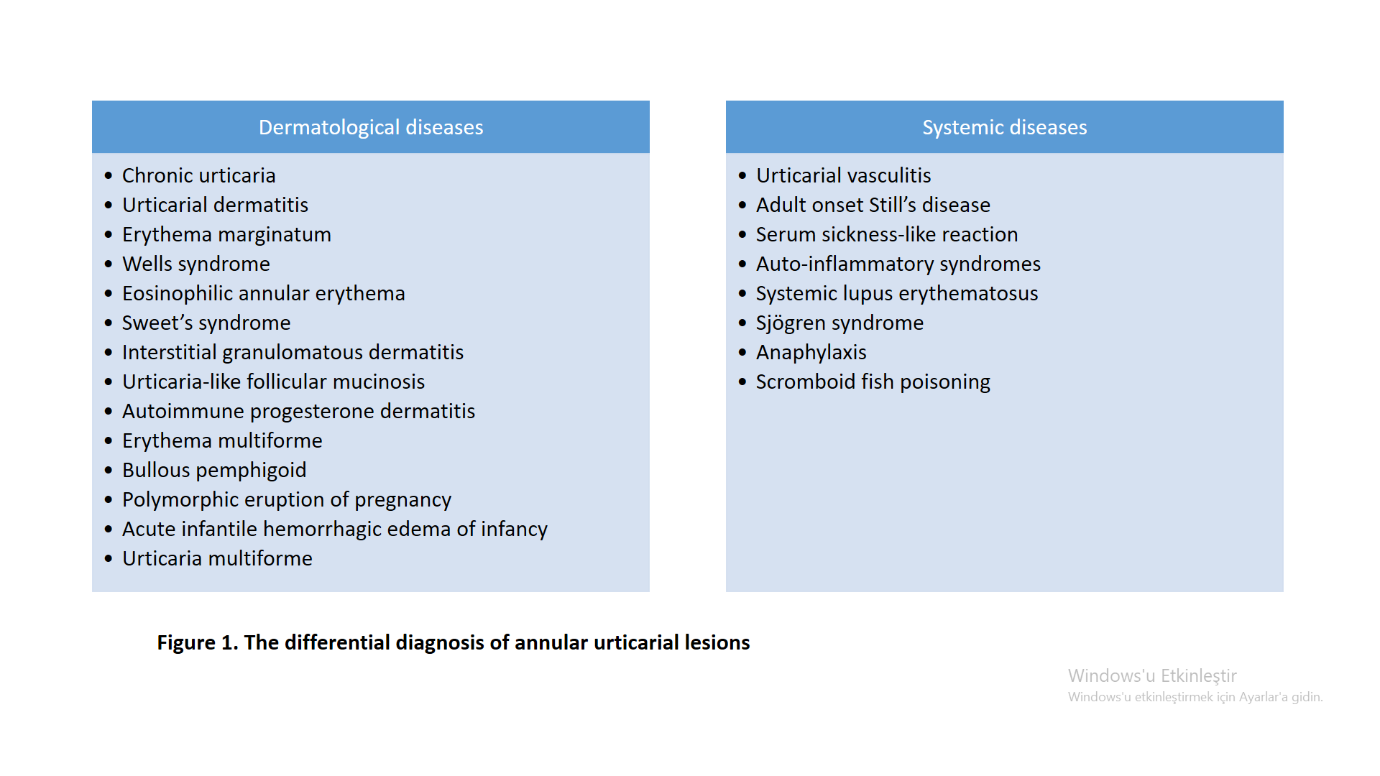
Recent Publications (minimum 5)
- Ornek S, Zuberbier T, Kocaturk E (2022) Annular urticarial lesions. Clinics in Dermatology 1;S0738-081X(21)00268-6.
- Peroni A, Colato C, Schena D, et al. (2010) Urticarial lesions: if not urticaria, what else? The differential diagnosis of urticaria: part I. Cutaneous diseases. The Journal of the American Academy of Dermatology 62:541-555.
- Davis MDP, van der Hilst JCH (2018) Mimickers of Urticaria: Urticarial Vasculitis and Autoinflammatory Diseases. The Journal of Allergy and Clinical Immunology: In Practice 6:1162-1170.
- Peroni A, Colato C, Zanoni G, et al. (2010) Urticarial lesions: if not urticaria, what else? The differential diagnosis of urticaria: part II. Systemic diseases. The Journal of the American Academy of Dermatology 62:557-570.
- Krause K, Grattan CE, Bindslev-Jensen C, et al. (2012) How not to miss autoinflammatory diseases masquerading as urticaria. Allergy 67:1465-1474.

Biography
Dr. Sinem Örnek is a Turkish and European dermatology board certified dermatology specialist. In addition to providing patient care services in the clinic, she also conducts clinical research and participates in international multicenter studies. She has advanced expertise in urticaria and angioedema and worked in the Urticaria Reference and Excellence Center (UCARE).
Email: snm.rnk@gmail.com

