The ONE21 Technique: an individualized and customized treatment of the forehead wrinkles, using botulinum toxin A, with a predictable eyebrow shaping

Carla de Sanctis Pecora, M.D., São Paulo, Brazil

Abstract (300 word limit)
Patients differ enormously in their facial anatomy regarding structure and function, both within and between genders, ethnicities, and age. Therefore, treating all patients with the same injection pattern and the same doses of botulinum toxin A can result in undesired outcomes. There is a need for a tailored approach to achieve optimal results, as well as to increase patient satisfaction. With this in mind, the novel ONE21 injection technique which allows for individualized treatment has been developed for the treatment of horizontal forehead lines, with a customized treatment, using a functional tool work, based on a unique structural and functional anatomy resulting in a positive impact on eyebrow position and shape. This technique consists of a three- step protocol: A - Assessment - to identify the individual’s unique forehead pattern; B - Bespoke - an evaluation to identify the individual’s desired results; C - Customised - dosing and injecting by the application of the 0,5-1-2U dosing of scheme. Based on the distribution and shape of the forehead lines a unique and individualized frontal muscle pattern can be identified, then seven vertical lines through inner and outer canthus, and medial facial line; and three horizontal lines over the lowest and the upper frown line, and one more in between those two lines are draw. The crossing lines will determine 21 possible injection points to be assessed. By touching each particular point in the forehead during maximum contraction, points and doses to be injected will be determined according to the patter and strength of the muscle. To reshape the eyebrow, we can deal with points distribution and doses in the lowest frown line in the forehead, called inferior limit line.
ONE21 technique using IncobotulinumtoxinA is the next step in a customized approach, giving natural-looking results and high patient satisfaction.

Image

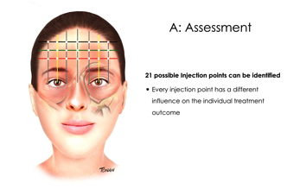

Recent Publications (minimum 5)
- De Sanctis Pecora, C. ONE21: a novel customized Injection Protocol for Treatment of the Forehead with IncobotulinumtoxinA Clinical, Cosmetic and Investigational Dermatology 2020:13 127–136
- Levy PH. Grid21. Presentation at Merz Expert Summit; 2017; Montreal, Canada.
- da Costa A, Pegas Pereira ES, Pereira MO, et al. Six-month com- parative analysis monitoring the progression of the largest diameter of the sweating inhibition halo of different botulinum toxins Type-A. Aesthet Surg J. 2018;39(9):993–1004.
- Kerscher M, Maack M, Reuther T, Krueger N. Diffusion character- istics of two different neurotoxins in patients with symmetric fore- head lines. J Am Acad Dermatol. 2007;56(2):AB199.
- Moqadam M, Frank K, Handayan C, et al. Understanding the shape of forehead lines. J Drugs Dermatol. 2017;16(5):471–477.
- Abramo AC, Do Amaral TP, Lessio BP, De Lima GA. Anatomy of forehead, glabellar, nasal and orbital muscles, and their correlation with distinctive patterns of skin lines on the upper third of the face: reviewing concepts. Aesthetic Plast Surg. 2016;40(6):962–971. doi:10.1007/s00266-016-0712-z

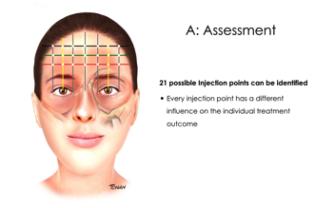
Photograph



Biography (150 word limit)

Graduated in Medicine at School of Medicine of University of São Paulo – 1993. Medical Residency in Dermatology at Federal University of São Paulo - 1994-1997. Specialization in Advanced Dermatology at Federal University of São Paulo - 1997-1998. Specialist in Dermatology by the Brazilian Society of Dermatology – 1997. Fellowship in Clinical, Surgical and Laser Dermatology at Hôpital Universitaire de L'Archet, Nice, France - 1998-1999. Associated Dermatologist at Department of Dermatology of Federal University of São Paulo, in Cosmetic and Aesthetic Dermatology- 1999-2013. Twenty years of experience in aesthetic dermatology, focusing mainly in fillers and botulinum toxin A.
Email: Carla@dermatologie.com.br

Notes/Comments:

