Combination of IPL and Radiofrequency for Total Skin Rejuvenation. Pilot Study
Name: Magdalena Atta-Motte
5th Avenue Medical Clinic, Lonodn, UK
VenusConcept UK, London, UK

Abstract

For several years an increasing demand of clients for non-invasive, effective, safe and long-lasting skin rejuvenation treatments has been noticed. For practitioners, it is important to understand exactly the nature of the devices available on the market that emit different forms of energy within the electromagnetic spectrum. In the aesthetics all of lasers (fractional, non-fractional, ablative, non-ablative, Q- switched, etc.), IPL devices, LED light, ultrasounds, acoustic waves, radio frequency waves or nanofractional, are cleared by FDA, and thus considered safe .

Devices such as IPL and lasers, works on the basis of absorption, transmission, reflection and scattering, giving effects on the tissue such as: photothermal, photomechanical, photoablative or photostimulation.

Radio frequency (RF) devices are designed to convert the energy of radio waves into thermal energy in various layers of skin and subcutaneous tissue. Based on the number of electrodes, RF devices are classified as monopolar, bipolar, tripolar or multipolar.

The aim of this pilot study was to assess the safety and efficacy of combined face facial therapy using three technologies: IPL Smart Pulse, RF (MP) 2 and RF NanoFractional Smart Scan to allow us to compare results with CO2 laser in clinical studies in future. Pilot study presents excellent results of firming, rejuvenating, lightening the skin and reducing wrinkles with a small convalescence time. Synergistic stimulation of keratinocytes and fibroblasts at the postmodern reduction of pigment and vascular lesions allows for long-lasting, satisfactory results achieved after just one treatment. Nevertheless, according to the researchers' assessment, the described TriBella treatment protocol shows further research in a wider group of participants to confirm effectiveness.After the analysis of the pilot study, it can be unequivocally concluded that the therapy used is a great surgical alternative with a wide range of efficacy for people who do not want to decide on injection methods, as well as for those who want to apply the broadly understood anti-ageing prevention. The natural capabilities of the organism resulting from the immune response to microdamages caused by IPL light, radio waves or RF RF nanofractional are enhanced, which ensures long-lasting post-treatment results.
Image
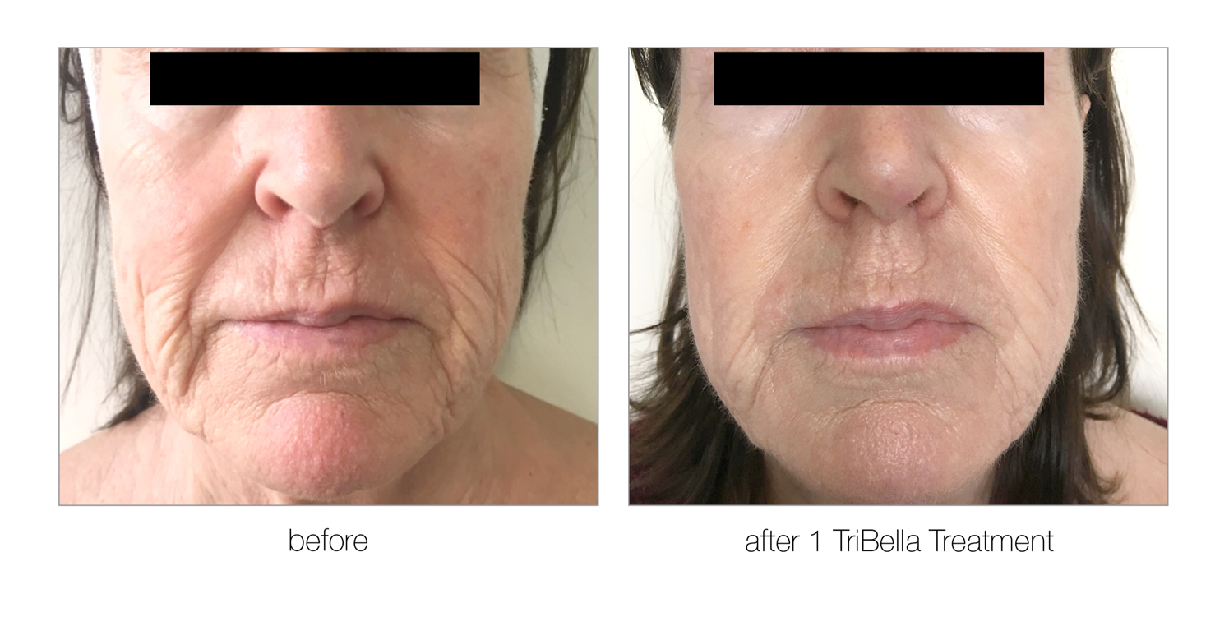Figure 1. Results 3 weeks after 1 treatment.
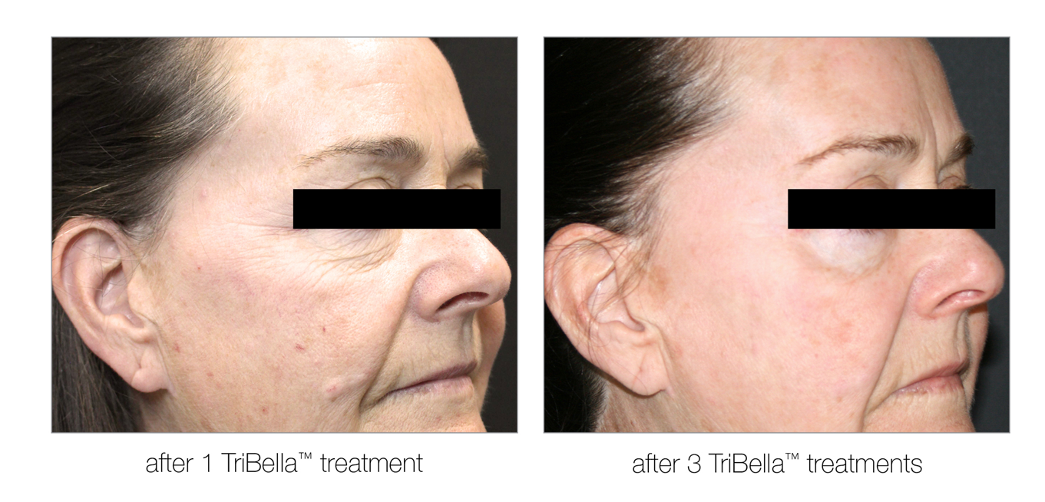
Figure 2. Results3 weeks after 1 and 3 weeks after 3 treatments
Recent Publications
1. U. Wollina, A Goldman, Minimally invasive aesthetic procedures in young adults. Clin Cosmet Investig Dermatol. 2011;4:19–26
2. N Sadick, KO Rothaus, Aesthetic Applications of Radiofrequency Devices. Clin Plast Surg. 2016 Jul;43(3):557-65.
3. N Sadick, SA Malerich, AH Nassar, et al, Radiofrequency: an update on latest innovations. J Drugs Dermatol. 2014;13:1331–1335
4. X Fu, J Dong, S Wang, M Yan, M Yao, Advances in the treatment of traumatic scars with laser, intense pulsed light, radiofrequency, and ultrasound. Burns Trauma. 2019. Jan 29;7:1


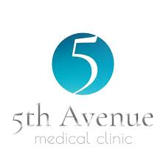
Biography
Magdalena Atta-Motte BSc, MSc, MPH, FRSPH Author of Number of publications in Cosmetology and Dermatology fiel with over 20 years' experience in the industry, Magdalena is a member of the British Medical Laser Association (BMLA), European Laser Aesthetic Member (ELA), Royal Society of Public Health Fellow and Society of Cosmetic Science (SCS). She is also an accredited lecturer at several academies and universities and she works as a international trainer and a Laser Protection Advisor (LPA)
Email: magda.atta.motte@consultant.com

Notes/Comments:

