Title: Heel reconstruction using medial plantar pedicled sensate island flaps after melanoma excision
Name: Jinsheng Li Haihua Chen
Hangzhou First People's Hospital, Zhejiang University School of Medicine, China

Abstract (300 word limit)

This study was aimed to explore the effect of medial plantar pedicled sensate island flaps in reconstructing heel after melanoma excision
According to the inclusive and exclusive criteria, 16 patients in group I received skin grafted to cover the defect in heel after melanoma excision 8 cases in group II received medial plantar pedicled sensate island flaps to reconstruct the defect were enrolled in this study. After surgery, a follow-up ranged from 1 to 2 years was conducted. The effectiveness of surgery was assessed by visual analogue scale (VAS).
There was no significant difference was identified in age, gender ratio and scar forming reason between two groups. After treatment, the VAS score in group II was significantly higher than that in group I (P<.001).
We advocate medial plantar pedicled sensate island flaps for the reconstruction of
defects of the heel units.

Image
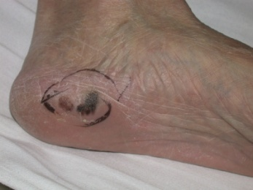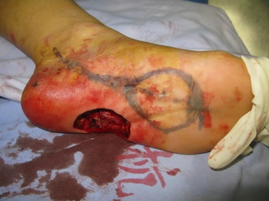
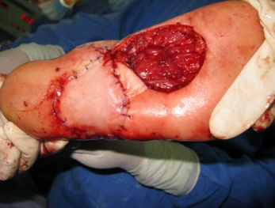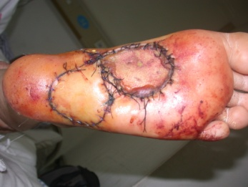

A 52-aged man with a melanoma in left heel before and after surgery.
Recent Publications

[1] Tsao H , Atkins M B , Sober A J . Management of Cutaneous Melanoma[J]. New England Journal of Medicine, 2004, 351(26):2770.
[2] Iii D G B , Sondak V K , Sabel M S . Surgical Therapy of Cutaneous Melanoma[J]. Seminars in Oncology, 2007, 34(3):270-280.
[3] Oh S J , Moon M , Cha J , et al. Weight-bearing plantar reconstruction using versatile medial plantar sensate flap.[J]. Journal of Plastic Reconstructive & Aesthetic Surgery, 2011, 64(2):248-254.



Paste your Photograph Here
Biography (150 word limit)
Jinsheng Li has a good experiences in plastic and reconstruction surgery especially in the fields:
The reconstruction of post-traumatic soft tissue & deformities, especially in reconstruction using free flaps.
Email: lijinsheng_sd@sina.com

Notes/Comments:

