Title: Composite Facial Scar Revision Surgery: W-plasty and botulinum toxin type A
Name: Haihua Chen
Hangzhou First People's Hospital, Zhejiang University School of Medicine, China

Abstract (300 word limit)

Objective: This study was aimed to explore the effect of W-plasty combined Botox-A injection in improving appearance of scar. Methods: According to the inclusive and exclusive criteria, patients received W-plasty combined Botox-A injection (study group) or W-plasty (control group) scar repairment were enrolled in this study. After surgery, a follow-up ranged from 1 to 2 years was conducted. The effectiveness of surgery was assessed by Visual Analogue Scale (VAS).
Results: A total of 38 patients were enrolled in this study, including 21 cases in the study group and 17 cases in the control group. There were no significant difference were identified in age (t = 0.339, P = 0.736), gender ratio (χ2 = 0.003, P = 0.955) and scar forming reason (χ2 = 0.391, P = 0.822) between two groups. After treatment, the VAS score in the study group was significantly higher than that in the control group (P < 0.001). Conclusion: W-plasty combined Botox-A injection can significantly improve the appearance of sunk scar on the face..

Image
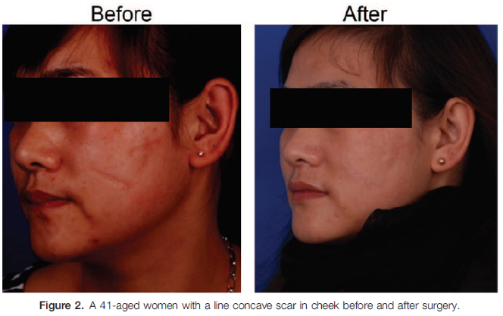
A 41-aged women with a line sunk scar in cheek before and after surgery.
Recent Publications

1.Atkinson JA, Mckenna KT, Barnett AG, et al. A randomized, controlled trial to determine the efficacy of paper tape in preventing hypertrophic scar formation in surgical incisions that traverse Langer’s skin tension lines. Plast Reconstr Surg 2005;116:203–11.
2. Jeong HS, Lee BH, Sung HM, et al. Effect of botulinum toxin type A on differentiation of fibroblasts derived from scar tissue. Plast Reconstr Surg 2015;136:171e–8e.
3. Gauglitz GG, Bureik D, Dombrowski Y, et al. Botulinum toxin A for the treatment of keloids. Skin Pharmacol Physiol 2012;25:313–8.
4. Gassner HG, Sherris DA, Otley CC. Treatment of facial wounds with
botulinum toxin A improves cosmetic outcome in primates. Plast
Reconstr Surg 2000;105:1948–53. discussion 1954–5.

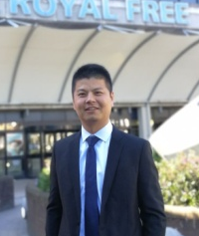

Paste your Photograph Here
Biography (150 word limit)
Haihua Chen has a good experiences in plastic surgery and maxillofacial surgery especially in the fields:
(1) conventional cosmetic plastic surgery and skin rejuvenation (botox/filler injection, laser resurfacing)
(2)The reconstruction of post-traumatic soft tissue & maxillofacial deformities, especially in scar revision.

Email: chhsimon@sina.com

Notes/Comments:

