HAIR
Autologous Serum Injection (ASI) in Androgenetic Alopecia (AGA)
Priti Anand Shringarpure

¹ Priti Shringarpure (National Board of Examinations (DNB Board), New Delhi, India)

Abstract

Androgenetic alopecia (AGA) is now commonly seen in younger age groups causing psychological trauma of getting bald due to a cosmetic concern. Various treatment modalities include orally hair vitamins and finasteride/dutasteride and mesotherapy (platelet rich plasma therapy-PRP).
The aim of my study was a retrospective audit to determine the efficacy and safety of autologous serum injection in AGA.
A retrospective analysis of patients treated with autologous serum injection in AGA was done. Outcome was measured using physician global assessment scale (PGAS).
A total of 50 patients aged between 20-40 years were evaluated. Autologous serum injection (ASI) was done in those patients in whom the usual treatment modalities did not give optimum results. 15 cc venous blood was collected from the patient and was autoclaved at 2000 rpm (revolutions per minute) for 20 minutes and the serum was separated under aseptic precautions. It was injected with prior 1 hour topical anaesthesia [prilocaine (2.5%) + lidocaine (2.5%)] around 0.05 cc at each point at a distance of 1 cm with an insulin syringe covering the low-density scalp. These sessions were done every fortnightly with total of 6-8 sessions. Adjuvant treatment given was oral vitamins and dutasteride and topical minoxidil.
Efficacy was evaluated (by PGAS) after minimum of 2 sessions (1 month). Good response (50-75%) was seen after 2-3 sessions and excellent improvement after 6-8 sessions. Side effects included immediate pain (mild) at injection site and headache which were temporary.
Conclusion Autologous serum injection is a simple, effective and newer therapeutic modality in AGA and provides satisfactory results with transient side effects as compared to the tedious and expensive procedure of PRP.

Symbols:
ASI- Autologous Serum Injection
AGA- Androgenetic Alopecia
PRP- Platelet rich plasma therapy
PGAS- Physician Global Assessment Scale

Keywords—AGA, Autologous serum, PRP, PGAS

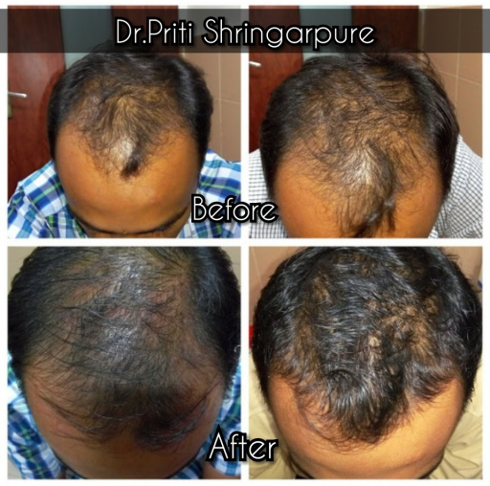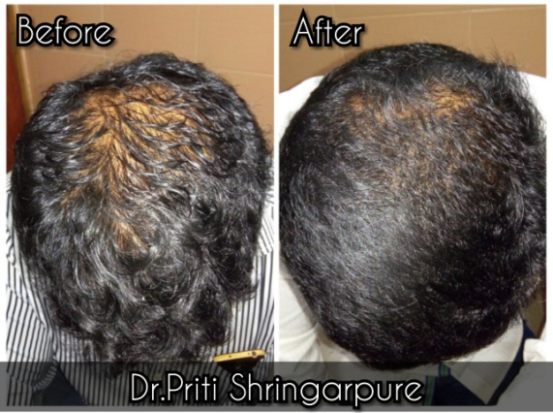

Professional Biography

Dr. Priti Shringarpure has completed her MBBS (Medicine Bachelors) graduation from MUHS (Maharashtra University of Health Sciences) Nasik, India. She then pursued DNB in Dermatology from National Board of Examinations (DNB Board), New Delhi, India and MD Dermatology from University of Seychelles - American Institute of Medicine (USAIM).

With many years of experience in this field and having studied at reputed institutes and trained at immensely prominent centre she is expert in clinical and paediatric dermatology, venereology, leprology, cosmetology, trichology and lasers.
She has publications in various renowned journals and has presented papers and posters in national and international conferences.
She is currently attached at various renowned and charitable hospitals in the heart city of India, Mumbai offering skin care at the best and highest quality in the least possible cost.



Email Id: drpritikarde@gmail.com
Contact Number: +91-9167780140

Any Comments:Kindly consider for oral paper presentation

