In Vivo Wound Healing and Anti-Inflammatory Activities of Leaf Latex of Aloe megalacantha Baker (Xanthorrhoeaceae)
Leake Gebremeskel,¹ Dayananda Bhoumik,² Gereziher Geremedhin Sibhat,³ and Kald Beshir Tuem ⁴
1Department of Pharmacy, College of Health Sciences, Aksum University, Aksum, Ethiopia
2Department of Pharmacology and Toxicology, School of Pharmacy, College of Health Sciences, Mekelle University, Mekelle, Ethiopia
3Department of Pharmacognosy, School of Pharmacy, College of Health Sciences, Mekelle University, Mekelle, Ethiopia

Abstract (300 word limit)
Background. Aloe megalacantha Baker (Xanthorrhoeaceae) is one of the Aloe species widely distributed in Ethiopia. The leaf latex of the plant is used for treatment of wounds, inflammation, and other multiple ailments in Ethiopian traditional medicine.
Purpose. The aim of this study was to evaluate in vivo wound healing and anti-inflammatory activities of the leaf latex of Aloe megalacantha in mice.
Methods. The wound healing activity of the leaf latex of the plant was studied topically by incorporating the latex in simple ointment base in a concentration of 5% (w/w) and 10% (w/w) using excision and incision models. In these models, wound contraction, period of epithelialization, and breaking strength of the wounded skin were determined. Carrageenan induced inflammation of paw model was also used to assess the anti-inflammatory activity of the leaf latex at doses of 200 mg/kg, 400mg/kg, and 600 mg/kg. The level of inflammation suppressions were measured at 1, 2, 3, and 4 hrs after carrageenan injection, and then the percentages of inflammation inhibition were computed as compared with the negative control. Result. In both wound models, mice treated with 5% (w/w) and 10% (w/w) latex ointment showed a significant (p<0.05) increment in the rate of wound contraction, reduction in epithelialization time, and higher skin breaking strength. Besides, the latex also exhibited a dose-dependent significant (p<0.05) reductions of inflammation as compared to negative control groups.
Conclusion. The overall results of this study demonstrate that the leaf latex of A. megalacantha possesses wound healing and anti-inflammatory activities which can scientifically substantiate the traditional use of the plant as a wound healing agent.

Image
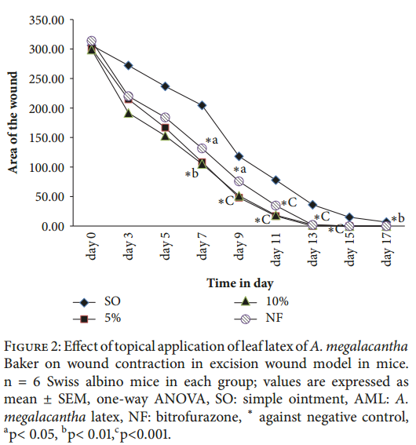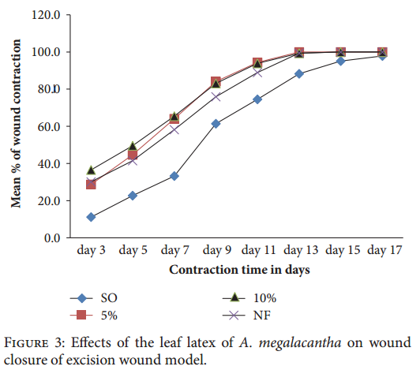Recent Publications (minimum 5)
- G. S. Lazarus, D. M. Cooper, D. R. Knighton et al., “Defnitions and guidelines for assessment of wounds and evaluation of healing,” Wound Repair and Regeneration, vol. 2, no. 3, pp. 165– 170, 1994.
- B. P. Nagori and R. Solanki, “Role of medicinal plants in wound healing,” Research Journal of Medicinal Plant, vol. 5, no. 4, pp. 392–405, 2011.
- M. C. Robson, D. L. Steed, and M. G. Franz, “Wound healing:biologic features and approaches to maximize healing trajectories.,” Current Problems in Surgery, vol. 38, no. 2, pp. 72–140, 2001.
- D. D. Kokane, R. Y. More, M. B. Kale, M. N. Nehete, P. C. Mehendale, and C. H. Gadgoli, “Evaluation of wound healing activity of root of Mimosa pudica,” Journal of Ethnopharmacology, vol. 124, no. 2, pp. 311–315, 2009.
- European Wound Management Association (EWMA), “Antimicrobials and Non-healing Wounds,” Journal of wound care, vol. 22, no. 5, pp. s2–s89, 2013.

Photograph

Biography (150 word limit)
I am Kald Beshir and I am 32 years old, currently I am working as a lecturer for medical students in Mekelle University, Ethiopia. I am a pharmacologist by profession. I involved in experimental researched including evaluation of wound healing, anti-inflammatory, antimalarial, antibacterial activities of certain plants.
Email: kalizad2003@gmail.com

Notes/Comments:

