Giant Condylomata Acuminata of Buschke-Lowenstein with Paraneoplastic Hypercalcemia
Frederick Venter et al.
Kern Medical Center, Bakersfield, California, USA
Ross University School of Medicine

Abstract
Long standing genital warts can turn malignant due to dynamics between the HPV virus and the immunologic response of the host. Giant Condyloma Acuminatum associated with Squamous Cell Carcinoma are termed Buschke Lowenstein Tumors. The E7 gene of HPV impairs antigen presenting cells in the skin, enabling the virus to stay undetected. E6, E7 oncogenes combined induce telomerase resulting in cellular immortalization of infected cells, they also induce chronic oxidative stress increasing susceptibility to DNA damage, paving way for carcinogenesis. Co-infection with HIV/HSV-1 further enhance the oncogenesis of HPV. An association of carcinoma with hypercalcemia usually indicate a poor prognosis.

We present a 42-year-old Native American male admitted to the emergency department with nausea, vomiting, abdominal pain localized to groin with foul-smelling discharge. The genital warts diagnosed at age 17 had reached a considerable size. For the past 5 months the friable mass rapidly increased in size and was associated with occasional serous/bloody discharge. Patient had unintended weight loss of 100 lbs in the past year with fatigue and loss of appetite. A large irregular mass over bilateral inguinal regions involved the penis, scrotum and perineum measuring 31x17x6cm draining foul-smelling purulent discharge. Serum blood calcium level at admission was 13.8 mg/dL with PTHrP 24.1 pmol/L, HSV-1 results were positive. HTLV and HIV sub types were negative. Biopsy H&E stain showed infiltrating hyperchromatic squamous cells, enlarged nuclei and high nuclear/cytoplasmic ratio, hyperkeratotic spears and acanthosis were also present. CT Pelvis revealed marked skin thickening and irregularity in the perineal/inguinal/upper thigh regions and the right inguinal region was associated with inflammation and fistulous tracts. CT Chest was negative for metastasis. The oncology team started Pembrolizumab for the inoperable mass.
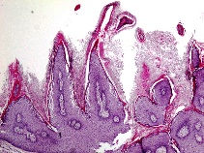
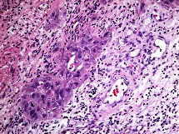
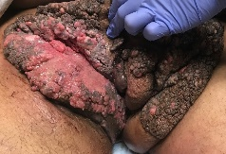
Image

Image (1): Condyloma Acuminatum Image (2): H&E 4X stain of Image (3):H&E 20X stain of
of the groin and pelvic region biopsy showing papillomatosis Condyloma Acuminatum showing
disfiguring the male genitalia. and hyperkeratosis, defining mitotic figures and Squamous
Condyloma Acuminatum Cell Carcinoma invasion

Recent Publications
Venter, F., Heidari, A., Viehweg, M., Rivera, M., Natarajan, P., & Cobos, E. (2018). Giant Condylomata Acuminata of Buschke-Lowenstein Associated With Paraneoplastic Hypercalcemia. Journal of investigative medicine high impact case reports, 6, 2324709618758348.





At the young age of 8 my family emigrated from South Africa to Canada, this is where I finished my schooling and completed my university degree at Mount Royal University in Calgary Alberta. During this time I also worked at a brain injury rehabilitation center for 3 years mostly taking care of patients post stroke. In January of 2015 I was accepted into Ross University School of Medicine and am currently a 4th medical student. I have recently completed rotations in Miami, California and New York as well as presented at the ACP Nationals in New Orleans last month.
frederickventer@students.rossu.edu

