Metadichol ® and Skin diseases. A poly pharmacological approach. One Process many possible cures
Dr P.R. Raghavan
NanoRx Inc, PO Box 131, Chappaqua, Ny 10514 USA

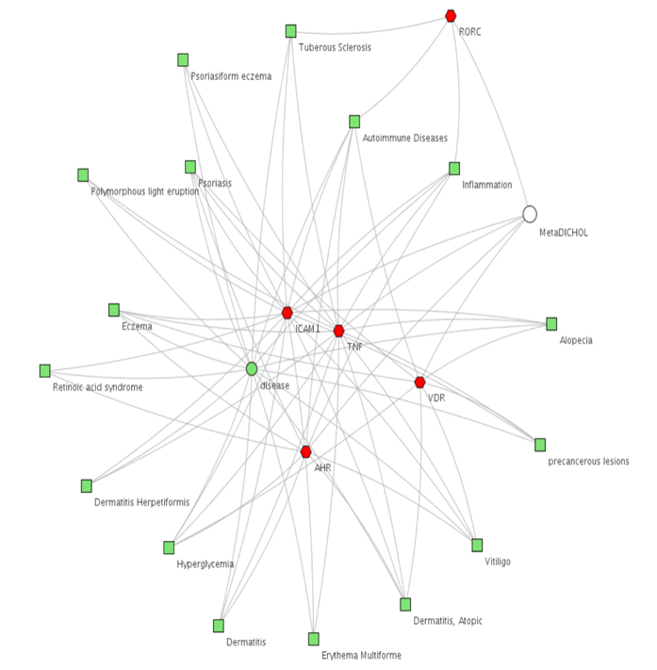
Abstract
The skin is the largest organ of the body that fulfills multiple essential tasks. It forms the boundary between the inside and outside. It protects against mechanical and chemical threats, it provides innate and adaptive immune defenses, it enables thermoregulation and vitamin D production, and it acts as the sensory organ of touch. Skin disease are a significant cause of global disease burden, affecting millions of people worldwide. There are more than 3000 known diseases of the skin. Aging, environmental and genetic factors, and trauma can result in the development of a diverse set of skin diseases.

Metadichol ® a Nano formulation of long-chain lipid alcohols derived from food It is a inverse agonist of Vitamin D receptor (VDR), Aryl hydrocarbon receptor (AHR), and Ror game (RORC) that could have beneficial effects on skin diseases. We now present case studies of patents with various skin disease show Metadichol is an inverse agonist of these named nuclear receptors thus modulating Th1 pathway towards
a TH2 and Th 17 and IL 17 and IL22.and also being a TNF alpha inhibitor can modulate IL23 thus blocking the major pathways that exacerbate many Skin diseases.

Metadichol is the first molecule to successfully navigate around the problems involved with promiscuous ligands and targets. It fulfills the goals of the emerging field of Polyphrmacology, ie a single drug is able to bind to multiple targets beyond the "one drug, one target" philosophy. We show how Metadichol is an innovative treatment or treating multiple skin diseases like eczema, acne, diabetic wounds and viral and bacterial infection and also improving skin texture. Metadichol ® is a safe non toxic low cost solution and is an alternative to numerous clinical candidates in combating over 3000 skin diseases.

Biography



CEO of Nanorx INC has a Ph.D. in Organic Chemistry from Oregon State University(1979) and M.S in Chemistry(1972) from I.I.T Mumbai, India. He has worked on drug discovery for over 25 years at Columbia University, Max-Planck Institute, Germany, Ciba-Geigy (now Novartis) and Boehringer Ingelheim. He has over 25 US and International patents and another 15 pending patent applications.
Linked In account: www.linkedin.com/in/palayakotai-raghavan-9327304
email; raghavan@nanorxinc.com
Contactnumber:001-914-671-0224

Recent Publications
- Raghavan, P.R, US Patents: 8,722,093 (2014); 9,034,383 (2015) ; 9,006,292 (2015)
- Raghavan PR (2018) Metadichol® and CD34 Expression in Umbilical Cord Cells. J Stem Cell Res Ther 8: 409. doi: 10.4172/2157-7633.1000409
- Raghavan PR (2018) Metadichol®, Vitamin C and GULO Gene Expression in Mouse Adipocytes. Biol Med (Aligarh) 10: 426. doi 10.4172/0974-8369.1000426.
- Raghavan PR (2017) Metadichol, A novel ROR Gamma Inverse Agonist and its Applications in Psoriasis. J Clin Exp Dermatol Res 8: 433. doi:10.4172/2155-9554.1000433
- Raghavan PR (2017); Metadichol ®. A Novel Inverse Agonist of Aryl Hydrocarbon Receptor (AHR) and NRF2 Inhibitor. J Cancer Sci Ther 9: 661-668. doi:10.4172/1948-5956.1000489
- Raghavan PR (2017). Metadichol® Induced High Levels of Vitamin C: Case Studies.Vitam Miner 6: 169. doi:10.4172/2376-1318.1000169
- Raghavan P.R (2017) Metadichol® and Vitamin C Increase In Vivo, an Open-Label Study. Vitam Miner 6: 163

