Harnessing the Antibacterial Properties of Fluoridated Chitosan Polymers against Oral Biofilms
Dien Puji Rahayu, Roger Draheim, Aikaterini Lalatsa, Marta Roldo

School of Pharmacy and Biomedical Sciences, University of Portsmouth, St Michael’s Building, White Swan Road, Portsmouth PO1 2DT, UK

Abstract

Dental caries is a worldwide endemic chronic disease affecting people of all ages, with high incidence in the young population of developing countries¹. Due to the limitations of daily used oral hygiene products, there is an unmet need for new, effective, safe and economic oral hygiene products. Using chitosan as a starting material we exploit a sustainable source and address an environmental issue as the same time. In fact, food waste from the shellfish food industry can be recycled to extract chitin the precursor of chitosan. We have recently demonstrated that N-(2(2,6-diaminohexanamide)-chitosan (CS3H Lys) has enhanced antibacterial properties against Staphylococcus aureus a bacterium responsible for a high percentage of implant associated infections². Therefore, in the present study we evaluated its efficacy against Streptococcus mutans, the main cariogenic bacterium. We further investigated the effect of fluoridation of this polymer (CS3H Lys F) on its antibacterial properties and the ability to protect teeth from acid demineralization. Finally, the polymers were formulated into mouthwash preparations and their cytocompatibility and physicochemical stability were assessed over 6 months³.

CS3H Lys F was found to be 1.6-fold more effective than a 1450 ppm NaF aqueous solution in preventing acid demineralization. This higher efficacy was obtained with a concentration of fluoride ions 3000 times lower compared to the NaF 1450ppm solution used as control. This demonstrated that the mode of delivery of fluoride ions is more important for efficacy that the dose⁴. CS3H Lys F also had a 3 to 5-fold lower minimum inhibitory concentration value against S. mutans than values reported in literature for other chitosan polymers⁵ and showed negligible cell toxicity. The mouthwash formulation developed containing the chitosan polymers was stable at both 25 and 40 °C for 6 months. Further work is under way towards other CS3H Lys F oral hygiene products such as a toothpaste.
Image
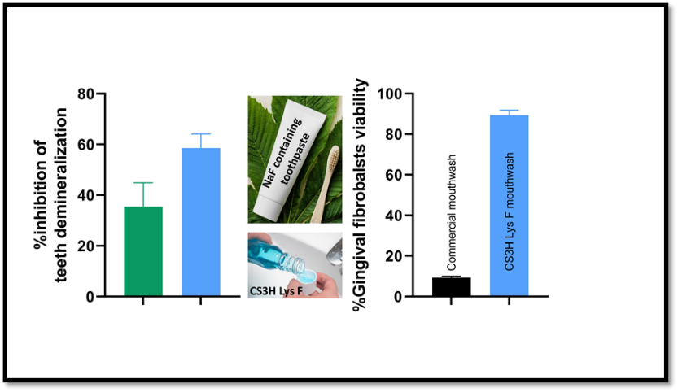
Recent Publications
- Duangthip D, Gao SS, Lo ECM, Chu CH. Early childhood caries among 5- to 6-year-old children in Southeast Asia. Int. Dent. J. 2017, 67, 98–106.
- Rahayu DP, De Mori A, Yusuf R, Draheim R, Lalatsa A, Roldo M. Enhancing the antibacterial effect of chitosan to combat orthopaedic implant-associated infections. Carbohydr Polym. 2022;289:119385.
- Rahayu DP, Draheim R, Lalatsa A, Roldo M. Harnessing the Antibacterial Properties of Fluoridated Chitosan Polymers against Oral Biofilms. Pharmaceutics. 2022;14(3):488.
- Chow, LC, Takagi S, Frukhtbeyn S, Sieck BA, Parry EE, Liao NS, Schumacher GE, Markovic M. Remineralization Effect of a Low-Concentration Fluoride Rinse in an Intraoral Model. Caries Res. 2002, 36, 136–141.
- Costa EM, Silva S, Pina C, Tavaria FK, Pintado MM. Evaluation and insights into chitosan antimicrobial activity against anaerobic oral pathogens. Anaerobe 2012, 18, 305–309.

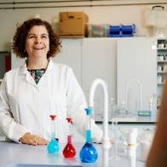 Biography
Dr Marta Roldo is a Reader in Biomaterials at the University of Portsmouth. Her research focuses on the development and characterization of novel biomaterials for biomedical applications. She has developed novel polymeric derivatives with antibacterial and anticoagulant properties, composite hydrogels for tissue regeneration and has an interest in the development of state of the art imaging techniques to visualize oral biofilm and test its removal efficacy using different oral hygiene strategies.
Email: marta.roldo@port.ac.uk

Notes/Comments:

